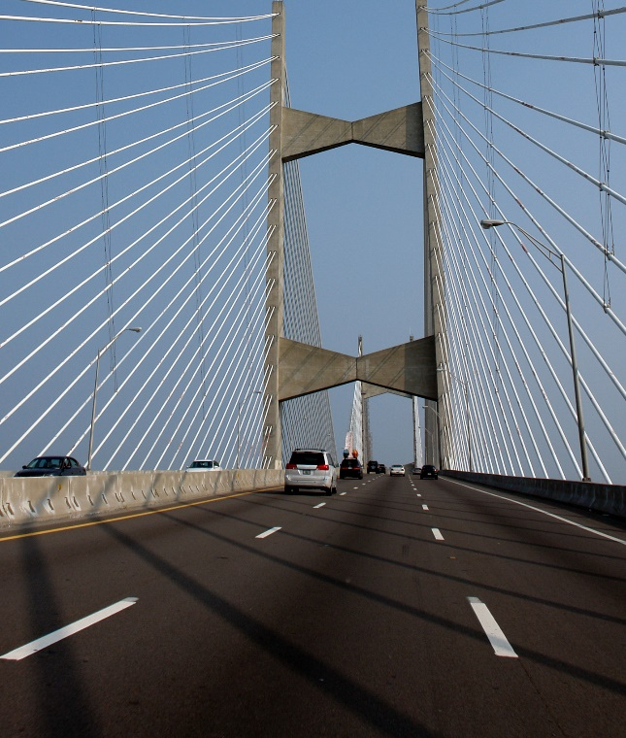 | 

1515 SW 5th Avenue, Suite 1030  Portland, OR 97201  503.200.6600  www.rsginc.com | prepared for:
 | North Florida Transportation Planning Organization
 | Submitted By:
 | rsg

1.0 Introduction 1
1.1 Disclaimer 1
1.2 Overview 1
2.0 Development of microzones and 2015 Land-Use data 3
2.1 Data processing steps/Methodology 3
2.2 Microzone summaries 11
2.3 Employment Data 12
2.4 school Enrollment Data 15
2.5 Parking 15
2.6 Lodging 16
2.7 Special Generators 16
3.0 Development of population synthesis for 2015 18
3.1 Input Data for population synthesis 18
Preparing Geographic Cross-walk 19
Preparing Seed Sample 19
Preparing Control Data 20
3.2 PopulationSim Validation 22
4.0 Development of 2045 Land-Use Data 26
4.1 Population Synthesis for 2045 30
5.0 Development of 2030 Land-Use Data 36
5.1 Population Synthesis for 2030 38
6.0 DaySim ABM Model Update 42
6.1 DaySim Summary Comparison 42
7.0 Development of External Model Inputs 56
7.1 Data Sources 56
7.2 Estimating The BT Expansion Factor 56
7.3 Estimating External-External Trips 58
7.4 QA/QC 58
7.5 Conclusion 80
8.0 Network Updates 81
8.1 Network Link Updates 81
8.2 Transit Network Updates 82
8.3 Volume Count Updates 82
9.0 Cube Model update 83
9.1 External-Internal Trips Calibration 83
9.2 transit skimming Updates 85
9.3 highway skimming for tolls 86
10.0 daysim model calibration & Validation 87
10.1 Calibration Summaries 89
10.2 model summaries 116
VMT by VC Ratio 116
Trips by Mode and Income 116
County-County Flows 118
10.3 Model Validation 120
Validation Data 120
Highway Validation 121
Transit Validation 123
Appendix A. Synthetic Population A-1
Software Requirements A-1
Anaconda with python 2.7 A-1
Setup & RUN Populationsim A-7
Setup Directory A-7
Appendix B. Prepare DaySim Inputs B-15
Transit Stops File B-15
DaySim Data Editing B-16
Running DSBuffTool.exe B-18
List of Figures
Figure 1 CBD AREA – UrbanCore, Springfield, Downtown. 6
Figure 2 SUBURBAN AREA - Middleburg. 7
Figure 3 RURAL AREA - Etoniah Creek State Forest, Palatka. 8
Figure 4 ALONG A MAJOR WATERWAY – Henry H Buckman Bridge. 9
Figure 5 DIFFERENCE BETWEEN OLD MAZs and NEW MAZs. 10
Figure 6 POPSIM Validation (standard deviation). 23
Figure 7 POPSIM validation (root mean square error). 25
Figure 8 INCREASE IN HOUSEHOLDS FROM 2015 TO 2045 29
Figure 9 POPULATION IN AGING (BEBR DATA) 31
Figure 10 POPULATIONSIM CONTROLS VALIDATION (2045) 34
Figure 11 POPULATIONSIM CONTROLS VALIDATION (2030) 41
Figure 12 Work Location Choice: Home-Work Distances. 44
Figure 13 School Location Choice: Home-School Distances. 45
Figure 14 TOUR LENGTH & DURATION FREQUENCY DISTRIBUTION (SHOP). 49
Figure 15 TOUR LENGTH & DURATION FREQUENCY DISTRIBUTION (Soc/Rec). 51
Figure 16 TRIP LENGTH & DURATION FREQUENCY DISTRIBUTION (SHOP). 52
Figure 17 TRIP LENGTH & DURATION FREQUENCY DISTRIBUTION (Soc/Rec). 53
Figure 18 ESTIMATED TOUR ARRIVAL AT PERIOD TIMES. 54
Figure 19 WORK STOP DEPARTURE & ARRIVAL TIMES. 55
Figure 20 Number of trips by origin and destination AADT 61
Figure 21 Old model vs. estimated X-X trips 63
Figure 22 2550 (I-95 North) – 2574 (US 17) – Old model trips = 1 vs. new estimates = 286 67
Figure 23 2564 (US 301) – 2574 (US 17) – Old model trips = 1 vs. new estimates = 187 69
Figure 24 2576 (US 1 South) – 2552 (US 1 North) – Old model trips = 1 vs. new estimates = 152 70
Figure 25 2576 (US 1 North) – 2559 (I-10 West) – Old model trips = 3 vs. new estimates = 440 71
Figure 26 2577 (I-95 South) – 2559 (I-10 West) - Old model trips = 639 vs. new estimates = 3854 73
Figure 27 2550 (I-95 North) – 2564 US 301) - - Old model trips = 4231 vs. new estimates = 2310 75
Figure 28 2550 (I-95 North) – 2568 (SR 100 North) - Old model trips = 1658 vs. new estimates = 85 76
Figure 29 2550 (I-95 North) – 2559 (I-10 West) - Old model trips = 2442 vs. new estimates = 3964 77
Figure 30 2577 (I-95 South) – 2568 (SR 100 North) - Old model trips = 1562 vs. new estimates = 84 79
Figure 31 transit trips by tour purposes 89
Figure 32 distribution of home to work distances 92
Figure 33 distribution of home to school distance 94
Figure 34 tour length distribution for discretionary travel 103
Figure 35 tour length distribution for maintenance level 103
Figure 36 TOUR LENGTH DISTRIBUTION FOR escort LEVEL 104
Figure 37 TOUR LENGTH DISTRIBUTION FOR work-based LEVEL 104
Figure 38 tour mode shares (total) 106
Figure 39 time of day distribution of work arrival times 109
Figure 40 TIME OF DAY DISTRIBUTION OF WORK DEPARTURE TIMES 110
Figure 41 TIME OF DAY DISTRIBUTION OF SCHOOL ARRIVAL TIMES 110
Figure 42 TIME OF DAY DISTRIBUTION OF SCHOOL DEPARTURE TIMES 111
Figure 43 TIME OF DAY DISTRIBUTION OF OTHER PURPOSE ARRIVAL TIMES 111
Figure 44 TIME OF DAY DISTRIBUTION OF OTHER PURPOSE DEPARTURE TIMES 112
Figure 45 TIME OF DAY DISTRIBUTION OF WORK-BASED ARRIVAL TIMES 112
Figure 46 TIME OF DAY DISTRIBUTION OF WORK-BASED DEPARTURE TIMES 113
Figure 47 trip mode shares (total) 114
Figure 48 Daily Traffic Counts Vs Model Flows 121
Figure 49 Obersved and Estimated Transit Boardings 125
Figure 50 Boardings by Transit Line 126
Figure 51 PopulationSim Directory Structure A-7
Figure 52 land-use file before adding 100 households A-13
Figure 53 land-use file after adding 100 households A-13
Figure 10-24 DaySim Buffering Tool Gui B-18
Figure 10-25 Buffer TooL File Selection Dialog B-19

List of Tables
Table 1 aggregation settings of parcel data fields 4
Table 2 microzones by county 11
Table 3 Microzone Households and Employment. 11
Table 4 NAICS CODE TO DAYSIM EMPLOYMENT CROSSWALK 13
Table 5 Geographic crosswalk sample. 19
Table 6 BEBR SUPER COUNTY TOTALS (2015) 20
Table 7 COntrol data summary. 21
Table 8 PopulationSim Data Summaries Comparison. 25
Table 9 BEBR COUNTY TOTALS 26
Table 10 FORECASTING LOGIC FOR 2045 27
Table 11 COMPARISON OF 2015 AND 2045 TOTALS 28
Table 12 COUNTY LEVEL CONTROLS FOR POPULATIONSIM 2045 30
Table 13 MAZ LEVEL CONTROL 32
Table 14 TAZ LEVEL CONTROL (PARTIAL) 32
Table 15 BEBR County Totals 36
Table 16 Forecasting Logic for 2030 36
Table 17 COMPARISON OF 2015 AND 2030 TOTALS 38
Table 18 COUNTY LEVEL CONTROLS FOR POPULATIONSIM 38
Table 19 2030 MAZ LEVEL CONTROL 39
Table 20 2030 TAZ LEVEL CONTROL (PARTIAL) 39
Table 21 Vehicle Availability 42
Table 22 TOURS BY PURPOSE & PERSON TYPE 45
Table 23 TRIPS BY PURPOSE & PERSON TYPE 46
Table 24 ESTIMATED TOUR MODES: ALL PURPOSES 47
Table 25 ESTIMATED TRIPS by MODE 48
Table 26 O-D PAIRS WITH HIGHEST TRIP VOLUME IN OLD MODEL AND ESTIMATED RESULTS 65
Table 27 O-D PAIRS WITH HIGHEST TRIP DIFFERENCE IN OLD MODEL VS. ESTIMATED RESULTS 66
Table 28 E+C Network (2040A) Links to change for 2015 Network 81
Table 29 Summary of EE trips for Major facilities (original input) 83
Table 30 Summary of EE trips for Major facilities (modified input) 84
Table 31 EI Trip Comparison 84
Table 32 Comparison of Average Trip Length 84
Table 33 Comparison of VMT 85
Table 34 IVT Modifier and ASC by Transit Mode 86
Table 35 model calibration datasets 87
Table 36 population by person type 90
Table 37 population by person type (%) 90
Table 38 average home to work distance 91
Table 39 workers by county 92
Table 40 average home to school distance 93
Table 41 share of vehicles by households and drivers (HTS) 94
Table 42 SHARE OF VEHICLES BY HOUSEHOLDS AND DRIVERS (daysim) 95
Table 43 difference in VEHICLES shares BY HOUSEHOLDS AND DRIVERs 95
Table 44 tours by purpose 96
Table 45 tour rate by purpose 96
Table 46 tours by person type 97
Table 47 tour rate by person type 98
Table 48 trips by purpose 98
Table 49 trip rate by purpose 99
Table 50 trips per tour by purpose 100
Table 51 trips by person type 100
Table 52 trip rate by person type 101
Table 53 average tour lengths for other tour purpose 102
Table 54 tour mode shares (HTS) 107
Table 55 tour mode shares (ABM) 107
Table 56 tour mode shares (HTS-ABM) 108
Table 57 trip lengths (miles) by destination purpose 108
Table 58 trip mode shares (HTS) 114
Table 59 trip mode shares (ABM) 115
Table 60 trip mode shares (ABM-HTS) 115
Table 61 VMT by VC Ratio (2045) 116
Table 62 Trips by Mode and Income (work) 116
Table 63 TRIPS BY MODE AND INCOME (School) 117
Table 64 TRIPS BY MODE AND INCOME (Shop) 117
Table 65 TRIPS BY MODE AND INCOME (Other) 117
Table 66 TRIPS BY MODE AND INCOME (Total) 118
Table 67 County to COunty Flows (Work) 118
Table 68 COUNTY TO COUNTY FLOWS (School) 118
Table 69 COUNTY TO COUNTY FLOWS (Shop) 119
Table 70 COUNTY TO COUNTY FLOWS (Other) 119
Table 71 COUNTY TO COUNTY FLOWS (Total) 119
Table 72 Model Validation Datasets 120
Table 73 Comparison by VoLume Group 122
Table 74 Root Mean Square Error (RMSE) by Volume Group 123
Table 75 Percent Difference by Facility Type 123
Table 76 Total Boardings 124
Table 77 Variables to update by user when updating popsim controls A-14
Table 78 Rename popsim_to_daysim.bat output B-22

LIST OF ACRONYMS

AADT - ANNUAL AVERAGE DAILY TRAFFIC
ABM - ACTIVITY BASED MODEL
ACS - AMERICAN COMMUNITY SURVEY
ASC - ALTERNATIVE SPECIFIC CONSTANT
BEBR - BUREAU OF ECONOMIC AND BUSINESS RESEARCH
CAC - CITIZENS' ADVISORY COMMITTEE
CBD - CENTRAL BUSINESS DISTRICT
CTPP - CENSUS TRANSPORTATION PLANNING PRODUCTS
EE - EXTERNAL-EXTERNAL
FDOE - FLORIDA DEPARTMENT OF EDUCATION
FDOT - FLORIDA DEPARTMENT OF TRANSPORTATION
FHWA - FEDERAL HIGHWAY ADMINISTRATION
HOV - HIGH OCCUPANCY VEHICLE
HTS - HOUSEHOLD TRAVEL SURVEY
IE - INTERNAL-EXTERNAL
II - INTERNAL-INTERNAL
IPF - ITERATIVE PROPORTIONAL FITTING
JTA - JACKSONVILLE TRANSPORTATION AUTHORITY
KNR - KISS AND RIDE
LRTP - LONG RANGE TRANSPORTATION PLAN
MAZ - MICRO ANALYSIS ZONE
MNL - MULTINOMIAL LOGIT
NAICS - NORTH AMERICAN INDUSTRY CLASSIFICATION SYSTEM
NERPM - NORTH EAST REGIONAL PLANNING MODEL: ACTIVITY BASED
NFTPO - NORTH FLORIDA TRANSPORTATION PLANNING ORGANIZATION
NHTS - NATIONAL HOUSEHOLD TRAVEL SURVEY
PNR - PARK AND RIDE
PUMA - PUBLIC USE MICRODATA AREA
PUMS - PUBLIC USE MICRDATA SAMPLE
QA/QC - QUALITY ASSURANCE/QUALITY CONTROL
RMSE - ROOT MEAN SQUARE ERROR
RSG - RESOURCE SYSTEMS GROUP
SOV - SINGLE OCCUPANCY VEHICLE
SR2 - SHARED RIDE 2 OCCUPANTS
SR3 - SHARED RIDE 3 OCCUPANTS
STDEV - STANDARD DEVIATION
TAZ - TRAFFIC ANALYSIS ZONE
TCC - TECHNICAL COORDINATION COMMITTEE
VC - VOLUME TO CAPACITY
VMT - VEHICLE MILES TRAVELED

Introduction

Disclaimer
The views and results expressed in this document do not represent the opinions of North Florida TPO and do not constitute an endorsement, recommendation, or specification by North Florida TPO. The document is based solely on the tasks and development conducted by RSG.

Overview
This report describes updates to the North Florida Transportation Planning Organization (NFTPO) activity-based travel demand model (NERPM-AB) to meet existing and evolving transportation planning needs. The new model system can address policies such as compact and mixed-use development, active transportation, transit, and pricing. The model is credible for forecasting demand for highway alternatives such as river crossings and network improvements, and appropriately sensitive to land-use changes such as new planned developments and provide useful information for traffic impact studies.
The report describes the model developments in detail and is also aimed to serve as a user’s guide for the model updates. The activity based model (ABM) is integrated with Cube software, which is primarily used for network models (skimming and assignment) and auxiliary demand models (truck model and external truck demand). The ABM base-year model (2015) is calibrated using 2017 Household Travel Survey and 2016 transit on-board survey. The model system was also validated against observed data for traffic counts and transit ridership.
This project undertook the following key tasks to update the NERPM-AB activity-based model:
- Development of microzones for base year 2015
- Development of 2015 land-use data
- Development of population synthesis for base year 2015
- Development of 2045 land-use data
- Development of 2045 population synthesis
- Development of 2030 land-use data
- Development of 2030 population synthesis
- Implementation of latest version of DaySim
- Development of external trip inputs
- Development of cube model updates
- Calibration and validation of ABM
- Development of new model summaries
- Examine model sensitivities to land-use and network changes
The rest of this report refers to the new ABM system as NERPM-AB and is organized as follows. The next chapter, Chapter 2, describes the development of microzones for 2015. Then Chapter 3 presents development of land-use data and population synthesis for various model years. Chapter 4 discusses the cube model updates. Chapter 5 presents the model calibration and validation results. Chapter 6 describes the model summaries. At the end of the report, several appendices (Appendix A-B) provide supplemental information about various tasks performed during this project. The model setup and further documentation can be found at http://northfloridatpo.com/modelwiki/NFTPO_Model.

Development of microzones and 2015 Land-Use data
As part of the Long-Range Transportation Plan (LRTP) update, the NERPM-AB model was updated, including migrating the base scenario from 2010 to 2015. This work involved development of updated land use and population data inputs for the new base year 2015 model scenario. The model structure was also updated to be easier to use and maintain. Although migrating from parcels to microzones is useful for land use data and trips, the auto and transit network modeling continue to use TAZs.
NERPM-AB uses two zones systems:
- TAZs for network modeling
- Microzones for land-use and ABM trips
The existing land use data such as households, employment by type, enrollment and parking is coded at the parcel level. There are approximately 700,000 parcels in the region, which makes it difficult to maintain, edit and attribute both the existing and alternative scenarios. This led to the creation and use of microzones as alternative, which is halfway between parcels and TAZs and are easier to maintain. Draft microzone geography and population synthesis were developed for the NERPM-AB model area. For this task, the microzones are assumed to be the blocks present in each block group from the Census data set. The existing parcel data was aggregated up to the microzones and aided in the QA/QC of the geography (i.e. zones with no households or employment were flagged for possible merging into neighbor zones).

Data processing steps/Methodology
To create new microzones for the NERPM-AB model update, the raw block data in ArcGIS shapefile format was first downloaded from Census. Along with the blocks, shapefiles of water bodies, network, parcel and TAZ data were also either downloaded or collected from existing Model folders. The data downloaded from Census consisted of the entire Florida region out of which, the data for North Florida TPO was extracted using the six county codes:
- Baker (003)
- Clay (019)
- Nassau (089)
- Duval (031)
- Putnam (107)
- St. Johns (109)
The waterbodies were also merged in ArcGIS in one single data base. This data was used to eliminate or remove the area from the microzones. The next step involved bringing all the dataset under the same projection. While observing the boundaries of blocks and TAZs, it was found that some of the blocks were larger than TAZs and vice versa. This led to the overlapping of boundaries which will lead to irregular distribution of household and land use data. Therefore, the blocks and the TAZs were intersected to create MAZ pieces which served as the starting point for the new microzones. To distribute the parcel data, it was essential to find the centroid of the parcel polygons which is the next step in the methodology. The consultant calculated the centroids of the parcel polygons and then using ‘Spatial Join’ tool the block ID was added to the parcels.
Next, new parcel file was created by joining the data from the centroid file (including Block ID) to the polygon file using common parcel ID. The consultant then used ‘Dissolve’ tool to merge parcels into super parcels using Block ID. Finally, the super parcel data was transferred to the new microzone polygon shapefile using Block ID. In addition, the TAZ centroid was also calculated and the TAZ data was added to the microzones using ‘Spatial Join’ tool. Table 1 below shows the aggregation settings used to transfer data from parcels to microzones.

Table 1 aggregation settings of parcel data fields
Parcel Field | Description | Aggregation Settings
sqft_p | The area of the parcel in thousands of square length units | SUM
hh_p | The number of households residing on the parcel | SUM
stugrd_p | The number of grade school (K-8) students enrolled at the parcel | SUM
stuhgh_p | The number of high school students enrolled at the parcel | SUM
stuuni_p | The number of college students enrolled at the parcel | SUM
empedu_p | The number of educational employees working at the parcel | SUM
empfoo_p | The number of food service employees working at the parcel | SUM
empgov_p | The number of government employees working at the parcel | SUM
empind_p | The number of industrial employees working at the parcel | SUM
empmed_p | The number of medical employees working at the parcel | SUM
empofc_p | The number of (other) office employees working at the parcel | SUM
empret_p | The number of retail employees working at the parcel | SUM
empsvc_p | The number of (other) service employees working at the parcel | SUM
empoth_p | The number of other sector employees working at the parcel (typically agriculture, mining - not used for SACOG) | SUM
emptot_p | The total number of employees working at the parcel (equals the sum of the previous 9 values) | SUM
parkdy_p | The number of paid off street parking spaces on the parcel with per day pricing | SUM
parkhr_p | The number of paid off street parking spaces on the parcel with per hour pricing | SUM
ppricdyp | The average price per day for paid off street parking spaces on the parcel | MEAN
pprichrp | The average price per hour for paid off street parking spaces on the parcel | MEAN
The new microzones were then loaded along with the network and waterbody data to check for discrepancy. The following series of ArcGIS figures show the creation of new microzones. Figure 1 shows a section of the CBD area, Figure 2 shows a section of the suburban area, Figure 3 shows a section or rural area and Figure 4 shows the section of area along a major waterway. Figure 5 shows difference between the old microzone boundaries, that is before intersecting the MAZ and TAZ boundaries and new ones which is after intersection.

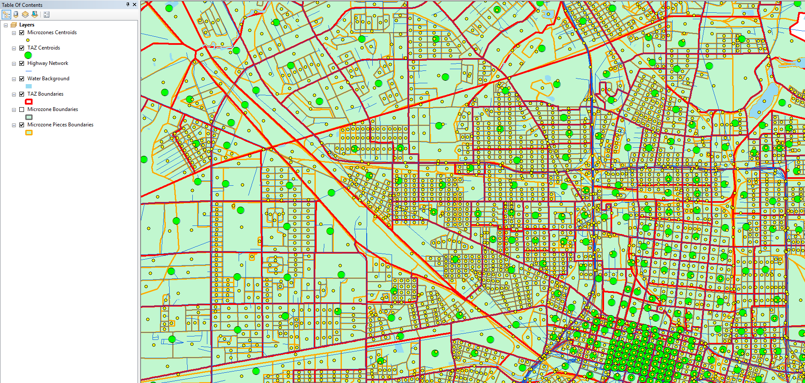
Figure 1 CBD AREA – UrbanCore, Springfield, Downtown.

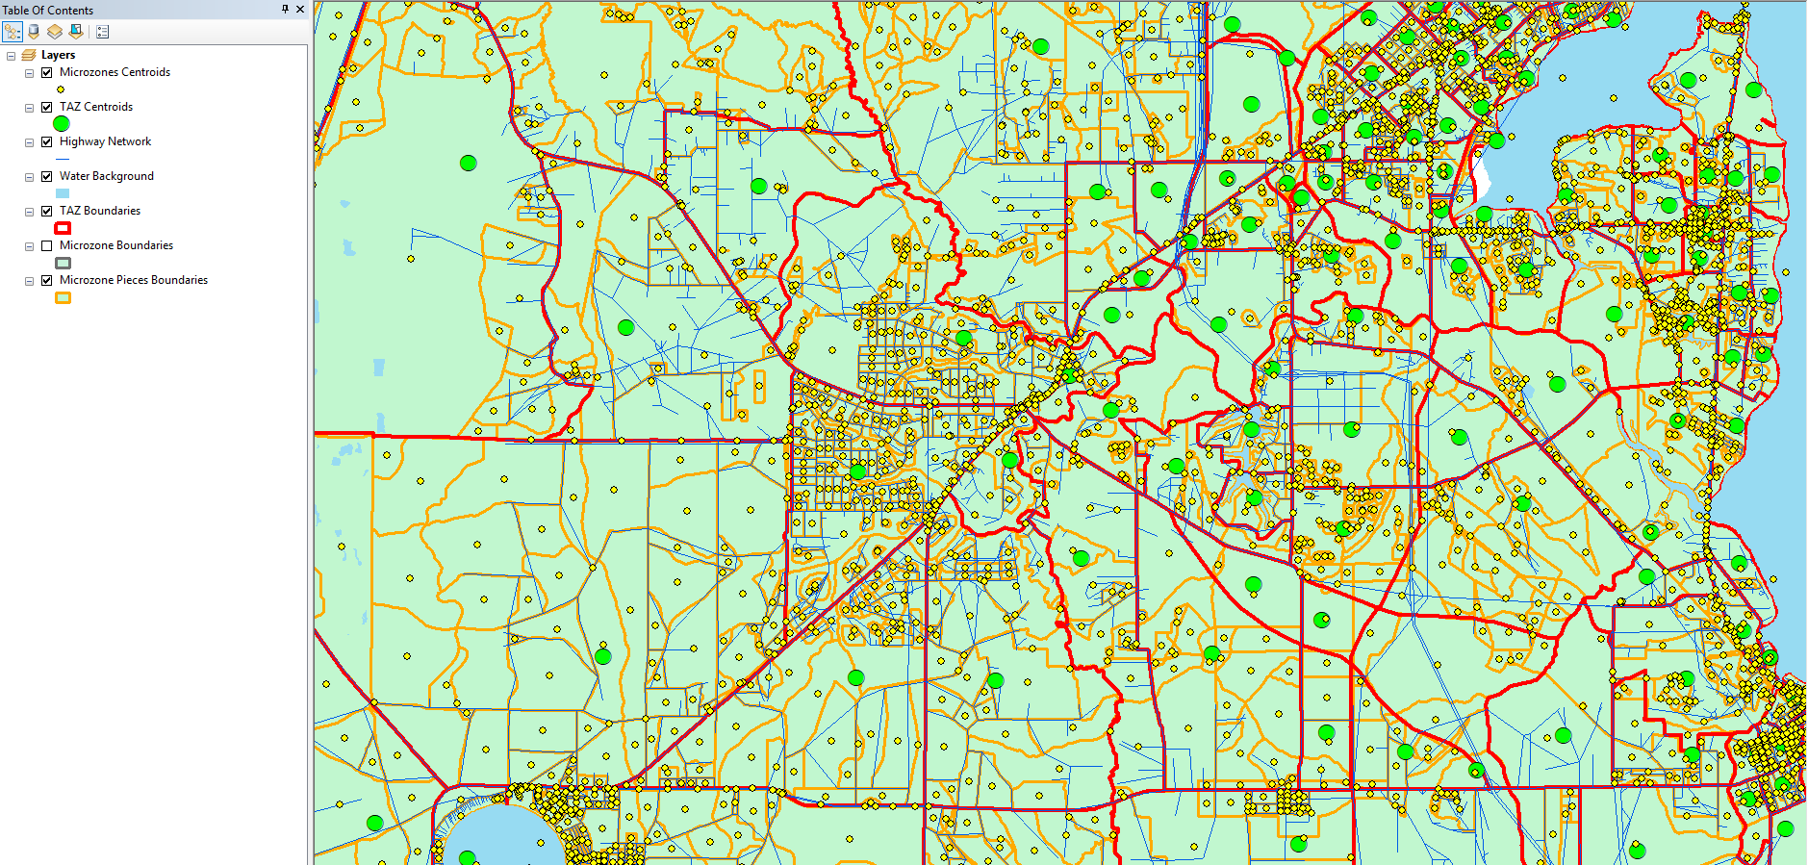
Figure 2 SUBURBAN AREA - Middleburg.

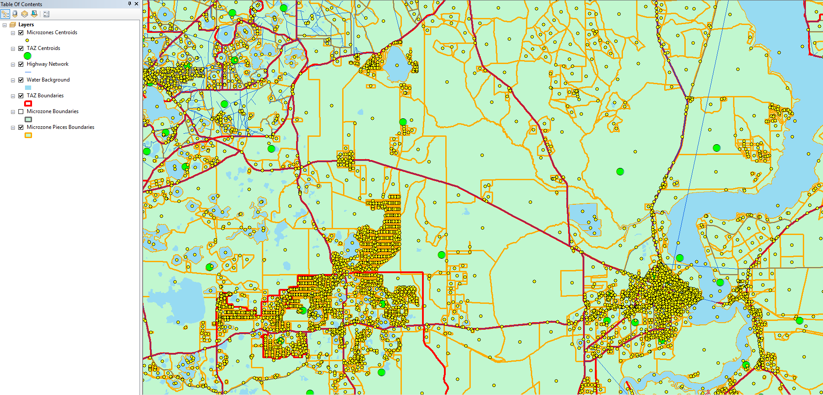
Figure 3 RURAL AREA - Etoniah Creek State Forest, Palatka.

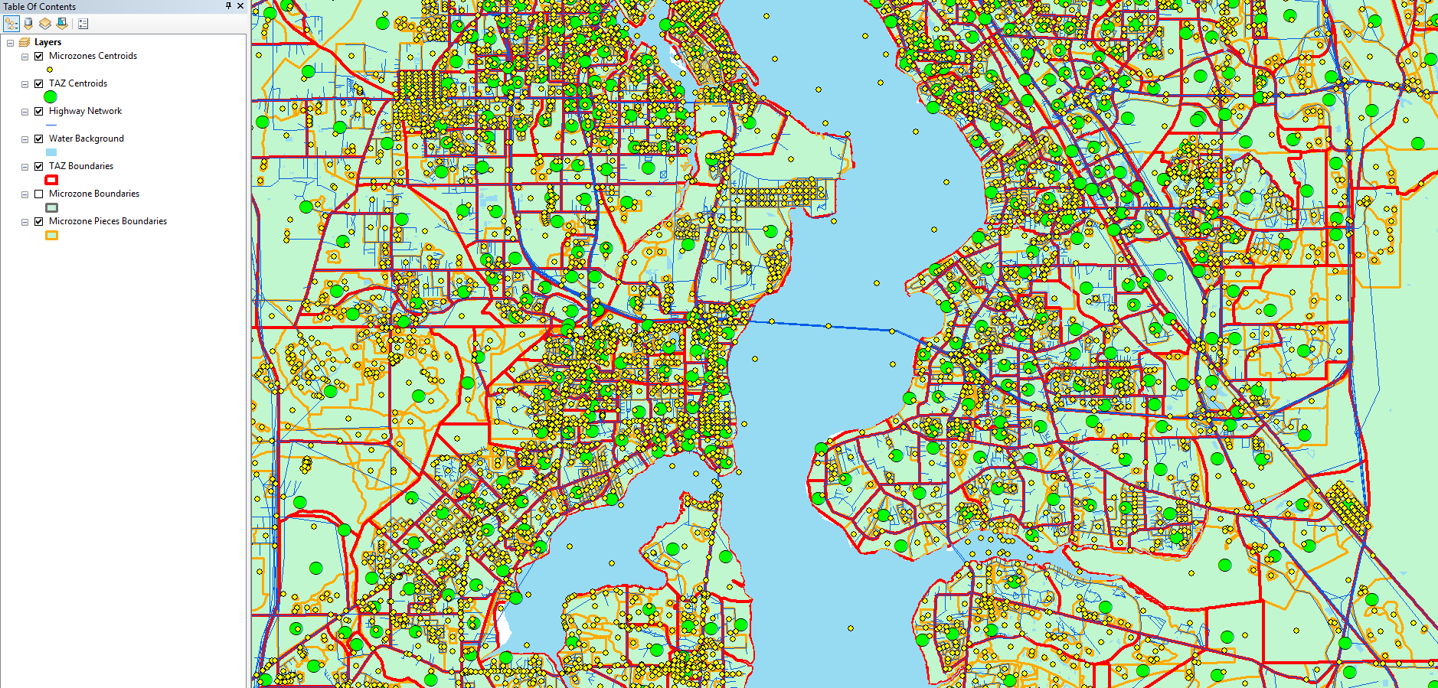
Figure 4 ALONG A MAJOR WATERWAY – Henry H Buckman Bridge.

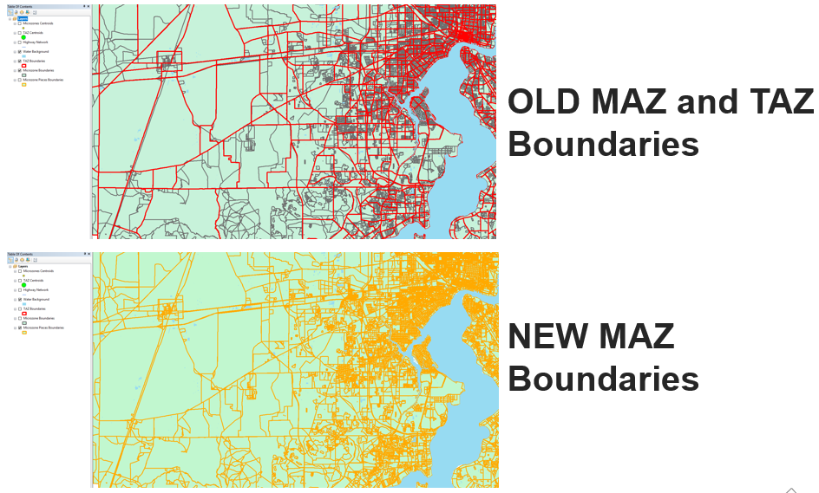
Figure 5 DIFFERENCE BETWEEN OLD MAZs and NEW MAZs.

Microzone summaries
Once the microzones were formed, summary tables were created to check for consistency. Table 2 shows the frequency of microzones, parcels and TAZ by County. It can be observed that Duval has the highest frequency for all three categories which is intuitive since this County contains the CBD area. Table 3 shows the distribution of households and employment by TAZs and MAZs. There are many empty microzones, which are kept for future year growth.

Table 2 microzones by county
County | Parcel Frequency | % Freq | Microzone Frequency | % Freq | TAZ Frequency | % Freq
003 – Baker | 12,490 | 1.78 | 1,735 | 3.14 | 29 | 1.56
019 – Clay | 84,529 | 12.02 | 7,796 | 14.13 | 184 | 9.88
031 – Duval | 355,805 | 50.59 | 28,263 | 51.22 | 1,281 | 68.80
089 – Nassau | 47,443 | 6.75 | 4,455 | 8.07 | 108 | 5.80
107 – Putnam | 102,053 | 14.51 | 6,652 | 12.05 | 44 | 2.36
109 – St. Johns | 100,950 | 14.35 | 6,283 | 11.39 | 216 | 11.60
Total | 703,270 | 100.00 | 55,184 | 100.00 | 1,862 | 100.00

Table 3 Microzone Households and Employment.
Category | MAZs | % | TAZs | %
Number of Households = Zero | 33,426 | 60.57 | 179 | 9.61
Number of Households > Zero | 21,758 | 39.43 | 1,683 | 90.39
Total | 55,184 | 100 | 1,862 | 100
Number of Employment = Zero | 45,549 | 82.54 | 86 | 4.62
Category | MAZs | % | TAZs | %
Number of Employment > Zero | 9,635 | 17.46 | 1,776 | 95.38
Total | 55,184 | 100 | 1,862 | 100
Zones with no parcels/MAZs | 0 | - | 13 | -
Zones joined to parcels/MAZs but HH=0 and Emp=0 | 32,549 | - | 21 | -
Total Number of Households | 582,199 | - | 582,199 | -
Total Employment | 736,435 | - | 736,435 | -

Employment Data
The NERPM-AB utilizes land use to predict travel patterns. These land use data are incorporated into various input files for both the Cube model and the DaySim model. This section explains how the land use data was updated for 2015 and which files used this data.
Employment data is stored at the microzone level, and nine types of employment are distinguished. The DaySim labels are provided in parentheses:
1. Education (empedu_p)
2. Food Service (empfoo_p)
3. Government (empgov_p)
4. Industrial (empind_p)
5. Medical (empmed_p)
6. Office (empofc_p)
7. Retail (empret_p)
8. Service (empsvc_p)
9. Other (empoth_p)
The 2015 data was updated using three sources of data:
1. The 2010 parcel employment data projected to 2015
2. Data provided by Infogroup and edited by North Florida TPO
3. Data provided by Cambridge Systematics as described in their June 30, 2017 memorandum “Development of 2015 Employment Data” for FDOT
To compare these three sources the data was converted to a common organization structure – the nine DaySim employment types above in each microzone. The project parcel data was already organized in this format and did not require conversion. The Infogroup data was organized by business and each entry included a point location (latitude and longitude), the number of employees, and a 3-digit NAICS code. Each entry was converted to a point in ArcMap and then spatially joined to the 2015 microzone shapefile. Each entry in the Cambridge Systematics data contained a census block ID, 3-digit NAICS code, and number of employees. Each entry was attached to its respective census block location in ArcMap and then spatially joined to the microzone file. For the latter two data sources, employees were assigned to one of the nine DaySim employment types based on the first two or three digits of their respective NAICS code using the crosswalk given in Table 4.
Table 4 NAICS CODE TO DAYSIM EMPLOYMENT CROSSWALK
NAICS Code | DaySim Type
11 | empoth_p
21 | empoth_p
22 | empsvc_p
23 | empsvc_p
31 | empind_p
32 | empind_p
33 | empind_p
42 | empofc_p
44 | empret_p
45 | empret_p
48 | empsvc_p
49 | empsvc_p
51 | empofc_p
NAICS Code | DaySim Type
52 | empofc_p
53 | empofc_p
54 | empofc_p
55 | empofc_p
561 | empofc_p
562 | empsvc_p
61 | empedu_p
62 | empmed_p
71 | empsvc_p
721 | empsvc_p
722 | empfoo_p
811 | empsvc_p
812 | empsvc_p
813 | empofc_p
814 | empsvc_p
92 | empgov_p
Because the three data sources did not match, a script was written to compare the number of employees in each microzone according to each data source. For microzones where two of the three sources had similar values (percent difference within 30% for over 100 employees, within 75% for 11 to 100 employees and within 150% for 10 or fewer employees), the average of the two similar values was used as the final employment number, and most of the microzones met these criteria. In cases where all three sources disagreed, the projected 2015 microzone data was used. In cases where two of the three sources had a value of zero, the source with a value greater than zero was used. After employment data was assigned to microzones, microzones with large changes were manually checked.

school Enrollment Data
DaySim uses three categories of school enrollment data, grades K-8, grades 9-12, and college/university. Enrollment data was updated to 2015 by assigning 2015 enrollment numbers to the appropriate categories in each microzone.
North Florida TPO provided school enrollment data from the Florida Department of Education (FDOE). This kindergarten through twelfth grade enrollment was divided into public and private schools and separated by county. Each entry included the name of the school, its address, the number of enrolled students according to FDOE, and enrollment according to the website Public School Review. The two enrollment numbers were generally in agreement and FDOE data was used.
Latitude and longitude coordinates were included for most, but not all, of the colleges. No location data beyond address was included for the schools. The ESRI Geocoder included in ArcMap was used to create point locations for entries that did not include location information.
School data does not included the type of school, e.g. preschool, elementary school, K-8, high school. First school names were manually inspected to determine the school type, e.g. “SAMUEL W. WOLFSON HIGH SCHOOL” was coded as 9-12, “R. V. DANIELS ELEMENTARY SCHOOL” was coded as K-8. If the type of school could not be determined from the name and enrollment was 100 students or more, the school type was manually determined from a web search. Where enrollment was less than 100 students, total enrollment numbers were assigned to a microzone and then 2010 enrollment numbers were used to distribute the total enrollment between K-8 and 9-12 categories. In most cases, only one type of school was present in a microzone, so the total enrollment for that microzone matched a single enrollment category.
After assigning enrollment, microzones with large discrepancies between 2010 and 2015 enrollment numbers were manually checked and revised if warranted.

Parking
Parking information was derived from FDOT parking shapefiles “Parking surface” and “g100freeway” and the website https://www.bestparking.com/jacksonville-fl-parking/. Data was visually checked against online maps. RSG added this parking data to the microzone DaySim input file, specifically, the fields parkdy_p, parkhr_p, ppricdyp, and pprichrp. Twenty-seven lots were used including 16 with day and hour rates and 11 hourly-rate only lots. Each lot entry contained a point location. Points were spatially joined to microzones in ArcMap. If a microzone contain multiple lots, the number of spaces were summed, and the parking price was calculated as a weighted average based on the number of spaces in each lot.

Lodging
North Florida TPO provided RSG with a list of 367 known hotels, motels, and bed and breakfasts from the Florida Department of Business and Professional Regulation. This list included each establishment’s name, address and number of rooms.
RSG used the ESRI Geocoder included in ArcMap by addresses to determine the location of each hotels. Spot checking the geocode showed that some hotels were not located correctly. As a check, the addresses were also run through Google’s geocoder, and these locations were compared with the ESRI-based locations. When discrepancies were found, the hotel’s location was determined from an internet search.
Lodging locations were then aggregated at the TAZ level and the final Hotel_Motel_TAZ_summary.txt was produced. This file was compared to the 2010 hotel file to check for major discrepancies. The number of rooms in 2010 and 2015 were 27,570 and 27,463, respectively. Approximately 3,200 rooms from the 2010 TAZs were not found in the 2015 TAZs, and approximately 3,100 rooms in the 2015 TAZs were not in the 2010 TAZs. In many cases, a hotel’s location was changed to a neighboring TAZ, which contributed to the discrepancies between the two datasets.

Special Generators
A special generator is a land use for which trip generation does not fall within the typical framework of the model. The file SPGEN_10A.DBF defines the behavior of special generators. A special generator is assigned to a single TAZ, and all trips associated with that generator originate or end at its respective TAZ. While the file lists 38 special generators, only two, Jacksonville International Airport and St. Augustine, have non-zero values of attraction or production. Effectively, these are the only special generators in the model.
The Airport had an attraction value of 15,000 in 2010. Based on several sources, RSG determined that the passenger traffic at the airport has decreased slightly between 2010 and 2015. CAPA – Centre for Aviation noted an overall downward trend in traffic since 2008 but traffic began to pick up in 2013. The airport’s website lists the 2010 and 2015 number of passengers as 5,602,000 and 5,502,000 respectively, which represents a 1.8% reduction in traffic. FDOT’s 2015 Airport Profile of JAX showed similar findings. Given the small change over the years, we recommend leaving the airport’s attraction value at 15,000 for 2015.
St. Augustine had an attraction value of 2,288 in 2010. This number accounts for tourists coming to the area. In 2010 and 2015, St. Johns County had 3.4 million and 6.3 million visitors, respectively, which represents an 85% growth over the five-year period. The 2015 number was considered an anomaly because it was the City’s 450th birthday. However, 2016 was even higher with 6.8 million visitors, so an 85% increase may be reasonable. Increasing the attractions value by 85% to 4,240 could have a noticeable impact on links near the TAZ

Development of population synthesis for 2015
Activity Based Models (ABMs) operate in a micro-simulation framework, wherein the travel choices of person and household decision-making agents are predicted by applying Monte Carlo methods to behavioral models. This requires a data set of households and persons representing the entire population in the modeling region. Population synthesis refers to the process used to create this data. Population synthesis requires a rich set of household and person level attributes by various levels of geography. The required inputs to population synthesis are a population sample and marginal distributions. The population sample is commonly referred to as the seed or reference sample and the marginal distributions are referred to as controls or targets. The process of expanding the seed sample to match the marginal distribution is termed population synthesis.
The software tool which implements this population synthesis process is termed as a population synthesizer. In this project, PopulationSim, an open platform for population synthesis funded by Oregon Department of Transportation was used. PopulationSim is used to generate population for the year of 2015 to represent the population in the NERPM-AB modeling region. The installation, setup and run description for PopulationSim is explained in Appendix A.

Input Data for population synthesis
The main inputs to a population synthesizer are
- Disaggregate population samples (Seed Sample)
- Marginal control distributions (Control variables)
The Seed sample is obtained from the Census Public Use Microdata Sample (PUMS)
https://www.census.gov/programs-surveys/acs/data/pums.html
and the Marginal distributions of person and household attributes are obtained from Bureau of Economic and Business Research (BEBR) and Census respectively.
The next step is the preparation of inputs to PopulationSim which includes:
- Geographic cross-walk
- Seed population (Household and Person tables)
- Controls
PopulationSim can represent both household and person level controls at multiple geographic levels. Therefore, the user must define what geographic units to use for each control. The hierarchy of geographies is important when establishing controls. The Meta geography is the entire region. Currently, PopulationSim can accommodate only one Meta geography. The Seed geography is the geographic resolution of the seed data. There can be one or more Seed geographies. PopulationSim can handle any number of nested Sub-Seed geographies. The geography level (hierarchy) selected for NERPM-AB 2015 to which the marginal distributions are specified are as follows:
- Meta Geography: Super County (SCOUNTY)
- Seed Geography: PUMA
- Sub-seed Geography: TAZ and MAZ
Super-County is chosen instead of County due to overlapping of county and PUMA boundaries. Super County is the combination of multiple County to form one geographic area.

Preparing Geographic Cross-walk
The geographic cross-walk is used to aggregate controls specified at a lower geography to upper geography and to allocate population from an upper geography to a lower geography. Table 5 below shows a sample of the geographic crosswalk created for this project.
Table 5 Geographic crosswalk sample.
MAZ | TAZ | BLKGRP* | TRACTCE* | PUMA | SCOUNTY
1 | 310 | 120310143321 | 12031014332 | 1203104 | 12031000
2 | 305 | 120310143321 | 12031014332 | 1203104 | 12031000
3 | 253 | 120310143302 | 12031014330 | 1203104 | 12031000
4 | 431 | 120310162001 | 12031016200 | 1203106 | 12031000
5 | 2016 | 120310162001 | 12031016200 | 1203105 | 12031000
*Block group (BLKGRP) and *Census tract (TRACTCE) ID are also kept in the crosswalk for data extraction from the census since the data is only available in these regions.

Preparing Seed Sample
One of the main requirements for the seed sample is that it should be representative of the modeling region. The seed sample is obtained from PUMS dataset. The PUMS data contain five years of household records. The seed sample should be representative of the modeling region. It must contain all the specified control variables, as well as any variables that are needed for the travel model but not specified as controls. The PUMS data is downloaded from PUMS website and it is extracted both demographically and geographically for the North Florida TPO region using PUMA codes conforming to the region. There are 11 PUMA regions in the North Florida TPO area. The seed sample must include an initial weight field. In this project, the Seed sample contains a weight field, WGTP, which is used for control of total households.

Preparing Control Data
Controls or targets are the marginal distributions that form the constraints for the population synthesis procedure. The objective of the population synthesis procedure is to produce a synthetic population with attributes matching these marginal distributions. Controls can be specified for both household and person variables. The choice of control variables depends on the needs of the project. The mandatory requirement for a population synthesizer is to generate the right number of households in each travel model geography. Therefore, it is mandatory to specify a control on total number of households in each geographical unit at the lowest geographical level. If this control is matched perfectly, it ensures that all the upper geographies also have the correct number of households assigned to them. Once the raw data is obtained, it is aggregated or disaggregated to the desired geography to build these controls.

Level: Super County
The raw input data was downloaded at county level from:
https://www.bebr.ufl.edu/sites/default/files/Research%20Reports/projections_2016_asrh.xlsx
Next, the data was aggregated to super county level. The data at super county level are person level attributes, namely, sex and person age group as shown below:
person_male  person_female  person_age0to4  person_age5to17 | person_age18to24  person_age25to54  person_age55m
Table 6 below shows the total 2015 population from University of Florida Bureau of Economic and Business Research (BEBR) data along with the person level attributes.

Table 6 BEBR SUPER COUNTY TOTALS (2015)
SCOUNTY | PERSONS | MALE | FEMALE | AGE0-4 | AGE5-17 | AGE18-24 | AGE25-54 | AGE55+
12109107 | 286,322 | 140,049 | 146,273 | 15,257 | 47,539 | 23,702 | 104,701 | 95,123
12031000 | 905,574 | 440,059 | 465,515 | 61,304 | 146,443 | 87,517 | 379,741 | 230,569
12003089 | 103,553 | 51,969 | 51,584 | 5,963 | 16,366 | 8,505 | 38,968 | 33,751
12019000 | 201,277 | 98,400 | 102,877 | 12,543 | 37,662 | 18,453 | 79,447 | 53,172

Level: TAZ
The raw input data was downloaded at various levels [Source: 2011-15 American Community Survey five-year estimates, ACS5]:
- Households by Household Size at Block Group Level
- Tenure by Age of Householder at Block Group Level
- Households by number of workers at Census Tract Level
- HHs by income at Census Tract Level
The data processed at TAZ level are household attributes:
hh_size_1  hh_size_2  hh_size_3  hh_size_4 | hh_age_15_to_44  hh_age_45_to_64  hh_age_65_abv | hh_wrks_0  hh_wrks_1  hh_wrks_2  hh_wrks_3m | hh_inc_0_25  hh_inc_25_60  hh_inc_60_100  hh_inc_100_plus

Level: MAZ
The raw input data was obtained at parcel level for the year 2010 and calculated for 2015 using growth factor from 2010 to 2015. The data obtained is total number of households and then aggregated for each MAZ. Once the control files are prepared, the total number of households and persons are calculated across geographies to check for consistency as shown in Table 7 below.
Table 7 COntrol data summary.
Data | Geography | Value
Total number of households | MAZ | 582,199
Total number of households | TAZ | 582,199
Data | Geography | Value
Number of households in HHSIZE=1 | TAZ | 155,522
Number of households in HHSIZE=2 | TAZ | 196,050
Number of households in HHSIZE=3 | TAZ | 87,996
Number of households in HHSIZE=4+ | TAZ | 110,821
Total number of persons (from HHSIZE) | TAZ | 1,397,535
Total number of persons | SCOUNTY | 1,397,534

PopulationSim Validation
One of the most critical steps in the population synthesis procedure is validation of the synthetic population. Validation provides clues about inconsistencies among controls, data processing errors or misspecification of settings. After a successful run of PopulationSim, the validation task is performed to check the synthetic population. PopulationSim reports the difference between the synthesized totals and the control totals for all the controls at each geographic level. The validation takes summaries and outputs from a PopulationSim run to generate plots and advanced summaries.
The following two statistics are computed as a part of this exercise:
- the standard deviation (STDEV) of the percentage difference – this measure informs us of how much dispersion from the average exists, and
- the percentage root means square error (RMSE) - an indicator of the proximity of synthesized and control totals.
The validation chart, a visualization of the disaggregate summary statistics – STDEV and RMSE of percentage differences is plotted. A form of dot and whisker plot is generated for each control where the dots are the mean percentage differences and horizontal bars are twice the STDEV or RMSE centered around zero. Figure 6 and Figure 7 display the validation plots for 2015 data.
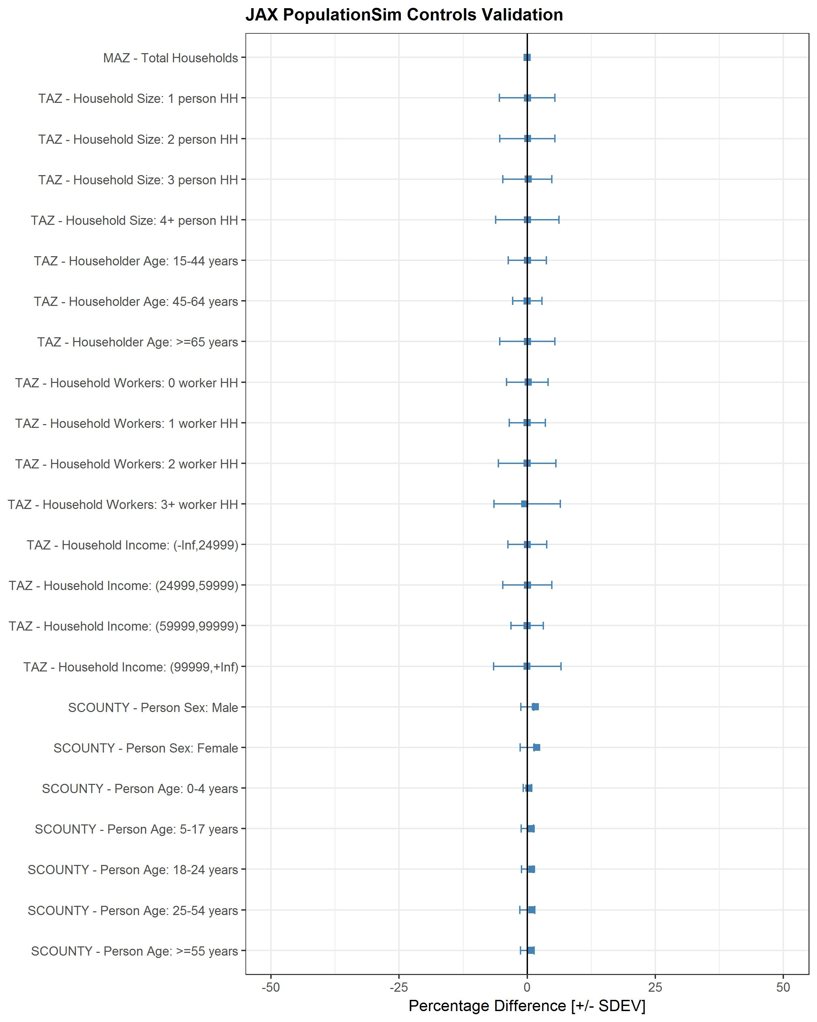
Figure 6 POPSIM Validation (standard deviation).
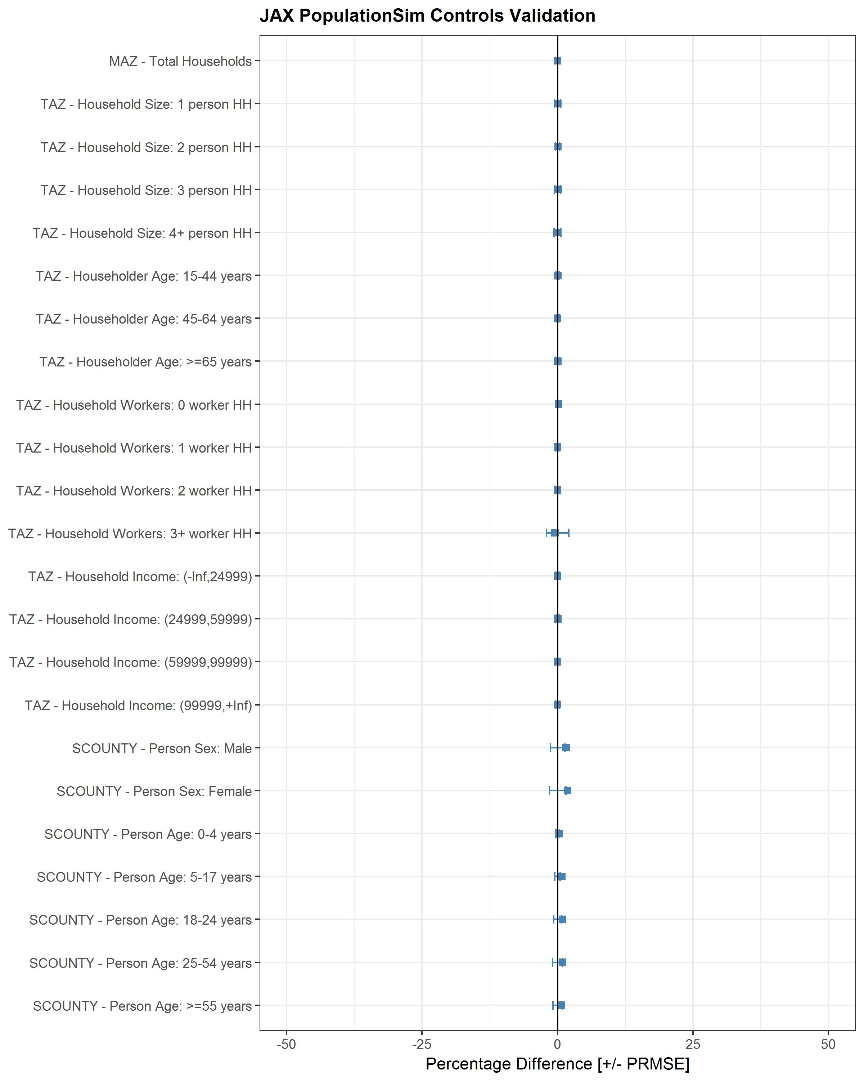
Figure 7 POPSIM validation (root mean square error).
After the completion of population synthesis, the final synthetic household and person data summaries were calculated and compared for consistency checks as shown in Table 8.
Table 8 PopulationSim Data Summaries Comparison.
County | Total number of households |  | Total number of Persons
County | 2010 | 2015 | 2010 | 2015
Baker | 8,800 | 8,815 | 24,834 | 23,082
Clay | 69,277 | 70,523 | 190,657 | 188,960
Duval | 348,911 | 354,060 | 855,223 | 850,383
Nassau | 32,235 | 32,983 | 80,593 | 76,792
Putnam | 31,648 | 31,278 | 77,859 | 70,016
St. Johns | 80,230 | 84,540 | 197,976 | 202,270
Total | 571,101 | 582,199 | 1,427,142 | 1,411,503
Average Number of persons per HH (2010) | 2.499
Average Number of persons per HH (2015) | 2.424
Average Number of persons per HH  (2015 Census) | 2.403

Development of 2045 Land-Use Data
This section describes the processes followed to create the 2045 land-use data and create the synthetic population for 2045. It describes the various internal and external data sources used and the methodology followed to create the land-use data for 2045.
To create 2045 land-use data, RSG used the 2015 base year land-use data as the starting point. Land-use forecasts for scenario years 2010 and 2040 were also used to calculate the growth rate. An external data source, Bureau of Economic and Business Research (BEBR), was used to calculate county wide growth rates, to be applied in special cases. The objective was to utilize available land-use data from 2015 and forecasts for 2010 and 2040 to create the data for 2045. Table 9 shows the total population of the six counties for years 2010, 2015, 2040 and 2045 retrieved from BEBR. These totals were used to calculate county wide growth rates from 2015 to 2045 and 2040 to 2045 which were later used to forecast 2045 data.
Table 10 shows the logic followed for various cases depending on the availability of valid values in previous years’ data. The logic varied depending on the availability of non-zero values in the base years.
Table 9 BEBR COUNTY TOTALS
COUNTY | 2010 | 2015 | 2040 | 2045
NASSAU | 73,314 | 76,536 | 111,283 | 116,513
DUVAL | 864,263 | 905,574 | 1,129,785 | 1,164,640
ST JOHNS | 190,039 | 213,566 | 382,701 | 409,339
CLAY | 190,865 | 201,277 | 304,669 | 320,265
BAKER | 27,115 | 27,017 | 34,452 | 35,473
PUTNAM | 74,364 | 72,756 | 75,078 | 75,518

Table 10 FORECASTING LOGIC FOR 2045
Case | 2010 | 2015 | 2040 | 2045
1 | 0 | 0 | 0 | 0
2 | > 0 | 0 | 0 | 0
3 | 0 | > 0 | 0 | 2015 * BEBR2045/BEBR2015
4 | 0 | 0 | > 0 | 2040 * BEBR2045/BEBR2040
5 | > 0 | > 0 | 0 | 2015 * BEBR2045/BEBR2015
6 | 0 | > 0 | > 0 | 2040 * BEBR2045/BEBR2040
7 | > 0 | 0 | > 0 | 2040 * BEBR2045/BEBR2040
8 | > 0 | > 0 | > 0 | if 2015 + (2040-2010) > 0, then 2015 + (2040-2010)  else 2040

The above forecasting logic resulted in MAZs with the 2045 household, employment and enrollment counts less than 2015 values. This occurred because of the similar trend in negative growth from 2010 to 2040. North Florida TPO commented that the 2045 counts should at least be equal to the 2015 values, if not greater. Hence, RSG set the floor of the 2045 counts to the 2015 value, ensuring that no MAZs have negative growth.
The total number of households obtained for 2045 was 1,004,721 across the region. Using the household size distribution from the 2015 PopulationSim controls, the implied population for 2045 was calculated and compared against BEBR 2045 totals. The household size distribution from 2015 was modified to account for the aging population trend observed in BEBR data (Figure 9). The modification is discussed in detail in the next section. To ensure that the implied population from the 2045 household counts match the BEBR population in 2045, adjustment rates were calculated for six counties and applied to the estimated household counts. After application of the adjustment rates, the final 2045 household counts in several MAZs were less than the 2015 household counts. In these cases, the 2045 value was set equal to the 2015 value. The final number of households in the region after adjustment is 963,386 in 2045. Employment and enrollment count for 2045 were obtained following a similar methodology. Total employment and total enrollment in 2045 are 1,102,150 and 643,524 respectively. Table 11 shows the final values of total households, total employment and total enrollment for 2045 and corresponding values for 2015. Figure 8 shows the increase in households from 2015 to 2045.
Table 11 COMPARISON OF 2015 AND 2045 TOTALS
COUNTY | Households 2015 | Households 2045 | EMPloyment 2015 | EMPloyment 2045 | ENRollment  2015 | ENRollment  2045
NASSAU | 32,983 | 51,902 | 28,480 | 55,393 | 13,368 | 31,576
DUVAL | 357,463 | 541,730 | 496,394 | 708,478 | 211,091 | 362,983
ST JOHNS | 84,540 | 181,500 | 66,355 | 179,066 | 43,977 | 116,687
CLAY | 70,523 | 132,830 | 46,539 | 105,158 | 40,877 | 98,998
BAKER | 8,815 | 15,117 | 8,909 | 18,491 | 5,128 | 9,876
PUTNAM | 31,278 | 40,307 | 21,521 | 35,564 | 14,856 | 23,404
TOTAL | 585,602 | 963,386 | 668,198 | 1,102,150 | 329,297 | 643,524

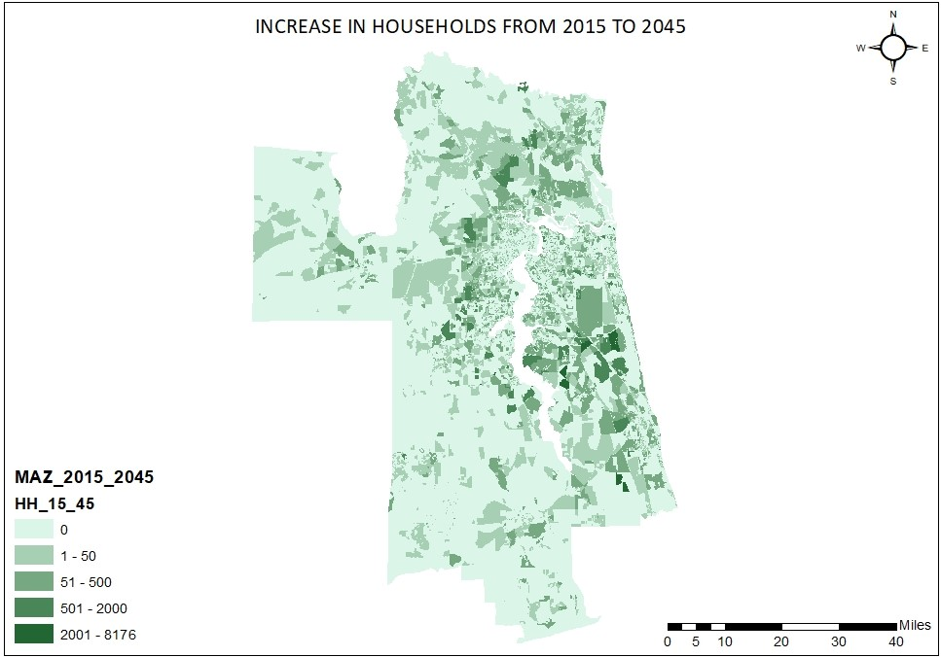
Figure 8 INCREASE IN HOUSEHOLDS FROM 2015 TO 2045

Population Synthesis for 2045
Controls refer to the targets that the Public Use Microdata Sample (PUMS) tries to match during synthetic population generation. Controls at three levels of geography are required to run PopulationSim for North Florida TPO:COUNTY, TAZ and MAZ. The COUNTY level controls (Table 12) were obtained from BEBR data and the TAZ and MAZ level controls were prepared using the 2045 land-use data. Counties were grouped into super counties to use Census 2000 and Census 2010 PUMS data, with their different geographies, in the same procedure.

Table 12 COUNTY LEVEL CONTROLS FOR POPULATIONSIM 2045
SCOUNTY | PERSONS | MALE | FEMALE | AGE0-4 | AGE5-17 | AGE18-24 | AGE25-54 | AGE55M
PUTNAM AND ST JOHNS | 484,857 | 236,952 | 247,905 | 24,268 | 75,251 | 34,859 | 181,863 | 168,616
DUVAL | 1,164,640 | 565,479 | 599,161 | 73,366 | 178,972 | 104,779 | 440,368 | 367,155
BAKER AND NASSAU | 151,986 | 75,008 | 76,978 | 7,794 | 21,657 | 10,771 | 52,109 | 59,655
CLAY | 320,265 | 155,562 | 164,703 | 18,106 | 55,544 | 24,361 | 122,213 | 100,041

It was observed from the BEBR data that population in North Florida is aging from 2015 to 2045. This means that the proportion of 70+ years individuals is increasing. This means that as the population ages, the share of 1-person and 2-person households will likely increase and that of -person and 4+ person households will decrease.

Figure 9 POPULATION IN AGING (BEBR DATA)

This led RSG to make assumptions that the distribution of households by household size will change in the future year and these assumptions need to be incorporated to the base year controls before scaling them up. It should be noted that base year controls do not change as a result of these assumptions, they only affect the future year controls. The following assumptions were made –
- If the sum of the proportion 3-person and 4+ person households for a certain TAZ is less than 10%, then no changes are made for that TAZ. The distribution is already skewed, so they are kept unchanged.
- If the proportion is more than 10% and less than 15% for a TAZ, then the proportion of 1-person and 2-person households in that TAZ increase by 5%. The proportion of 3-person and 4+ person households is proportionately decreased so that the total adds up to 100%.
- If the proportion is more than 15% and less than 20% for a TAZ, then the proportion of 1-person and 2-person households in that TAZ increase by 8%. The proportion of 3-person and 4+ person households is proportionately decreased so that the total adds up to 100%.
- If the proportion is more than 20% for a TAZ, then the proportion of 1-person and 2-person households in that TAZ increase by 10%. The proportion of 3-person and 4+ person households is proportionately decreased so that the total adds up to 100%.
This gradual increase is done to ensure that the resulting distribution of household size is not skewed. The distribution of households by number of workers, householder age and household income were kept the same as 2015. In the TAZ control file, the total households in 2045 were distributed according to the newly calculated distribution by household size. Similarly, households by number of workers, householder age and household income were distributed using the same distributions as 2015. There were cases where the 2015 household count was zero whereas that of 2045 was non-zero. This meant that no base year distribution was available for those TAZs and a county level distribution was applied instead. Table 13 shows the first five rows of the MAZ control file and

Table 14 shows the first five rows and a few selected columns of the TAZ control file.
Table 13 MAZ LEVEL CONTROL
MAZ | TAZ | PUMA | SCOUNTY | households
1 | 310 | 1203104 | 12031000 | 155
2 | 305 | 1203104 | 12031000 | 0
3 | 253 | 1203104 | 12031000 | 55
4 | 431 | 1203106 | 12031000 | 0
5 | 2016 | 1203105 | 12031000 | 0

Table 14 TAZ LEVEL CONTROL (PARTIAL)
TAZ | HHS | PUMA | HHS1 | HHS2 | HHS3 | HHS4M | WRK1 | WRK2 | WRK3 | WRK4
1 | 194 | 1208900 | 74 | 106 | 6 | 8 | 73 | 68 | 47 | 6
2 | 1169 | 1208900 | 409 | 421 | 117 | 222 | 432 | 421 | 281 | 35
3 | 127 | 1208900 | 49 | 44 | 11 | 23 | 51 | 44 | 29 | 3
4 | 494 | 1208900 | 193 | 266 | 15 | 20 | 182 | 178 | 119 | 15
5 | 643 | 1208900 | 431 | 167 | 45 | 0 | 238 | 270 | 116 | 19

Using these three files as controls, PopulationSim was run for 2045 which created 963,386 synthetic households and 2,150,870 synthetic persons for the entire NFTPO region. The total population in 2045 according to BEBR is 2,121,748 which is slightly smaller than the synthetic population generated by PopulationSim. The difference is due to not allowing negative growth from 2015 to 2045 and forcing 2045 household counts to be at least equal to the 2015 counts. As a result, number of households were greater, which subsequently increased the population.
Figure 10 shows the comparison of observed controls vs. estimated synthetic population across multiple variables at the MAZ, TAZ and COUNTY levels. The small values of standard deviation, as seen in the figure, suggests that the synthetic population matches the targets well.

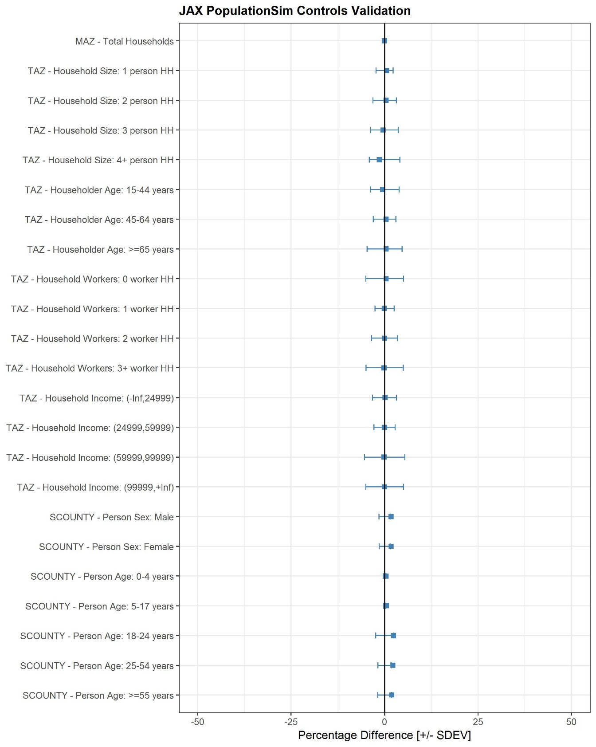
Figure 10 POPULATIONSIM CONTROLS VALIDATION (2045)

Development of 2030 Land-Use Data
This section describes the processes followed to create the 2030 land-use data and create the synthetic population for year 2030. The procedure followed to create 2030 data is similar to the procedure used to create 2045 data described above.
In order to create 2030 land-use data, RSG used the 2015 base year land-use data as the starting point. Land-use forecasts for scenario years 2010 and 2025 were used to calculate the growth rate. An external data source, Bureau of Economic and Business Research (BEBR), was used to calculate county wide growth rates, to be applied in special cases. The objective was to utilize available land-use data from 2015 and forecasts for 2010 and 2025 to create the data for 2030. Table 15 shows the total population of the six counties for years 2010, 2015, 2025 and 2030 retrieved from BEBR. These totals were used to calculate county wide growth rates from 2015 to 2030 and 2025 to 2030 which were later used to forecast 2030 data. Similar to
Table 10, Table 16 shows the logic followed for various cases depending on the availability of valid values in previous years’ data. The logic varied depending on the availability of non-zero values in the base years.
Table 15 BEBR County Totals
COUNTY | 2010 | 2015 | 2025 | 2030
NASSAU | 73,314 | 76,536 | 92,013 | 98,918
DUVAL | 864,263 | 905,574 | 1,008,324 | 1,053,582
ST JOHNS | 190,039 | 213,566 | 292,217 | 326,938
CLAY | 190,865 | 201,277 | 247,223 | 267,757
BAKER | 27,115 | 27,017 | 30,624 | 32,017
PUTNAM | 74,364 | 72,756 | 73,721 | 74,182

Table 16 Forecasting Logic for 2030
Case | 2010 | 2015 | 2025 | 2030
1 | 0 | 0 | 0 | 0
2 | > 0 | 0 | 0 | 0
3 | 0 | > 0 | 0 | 2015 * BEBR2030/BEBR2015
Case | 2010 | 2015 | 2025 | 2030
4 | 0 | 0 | > 0 | 2025 * BEBR2030/BEBR2025
5 | > 0 | > 0 | 0 | 2015 * BEBR2030/BEBR2015
6 | 0 | > 0 | > 0 | 2025 * BEBR2030/BEBR2025
7 | > 0 | 0 | > 0 | 2025 * BEBR2030/BEBR2025
8 | > 0 | > 0 | > 0 | if 2015 + (2025-2010) > 0, then 2015 + (2025-2010)  else 2025
The above forecasting logic resulted in some certain MAZs with the 2030 household, employment and enrollment counts were smaller than 2015 counts. This resulted because of the similar trend in negative growth from 2010 to 2025 scenario years. North Florida TPO recommended that the 2030 counts should at least be equal to the 2015 values, if not greater. Hence, RSG set the floor of the 2030 counts to the 2015 value, ensuring that no MAZs have negative growth.
The total number of households obtained for 2030 was 803,003 across the region. Using the household size distribution from the 2015 PopulationSim controls, the implied population for 2030 was calculated and compared against BEBR 2030 totals. The household size distribution from 2015 was modified to account for the aging population trend observed in BEBR data (Figure 9). In order to make sure that the implied population from the 2030 household counts match the BEBR population in 2030, adjustment rates were calculated for six counties and applied to the estimated household counts. After the adjustment rates are applied, the final 2030 household counts in several MAZs fall below the 2015 household counts. In such cases, the 2030 value was set equal to the 2015 value. Another comparison was made between the household, employment and enrollment numbers of 2030 with that of 2045 and it was found that several MAZs had 2030 values higher than 2045. This is because the parcel level data of scenario 2025 used to calculate the 2030 data had a higher number of households, employment and enrollment. Since there should be no MAZs with 2030 households greater than 2045, the 2030 values were capped at 2045. The final number of households in the region after adjustment is 779,154 in 2030. Employment and enrollment counts for 2030 were obtained following a similar methodology. Total employment and total enrollment in 2030 are 921,785 and 523,000 respectively.
Table 17 shows the final values of total households, total employment and total enrollment for 2030 and corresponding values for 2015.

Table 17 COMPARISON OF 2015 AND 2030 TOTALS
COUNTY | HH2015 | HH2030 | EMP2015 | EMP2030 | ENR2015 | ENR2030
NASSAU | 32,983 | 41,948 | 28,480 | 45,394 | 13,368 | 25,998
DUVAL | 357,463 | 453,184 | 496,394 | 622,922 | 211,091 | 311,765
ST JOHNS | 84,540 | 135,295 | 66,355 | 124,742 | 43,977 | 79,721
CLAY | 70,523 | 100,980 | 46,539 | 81,119 | 40,877 | 75,838
BAKER | 8,815 | 12,212 | 8,909 | 14,615 | 5,128 | 7,602
PUTNAM | 31,278 | 35,535 | 21,521 | 32,993 | 14,856 | 22,076
TOTAL | 585,602 | 779,154 | 668,198 | 921,785 | 329,297 | 523,000

Population Synthesis for 2030
Similar to 2045, controls for 2030 were obtained at three levels to run PopulationSim for North Florida TPO, specifically, COUNTY, TAZ and MAZ. The COUNTY level controls (Table 18) were obtained from BEBR and the TAZ and MAZ level controls were prepared using the 2030 land-use data.

Table 18 COUNTY LEVEL CONTROLS FOR POPULATIONSIM
SCOUNTY | PERSONS | MALE | FEMALE | AGE0-4 | AGE5-17 | AGE18-24 | AGE25-54 | AGE55M
PUTNAM AND ST JOHNS | 401,120 | 196,142 | 204,978 | 20,893 | 62,021 | 28,958 | 145,008 | 144,240
DUVAL | 1,053,582 | 511,950 | 541,632 | 67,691 | 166,588 | 96,195 | 411,432 | 311,676
BAKER AND NASSAU | 130,935 | 65,219 | 65,716 | 6,926 | 19,104 | 9,357 | 44,840 | 50,708
CLAY | 267,757 | 130,281 | 137,476 | 15,883 | 47,219 | 20,562 | 101,159 | 82,934

The increasing population trend seen in Figure 9 led to the incorporation of the assumptions to the base year controls before scaling up for 2030. The distribution of households by number of workers, householder age and household income were kept the same as 2015. In the TAZ control file, the total households in 2030 were distributed according to the newly calculated distribution by household size. Similarly, households by number of workers, householder age and household income were distributed using the same distributions as 2015. There were cases where the 2015 household count was zero and of 2030 was non-zero. This meant that no base year distribution was available for those TAZs and a county level distribution was applied instead. Table 19 shows the first five rows of the MAZ control file and Table 20 shows the first five rows and a few selected columns of the TAZ control file.
Table 19 2030 MAZ LEVEL CONTROL
MAZ | TAZ | PUMA | SCOUNTY | HHS
1 | 310 | 1203104 | 12031000 | 155
2 | 305 | 1203104 | 12031000 | 0
3 | 253 | 1203104 | 12031000 | 55
4 | 431 | 1203106 | 12031000 | 0
5 | 2016 | 1203105 | 12031000 | 0

Table 20 2030 TAZ LEVEL CONTROL (PARTIAL)
TAZ | HHS | PUMA | HHS1 | HHS2 | HHS3 | HHS4M | WRK1 | WRK2 | WRK3 | WRK4
1 | 167 | 1208900 | 63 | 92 | 5 | 7 | 64 | 58 | 40 | 5
2 | 1058 | 1208900 | 370 | 381 | 106 | 201 | 391 | 381 | 254 | 32
3 | 97 | 1208900 | 37 | 34 | 9 | 17 | 39 | 34 | 22 | 2
4 | 399 | 1208900 | 156 | 215 | 12 | 16 | 147 | 144 | 96 | 12
5 | 518 | 1208900 | 347 | 135 | 36 | 0 | 192 | 217 | 93 | 16

Using these three files as controls, PopulationSim was run for 2030 creating 779,154 synthetic households and 1,838,778 synthetic persons for the entire NFTPO region. The total population in 2030 according to BEBR is 1,853,394 which is slightly higher than the synthetic population generated by PopulationSim. The difference is due to not allowing negative growth from 2015 to 2030 and forcing 2015 and 2045 household counts to be at least equal to the 2030 counts.
Figure 11 shows the comparison of observed controls vs. estimated synthetic population across multiple variables at the MAZ, TAZ and COUNTY levels. The small values of standard deviation, as seen in the figure, suggests that the synthetic population matches the targets well.

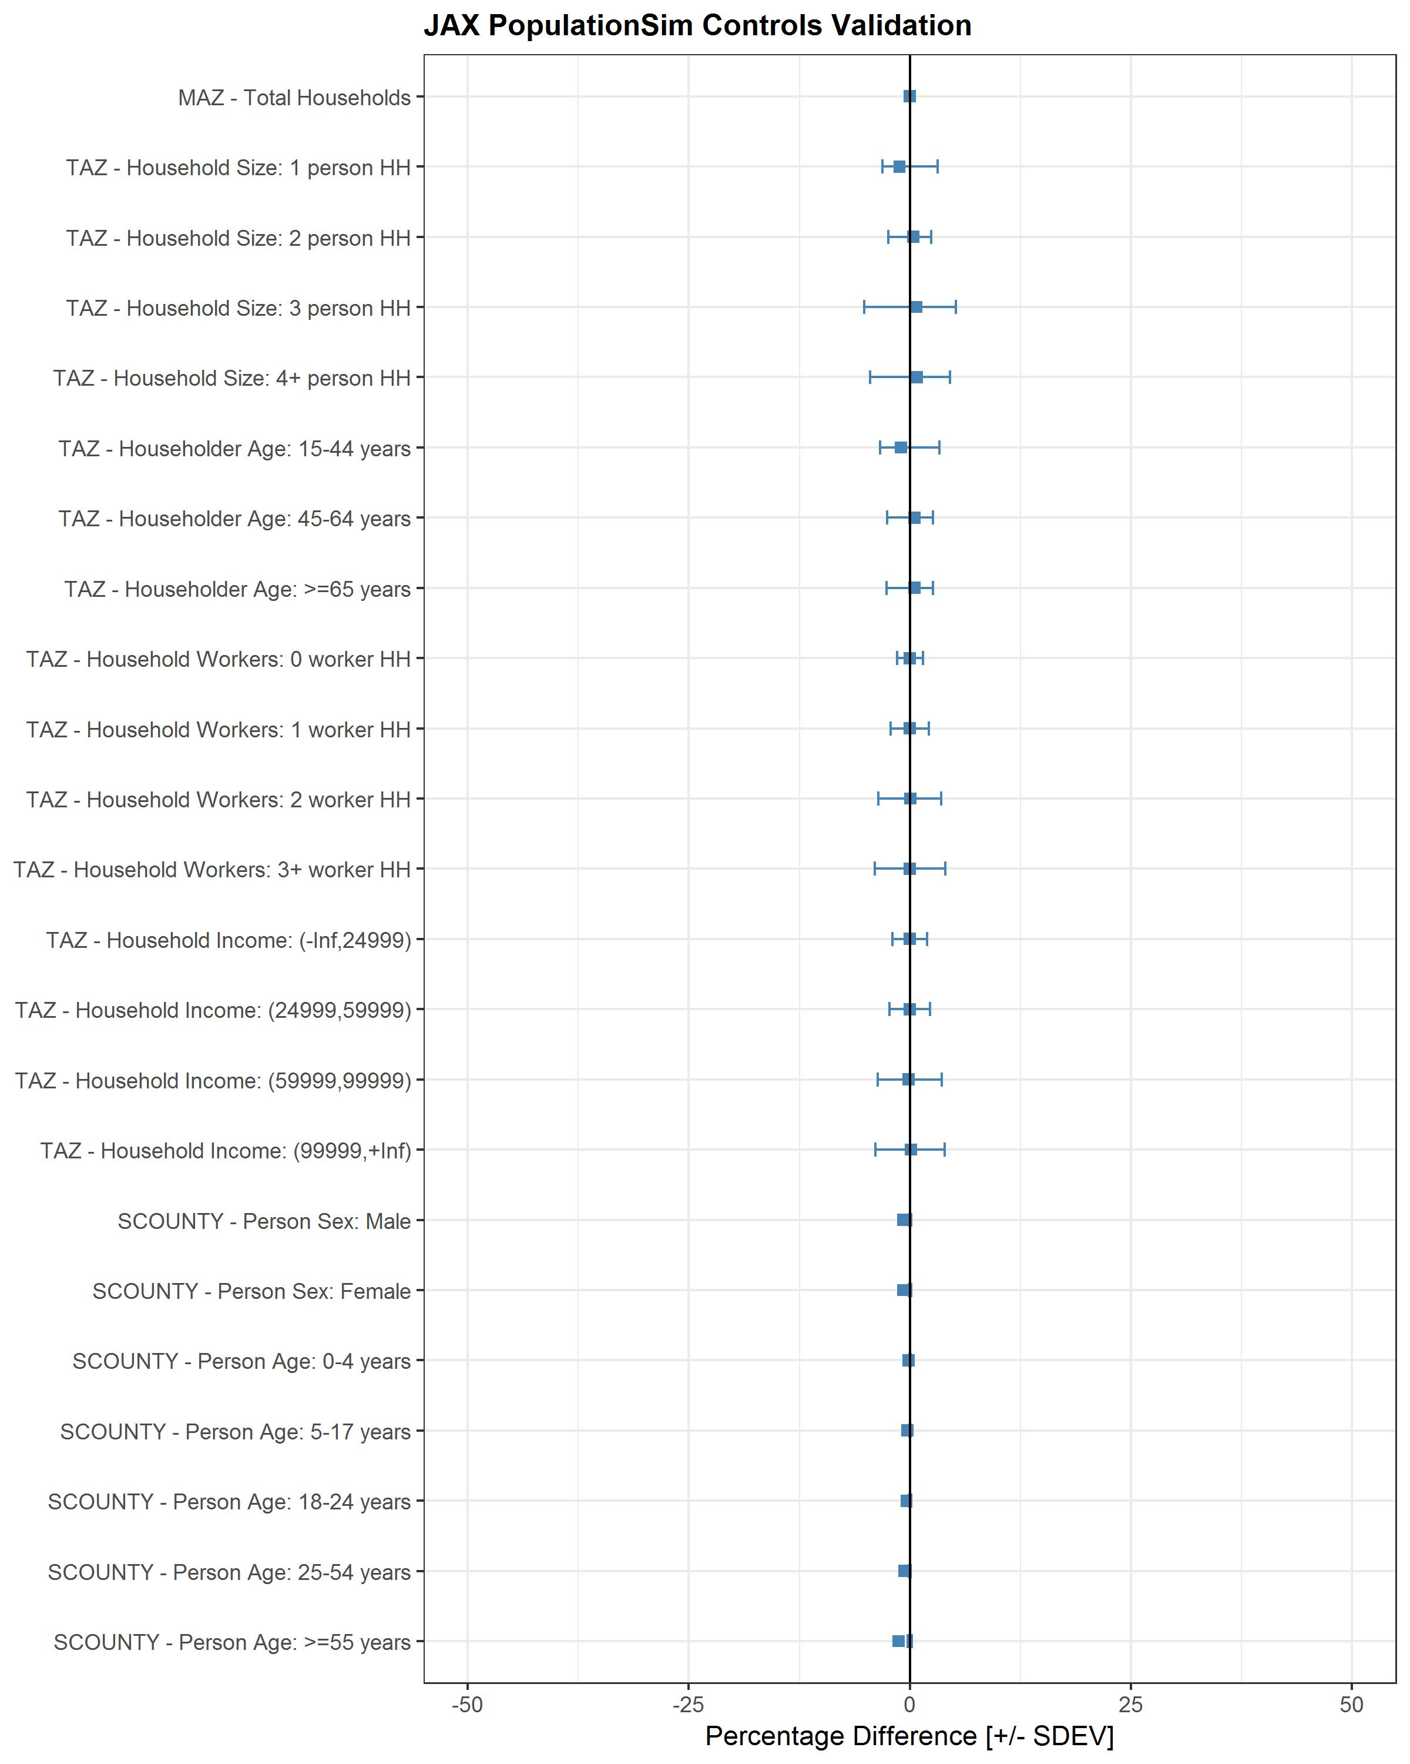
Figure 11 POPULATIONSIM CONTROLS VALIDATION (2030)

DaySim ABM Model Update
After completion of base year 2015 data aggregation from parcels to microzones, DaySim was tested for the new geographies and the results compared against the parcel results to check for consistencies. The necessary input files were created for DaySim run as explained in detail in Appendix B. After a successful run of DaySim using updated 2015 Microzone and Population synthesis dataset, the results were compared with previous DaySim run using parcels. The following series of tables and figures show the consistency of the 2015 dataset in DaySim performance.

DaySim Summary Comparison
Table 21 compares the vehicle availability across the three different types of DaySim runs. The first run included the parcel data set. The second run included the microzone input data as well as the updated DaySim including the node to node distance feature. The third run included the inputs from the second run and the household and population data from population synthesis for 2015. The percent total for all Counties look consistent across the three DaySim runs.
Table 21 Vehicle Availability
Estimated Households by Number of Vehicles and County (Parcel)
 | Number of Vehicles
County | 0 | 1 | 2 |  | 3 |  | 4+ |  | Total |  | % Total
Baker | 309 | 2,750 | 3,899 |  | 1,285 |  | 557 |  | 8,800 |  | 2%
Clay | 2,154 | 19,501 | 32,064 |  | 11,436 |  | 4,123 |  | 69,278 |  | 12%
Duval | 27,194 | 126,487 | 137,367 |  | 42,231 |  | 15,633 |  | 348,912 |  | 61%
Nassau | 1,212 | 10,006 | 14,514 |  | 4,681 |  | 1,820 |  | 32,233 |  | 6%
Putnam | 1,594 | 11,944 | 12,800 |  | 3,767 |  | 1,543 |  | 31,648 |  | 6%
St. Johns | 3,097 | 25,256 | 36,209 |  | 11,566 |  | 4,102 |  | 80,230 |  | 14%
Total | 35,560 | 195,944 | 236,853 |  | 74,966 |  | 27,778 |  | 571,101 |  | 100%
Estimated Households by Number of Vehicles and County (Microzone + Node to Node Distances)
 | Number of Vehicles
County | 0 | 1 |  | 2 |  | 3 |  | 4+ |  | Total | % Total
Baker | 333 | 2,781 |  | 3,868 |  | 1,261 |  | 557 |  | 8,800 | 2%
Clay | 2,491 | 19,945 |  | 31,772 |  | 11,122 |  | 3,948 |  | 69,278 | 12%
Duval | 28,867 | 126,963 |  | 136,315 |  | 41,659 |  | 15,108 |  | 348,912 | 61%
Nassau | 1,329 | 10,195 |  | 14,426 |  | 4,515 |  | 1,768 |  | 32,233 | 6%
Putnam | 1,627 | 11,994 |  | 12,767 |  | 3,750 |  | 1,510 |  | 31,648 | 6%
St. Johns | 3,795 | 25,835 |  | 35,721 |  | 11,105 |  | 3,774 |  | 80,230 | 14%
Total | 38,442 | 197,713 |  | 234,869 |  | 73,412 |  | 26,665 |  | 571,101 | 100%
Estimated Households by Number of Vehicles and County (Microzone + N2N Distances + PopSim 2015)
 | Number of Vehicles
County | 0 | 1 |  | 2 | 3 |  | 4+ |  | Total |  | % Total
Baker | 403 | 3,021 |  | 3,704 | 1,015 |  | 672 |  | 8,815 |  | 2%
Clay | 2,742 | 21,083 |  | 31,758 | 11,032 |  | 3,908 |  | 70,523 |  | 12%
Duval | 29,793 | 131,763 |  | 131,610 | 44,856 |  | 16,038 |  | 354,060 |  | 61%
Nassau | 1,471 | 12,051 |  | 13,617 | 3,469 |  | 2,375 |  | 32,983 |  | 6%
Putnam | 2,158 | 13,690 |  | 10,852 | 3,059 |  | 1,519 |  | 31,278 |  | 5%
St. Johns | 3,652 | 28,418 |  | 37,278 | 11,588 |  | 3,604 |  | 84,540 |  | 15%
Total | 40,219 | 210,026 |  | 228,819 | 75,019 |  | 28,116 |  | 582,199 |  | 100%

Figure 12 shows a distribution of home to work distances of individuals for the three DaySim runs. Due to relatively lower samples, the HTS dataset shows lumpy distributions. All the DaySim results show generally smooth and consistent distribution.

Figure 12 Work Location Choice: Home-Work Distances.
Figure 13 shows a distribution of home to school distances of individuals for the three DaySim runs. Due to relatively lower samples, the HTS dataset shows lumpy distributions. All the DaySim results show generally smooth and consistent distribution.

Figure 13 School Location Choice: Home-School Distances.
Table 22 compares tours by purpose and person type across the three DaySim runs. The percent total across the tour purposes as well as the person type looks consistent.

Table 22 TOURS BY PURPOSE & PERSON TYPE
Purpose | Tours by Purpose |  |  | % Total (Parcel) | % Total (Microzone) | % Total (PopSim 2015)
Purpose | Parcel | Microzone | PopSim 2015 | % Total (Parcel) | % Total (Microzone) | % Total (PopSim 2015)
Work | 446,186 | 433,871 | 458,448 | 20.57% | 20.18% | 21.41%
School | 203,181 | 195,477 | 196,634 | 9.37% | 9.09% | 9.18%
Escort | 211,411 | 215,585 | 234,875 | 9.75% | 10.03% | 10.97%
Pers.Bus | 273,253 | 275,738 | 255,118 | 12.60% | 12.83% | 11.92%
Shop | 344,347 | 345,794 | 334,157 | 15.87% | 16.08% | 15.61%
Meal | 138,612 | 139,199 | 124,038 | 6.39% | 6.47% | 5.79%
Soc/Rec | 474,073 | 472,508 | 461,140 | 21.85% | 21.98% | 21.54%
Work-based | 78,212 | 71,749 | 76,435 | 3.61% | 3.34% | 3.57%
Total | 2,169,275 | 2,149,921 | 2,140,845 | 100.00% | 100.00% | 100.00%
Persontype | Tours by Person Type |  |  | % Total (Parcel) | % Total (Microzone) | % Total (PopSim 2015)
Persontype | Parcel | Microzone | PopSim 2015 | % Total (Parcel) | % Total (Microzone) | % Total (PopSim 2015)
FT worker | 873,964 | 864,205 | 912,307 | 40.29% | 40.20% | 42.61%
PT worker | 259,317 | 257,626 | 162,927 | 11.95% | 11.98% | 7.61%
Retired | 246,317 | 245,277 | 213,849 | 11.35% | 11.41% | 9.99%
Nonworker | 313,728 | 312,677 | 373,957 | 14.46% | 14.54% | 17.47%
Univ.Stud | 74,397 | 73,953 | 110,840 | 3.43% | 3.44% | 5.18%
Stud 16+ | 64,194 | 63,079 | 68,264 | 2.96% | 2.93% | 3.19%
Stud.5-15 | 337,358 | 333,104 | 298,701 | 15.55% | 15.49% | 13.95%
Under 5 | 0 | 0 | 0 | 0.00% | 0.00% | 0.00%
Total | 2,169,275 | 2,149,921 | 2,140,845 | 100.00% | 100.00% | 100.00%

Table 23 compares trips by tour purpose and person type across the three DaySim runs. The percent total across the tour purposes as well as the person type looks consistent.

Table 23 TRIPS BY PURPOSE & PERSON TYPE
Purpose | Trips by Purpose |  |  | % Total (Parcel) | % Total (Microzone) | % Total (PopSim 2015)
Purpose | Parcel | Microzone | PopSim 2015 | % Total (Parcel) | % Total (Microzone) | % Total (PopSim 2015)
Work | 621,563 | 599,380 | 632,424 | 10.41% | 10.15% | 11.28%
School | 205,926 | 197,994 | 198,936 | 3.55% | 3.35% | 3.55%
Escort | 355,492 | 355,944 | 398,798 | 6.00% | 6.04% | 7.11%
Pers.Bus | 482,082 | 483,000 | 451,496 | 8.70% | 8.83% | 8.05%
Shop | 937,525 | 934,075 | 914,772 | 16.71% | 16.79% | 16.31%
Meal | 342,056 | 338,042 | 314,379 | 5.75% | 5.73% | 5.61%
Soc/Rec | 649,699 | 644,215 | 632,138 | 11.91% | 11.96% | 11.27%
Work-based | 2,091,063 | 2,078,172 | 2,064,410 | 36.98% | 37.14% | 36.82%
Total | 5,685,406 | 5,630,822 | 5,607,353 | 100.00% | 100.00% | 100.00%
Persontype | Trips by Person Type |  |  | % Total (Parcel) | % Total (Microzone) | % Total (PopSim 2015)
Persontype | Parcel | Microzone | PopSim 2015 | % Total (Parcel) | % Total (Microzone) | % Total (PopSim 2015)
FT worker | 2,361,771 | 2,335,255 | 2,473,142 | 40.29% | 40.20% | 44.11%
PT worker | 712,885 | 708,125 | 449,892 | 11.95% | 11.98% | 8.02%
Retired | 653,979 | 650,994 | 568,140 | 11.35% | 11.41% | 10.13%
Nonworker | 824,706 | 821,433 | 978,196 | 14.46% | 14.54% | 17.44%
Univ.Stud | 187,671 | 186,279 | 280,868 | 3.43% | 3.44% | 5.01%
Stud 16+ | 145,561 | 142,455 | 152,648 | 2.96% | 2.93% | 2.72%
Stud.5-15 | 798,833 | 786,281 | 704,467 | 15.55% | 15.49% | 12.56%
Under 5 | 0 | 0 | 0 | 0.00% | 0.00% | 0.00%
Total | 5,685,406 | 5,630,822 | 5,607,353 | 100.00% | 100.00% | 100.00%

Table 24 and
Table 25 compares estimated tour modes and trips for all purposes across the three DaySim runs, respectively. The percent total across the modes looks consistent.

Table 24 ESTIMATED TOUR MODES: ALL PURPOSES
Mode | Estimated Tours |  |  | % Total (Parcel) | % Total (Microzone) | % Total (PopSim 2015)
Mode | Parcel | Microzone | PopSim 2015 | % Total (Parcel) | % Total (Microzone) | % Total (PopSim 2015)
Drive Alone | 861,055 | 839,612 | 860,682 | 39.60% | 38.98% | 40.10%
SR2 | 541,981 | 548,781 | 536,961 | 24.93% | 25.48% | 25.02%
SR3 | 463,617 | 468,362 | 468,091 | 21.32% | 21.75% | 21.81%
Transit | 22,115 | 23,796 | 22,115 | 1.02% | 1.10% | 1.03%
Bike | 39,034 | 37,869 | 38,435 | 1.80% | 1.76% | 1.79%
Walk | 176,796 | 166,527 | 154,883 | 8.13% | 7.73% | 7.22%
School Bus | 69,757 | 68,875 | 65,110 | 3.21% | 3.20% | 3.03%
Total | 2,174,415 | 2,153,822 | 2,146,277 | 100.00% | 100.00% | 100.00%

Table 25 ESTIMATED TRIPS by MODE
Mode | Estimated Tours |  |  | % Total (Parcel) | % Total (Microzone) | % Total (PopSim 2015)
Mode | Parcel | Microzone | PopSim 2015 | % Total (Parcel) | % Total (Microzone) | % Total (PopSim 2015)
Drive Alone | 2,667,125 | 2,607,784 | 2,685,434 | 46.89% | 46.28% | 47.87%
SR2 | 1,418,360 | 1,436,979 | 1,390,098 | 24.94% | 25.50% | 24.78%
SR3 | 923,041 | 931,974 | 918,627 | 16.23% | 16.54% | 16.37%
Transit | 43,760 | 47,871 | 43,723 | 0.77% | 0.85% | 0.78%
Bike | 83,125 | 81,801 | 80,835 | 1.46% | 1.45% | 1.44%
Walk | 434,449 | 411,539 | 383,006 | 7.64% | 7.30% | 6.83%
School Bus | 118,316 | 116,589 | 108,502 | 2.08% | 2.07% | 1.93%
Total | 5,688,176 | 5,634,537 | 5,610,225 | 100.00% | 100.00% | 100.00%

Figure 14 to Figure 17 illustrate tour length and duration distribution for destination purposes, shopping and social/recreation. The figures show consistent distribution trends across the three DaySim runs.

Figure 14 TOUR LENGTH & DURATION FREQUENCY DISTRIBUTION (SHOP).

Figure 15 TOUR LENGTH & DURATION FREQUENCY DISTRIBUTION (Soc/Rec).

Figure 16 TRIP LENGTH & DURATION FREQUENCY DISTRIBUTION (SHOP).

Figure 17 TRIP LENGTH & DURATION FREQUENCY DISTRIBUTION (Soc/Rec).

Figure 18 and Figure 19 show the time-of-day distribution across the three DaySim runs. The distribution across the three DaySim runs generally smooth and matched.

Figure 18 ESTIMATED TOUR ARRIVAL AT PERIOD TIMES.

Figure 19 WORK STOP DEPARTURE & ARRIVAL TIMES.

Development of External Model Inputs

Data Sources
The source data for the X-X trip table has been obtained from Bluetooth detectors that were installed at 17 locations adjacent to highways at external model stations. This work was conducted under a separate contract with Florida DOT. The raw data from the Bluetooth deployment were obtained by HNTB and processed for further analysis by RSG.
- 2010 North Florida TPO model X-X trip table (EETRIPS.dbf): (29 nodes)
The total trips originating for each external node and destined for other external nodes are calculated by assigning a proportion of the total incoming traffic (e.g. 16%). Incoming traffic is distributed from each origin external node to each other external node in proportion to the destination node’s AADT.
- EE_O-D_Study spreadsheet provided by HNTB: (17 nodes)
This spreadsheet was provided by HNTB and contains the raw matched BT X-X data, total traffic counts, total truck counts, matched BT X-X/X-I data (17 external and 150 internal nodes), and related pivot tables.

Estimating The BT Expansion Factor
The BT expansion factor (or penetration rate) is the percentage of total traffic recorded with having a discoverable Bluetooth device on or within the vehicle. The expansion factors imputed from the HNTB data were abnormally high given RSG’s prior experience in working with data of this type. RSG requested, but never received from HNTB, the raw Bluetooth data. For this reason, RSG developed a method to estimate an expansion factor for each station.
The following steps were taken to generate and modify the BT expansion factors:
- Preliminary BT expansion factors were generated by HNTB by calculating the ratio of matched X-X/X-I data to total traffic counts at each external station, by time of day and day of week. These factors were provided in a spreadsheet, EE_O-D_Study, on a tab named “Entry Node Data by TOD”. The North Florida TPO travel model is based on weekday trips. Since travel patterns for Monday and Friday are often affected by weekend-related travel, RSG focused the analysis on data for Tuesday, Wednesday, and Thursday.
- RSG identified three issues with the expansion factors in the data provided:
  - The matched X-X/X-I BT data doesn’t represent the total BT data (thus overestimates the expansion factor);
  - The data was not fully “cleaned” which results in overestimating the expansion factor and, as a result, underestimating X-X trips;
  - The matched X-X/X-I BT data were mistakenly aggregated for two days whereas traffic counts represent one day (overestimating expansion factor by factor of 2). Because of this, the preliminary expansion factor needed to be divided by 2.
$$Expansion Factor_{it}=\frac{Prelim. Expansion Factor_{it}}{2}$$where subscripts i and t represents i^{th} external node and t^{th} time of day.
- We applied the revised expansion factor to the raw matched X-X BT data to calculate a revised estimate of X-X trips. This is explained in the next Section 1.3.
- Then we aggregated the results and EETRIPS.dbf by origin nodes.
- Then the ratios of aggregated EETRIPS to aggregated results are calculated for each external origin node (external BT detector).
$$ratio_{i}=\frac{aggregated EETRIPS_{i}}{aggregated results_{i}}$$
  - Where $aggregated EETRIPS_{i}$ is the sum of X-X trips originating from i^{th} external node calculated using EETRIPS data; $aggregated results_{i}$ is the sum of X-X trips originating from i^{th} external node calculated using BT data and expansion factors.
- These ratios are multiplied by the growth rate in AADT from 2010 to 2015 to adjust for traffic increases.
- It is reasonable to assume that the growth rate of X-X trips would be similar to the growth rate of AADT from 2010 to 2015 passing through the same external station. In other words, the adjusted ratio (i.e. $ratio_{i}*traffic increase rate_{i}$) for each external station must be around 1. However, based on the data supplied by HNTB, the results show that adjusted ratios are much larger than 1.0 for eleven external stations, indicating that the expansion factors for these stations has been overestimated. We use the ratios calculated in the last step to adjust our expansion factors as follows:

- if ratio < 1.8, then use 1.8;
- if ratio > 4.4, then use 4.4;
- otherwise use the ratio.
$$Adjusted Expnsion Factor_{it}=\frac{Expansion Factor_{it}}{ratio_{i}*traffic increase rate_{i}}$$These upper-bound (4.4) and lower-bound (1.8) were set to prevent the adjusted expansion factor to grow greater than 55% or become less than 2%.

Estimating External-External Trips
The raw matched X-X BT data alongside with expansion factors are used to estimate the X-X trips. The raw matched X-X BT data is cleaned as follows:
- X-X trips with same vehicle ID, origin, destination, date, and detected within a 5-minute interval were counted. Only one trip per count bin was kept and the rest were removed.
- Trips where starting time was less than end time of vehicles last trip were also removed.
- Trips with short travel time (1 or 2) minute were included because we have no basis upon which to adjust.
- Only trips occurring on Tuesday, Wednesday, and Friday were utilized.
- The data collection period was two weeks, providing 6 days of BT data. The observed BT trips must be divided by 6 to adjust for data collection period.
Once the data were cleaned the following equation was used to estimate the X-X trips:
$$Est. trips_{ijt}=\frac{(observed BT trips_{ijt})/6}{Adjusted Expansion Factor_{it}}$$
Where $observed BT trips_{ijt}$ is the sum of trips origination from i^{th} external node and ending at j^{th} external node at t^{th} time-of-day, $Est. trips_{ijt}$ is the estimated sum of trips origination from i^{th} external node and ending at j^{th} external node at t^{th} time-of-day, and $Adjusted Expansion Factor_{it}$ is calculated in previous section.

QA/QC
This section compares the estimated X-X trip table with old model’s X-X trip table to check the quality of results.
Figure 20 shows the plots of old model’s X-X trips by origin and destination AADTs in year 2012 and estimated trips by origin and destination AADTs in year 2016.

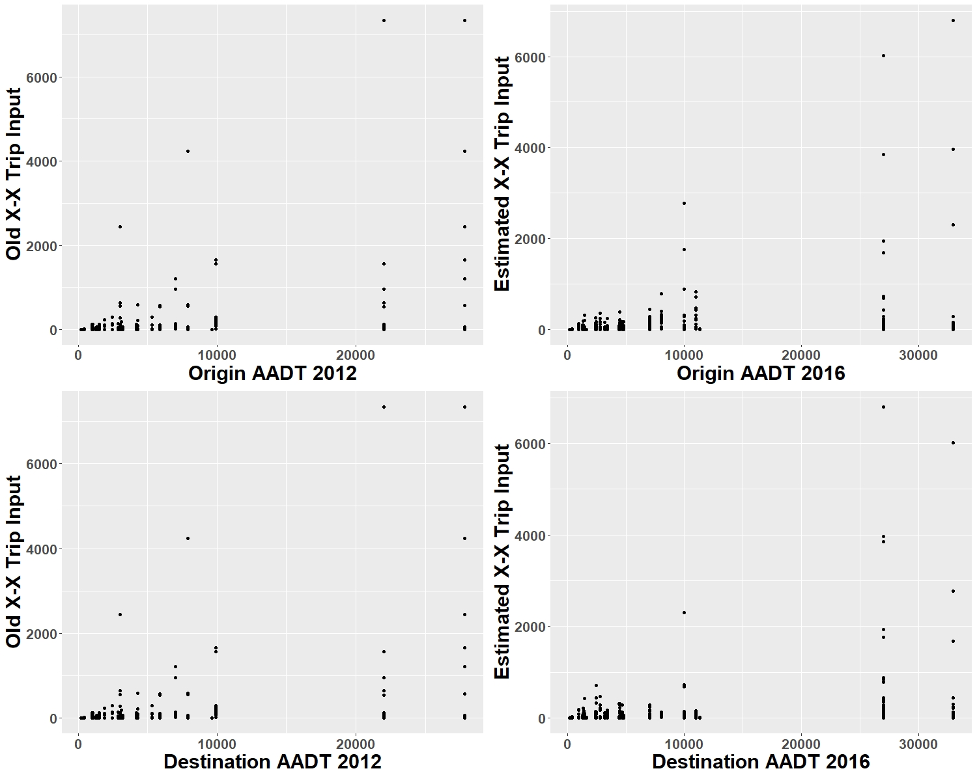
Figure 20 Number of trips by origin and destination AADT

As illustrated by Figure 20, in the previous version of the NERPM-AB X-X trips by origin is identical to X-X trips by destination. This suggests that the earlier model’s X-X trips was generated based on the assumption that the number of inbound and outbound X-X trips are equal for each external station in old model. This is not always the case.
The earlier model’s X-X trips for each station has two (or three) points representing significantly higher trips than the rest. These points are originating from or going to the two external stations with higher AADT. This suggests X-X trips were generated based on AADT. Other factors impacting likelihood of trips (e.g. distance, location, etc.) between O-D pairs were not considered.
Figure 21 shows the scatterplot of the earlier model’s X-X trips vs. estimated X-X trips for identical O-D pairs with the best linear fit line. The linear fitted line shows the goodness of fit (R-squared) of 0.76. The line intercepts the estimated trips at 45, meaning the estimated trips in the new version are longer than old model’s trips for lower values of old model’s trips.

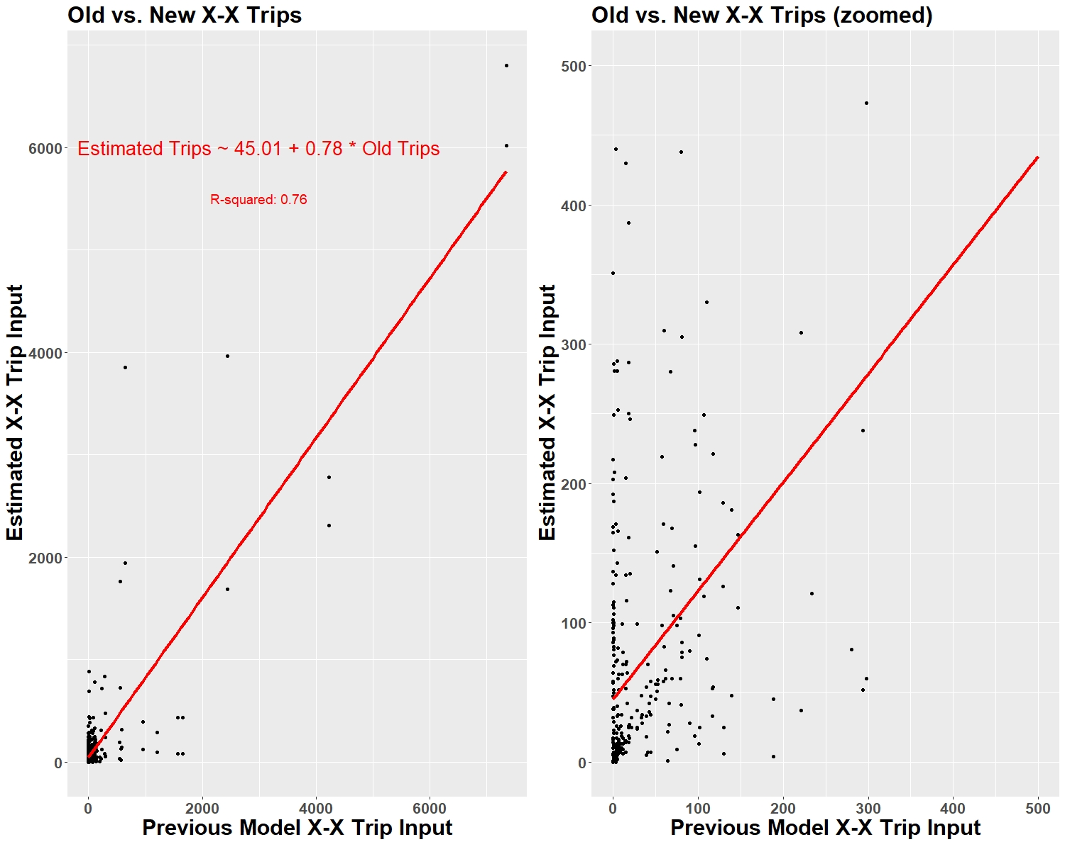
Figure 21 Old model vs. estimated X-X trips

A significant portion of the earlier model’s X-X trips are set to 0 or 1 for smaller trips values (<500). This is probably due to lack of data. However, the raw matched X-X BT data shows that number of trips between these X-X O-D pairs are higher, resulting in a more reliable estimate.
Table 26 shows the O-D pairs with highest volumes in the earlier model’s X-X trips and estimated trips. The number of X-X trips to AADT ratio (shown in table 1) can be analyzed to check the validity of results. For example, 4231 trips per day is originating from node 2564 (US 301) and going to node 2550 (I-95 North) in the old model accounting for the 54% of total AADT of the origin location (node 2564) which is unreasonably high. However, the number of trips between this O-D pair in the estimated results is 2777 accounting for 28% of total AADT of the origin location which seems more reasonable.
Table 26 O-D PAIRS WITH HIGHEST TRIP VOLUME IN OLD MODEL AND ESTIMATED RESULTS

Table 27 shows O-D pairs with highest trip difference (absolute value and percentage) between the old model and the estimated results. The number of X-X trips to AADT ratio in both the old model and estimated results seem reasonable. We have traced these O-D pairs in Google Maps to assess the likelihood of the old model vs. estimated results.

Table 27 O-D PAIRS WITH HIGHEST TRIP DIFFERENCE IN OLD MODEL VS. ESTIMATED RESULTS

Figure 22, Figure 23, Figure 24 and Figure 25 show the O-D pairs with highest trips percentage difference between old model and estimated results (see The) on Google maps. The estimated results for these O-D pairs seems more reliable than old model’s trips since:
- The old model’s trips are significantly lower than observed matched BTs at these locations.
- The number of X-X trips to AADT ratio in the old model is zero whereas the estimated results ratio is between 1-10% which seems more reasonable.
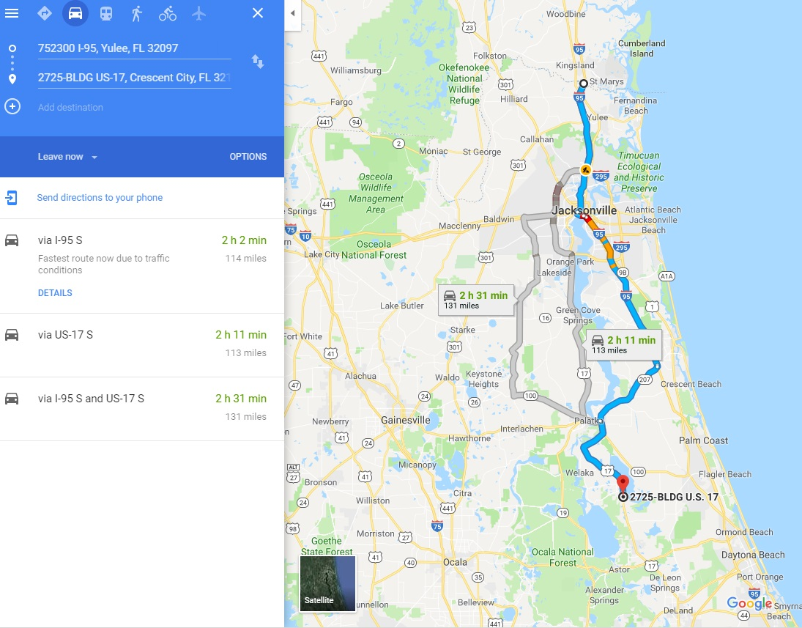
Figure 22 2550 (I-95 North) – 2574 (US 17) – Old model trips = 1 vs. new estimates = 286
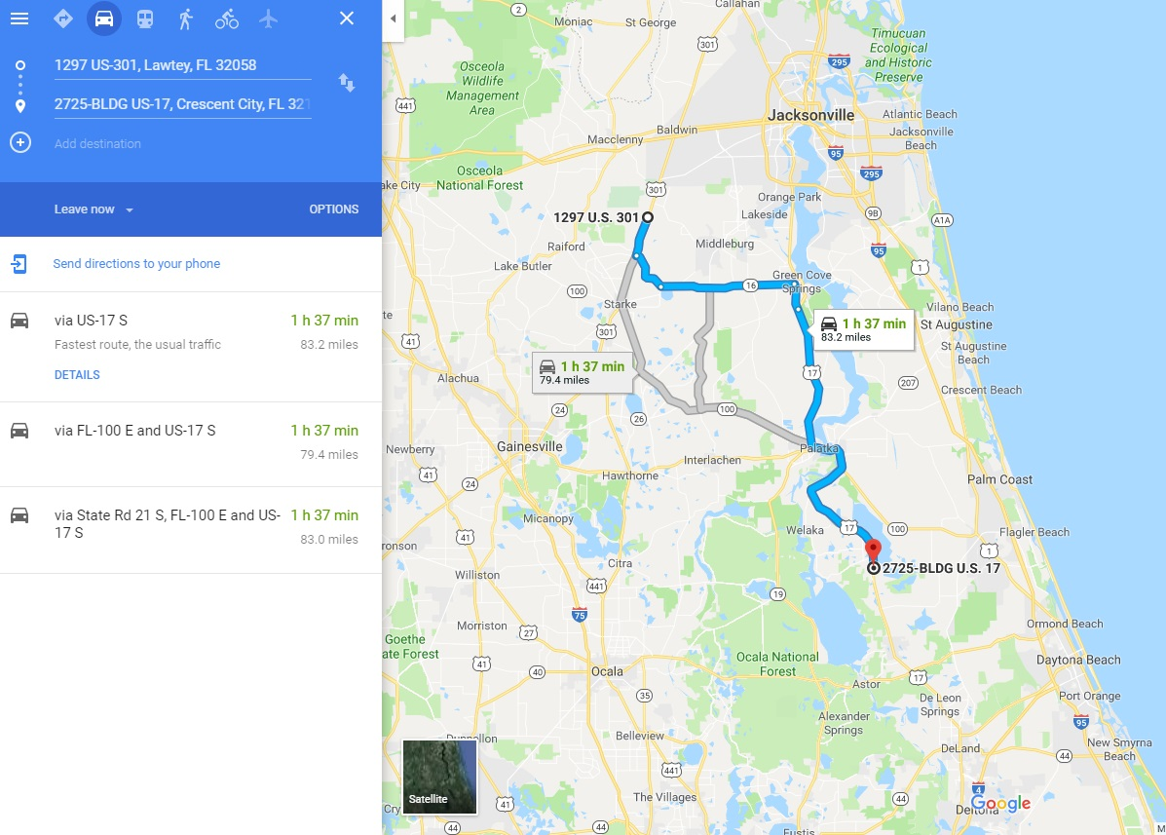
Figure 23 2564 (US 301) – 2574 (US 17) – Old model trips = 1 vs. new estimates = 187
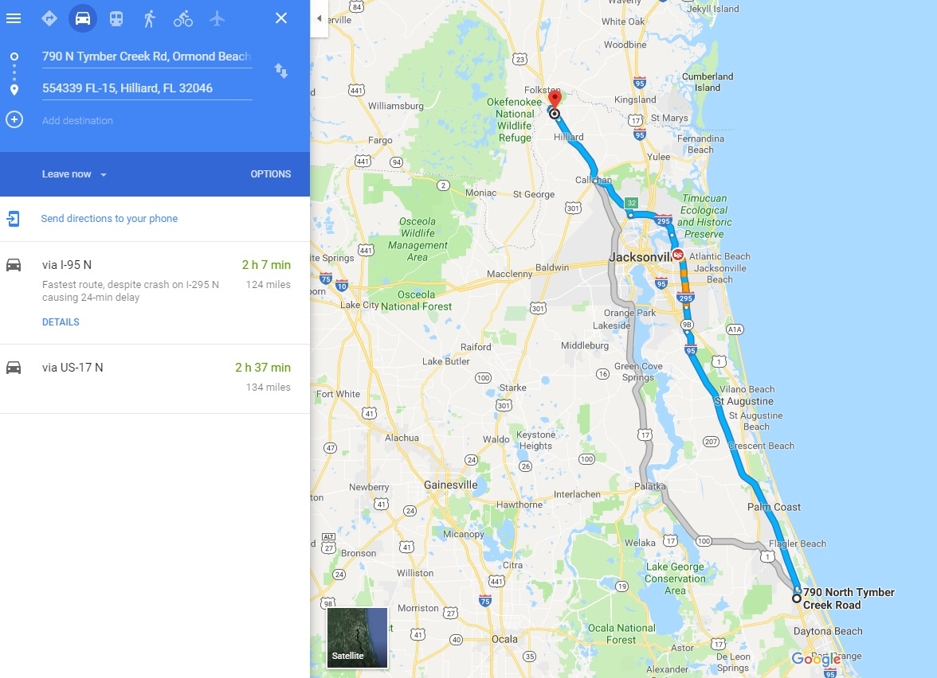
Figure 24 2576 (US 1 South) – 2552 (US 1 North) – Old model trips = 1 vs. new estimates = 152
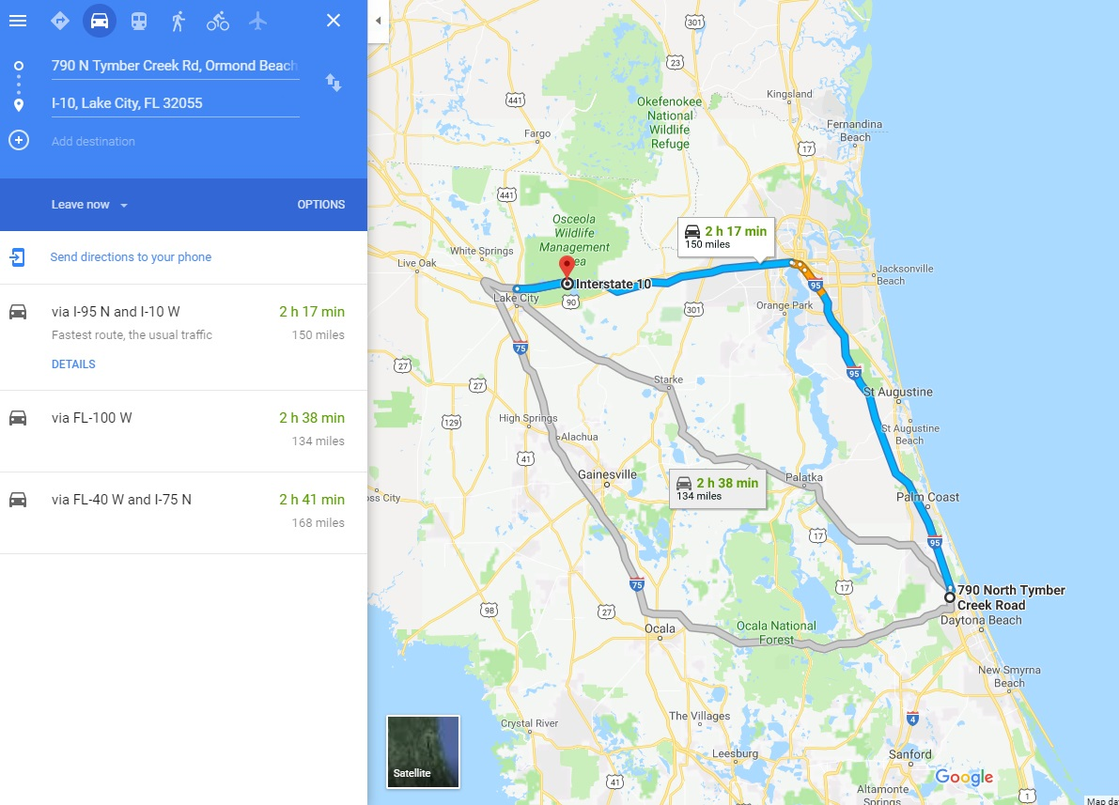
Figure 25 2576 (US 1 North) – 2559 (I-10 West) – Old model trips = 3 vs. new estimates = 440

Figure 26 to Figure 30 shows the O-D pairs with highest trip difference between old model and estimated results (see Table 27) on Google Maps.
Figure 26 shows the route from node 2577 (I-95 south) to node 2559 (I-10 west). Both origin and destination are located on interstates with relatively high AADT value. It is expected that significant trips occur for this O-D pair. As a result, estimated results (accounting for 14% of AADT) seems more reasonable than old model’s trip (accounting for only 3% of AADT).
Figure 27 shows the route from node 2550 (I-95 North) to node 2564 (US 301 west). The old model trips account for 54% of total AADT at the destination which seems very unlikely. Hence, the estimated result seems more reasonable.
Figure 28 shows the route from node 2550 (I-95 North) to node 2568 (SR 100). It is expected that a portion of traffic going from 2550 to 2564 be directed on to 2568. As a result, neither of the trips values (old model and estimated result) appear correct.
Figure 29 shows the route from node 2550 (I-95 North) to node 2559 (I-10 West). Both origin and destination are located on interstates with relatively high AADT value. It is expected that significant trips occur for this O-D pair. As a result, estimated results (accounting for 12% of AADT) seems more reasonable than old model’s trip (accounting for only 9% of AADT).
Figure 30 shows the route from node 2577 (I-95 South) to node 2568 (SR 100). This route seems very unlikely since X-X trips going from south to west can use the faster route through interstates and there is almost no attraction location around node 2568. Hence, the estimated result are more reasonable.
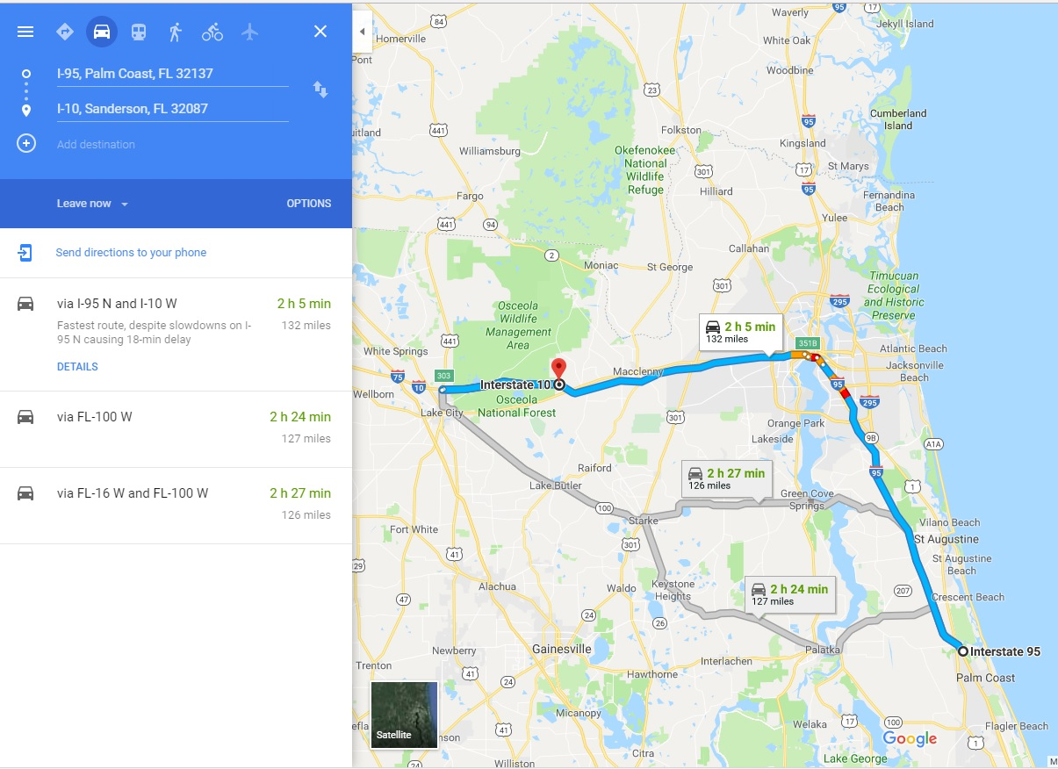
Figure 26 2577 (I-95 South) – 2559 (I-10 West) - Old model trips = 639 vs. new estimates = 3854

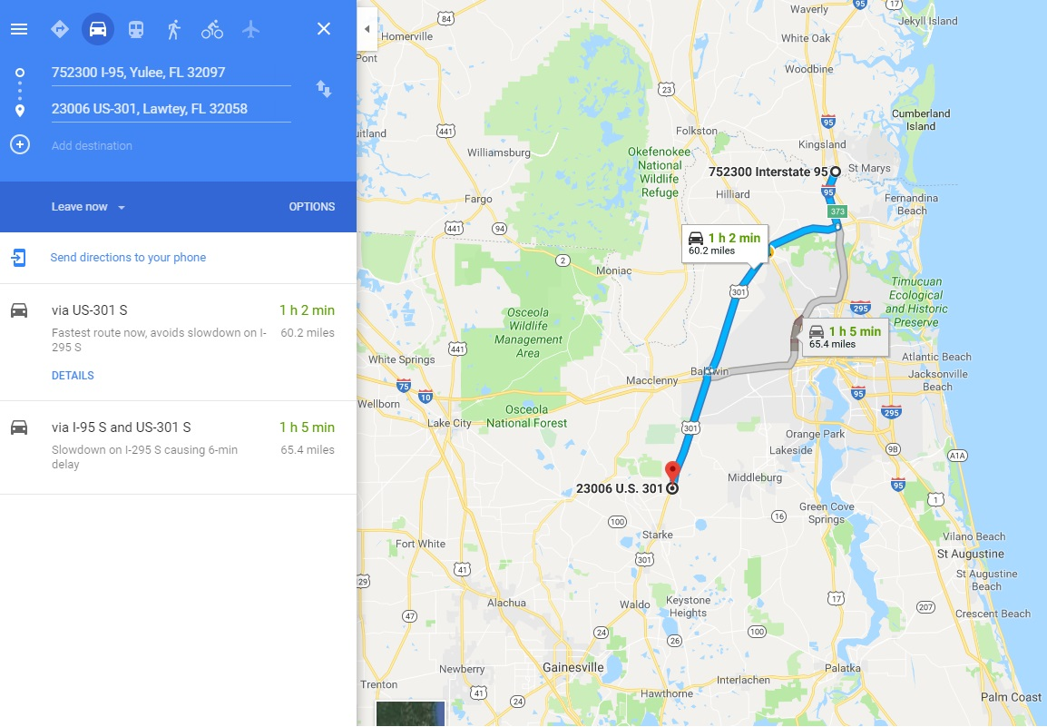
Figure 27 2550 (I-95 North) – 2564 US 301) - - Old model trips = 4231 vs. new estimates = 2310
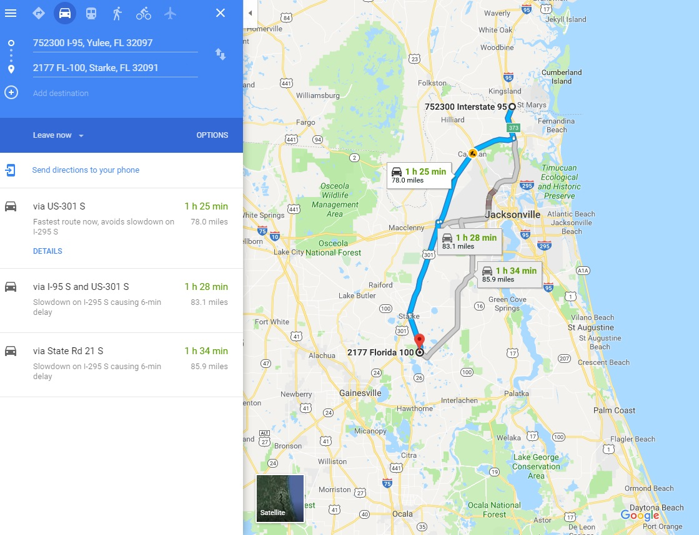
Figure 28 2550 (I-95 North) – 2568 (SR 100 North) - Old model trips = 1658 vs. new estimates = 85

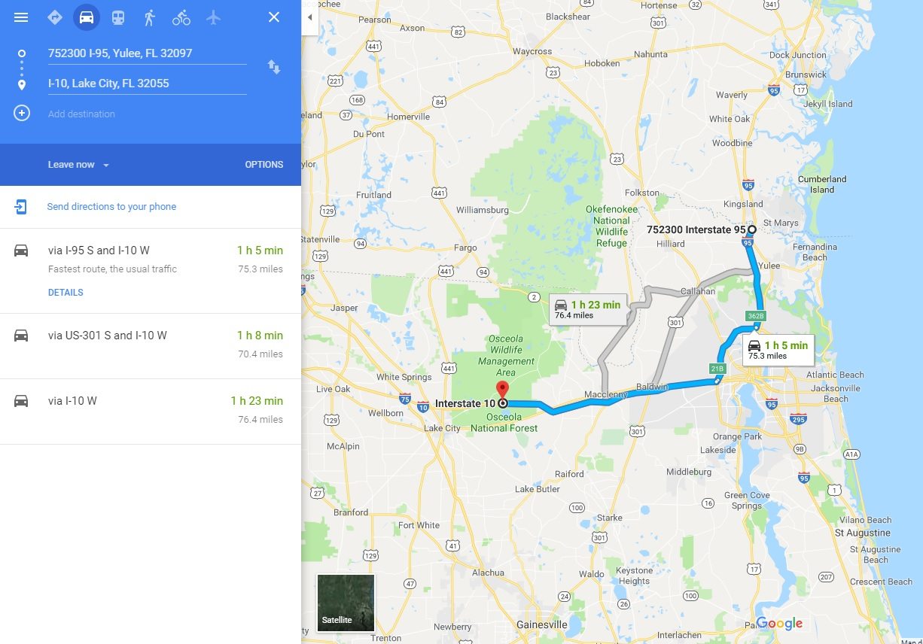
Figure 29 2550 (I-95 North) – 2559 (I-10 West) - Old model trips = 2442 vs. new estimates = 3964

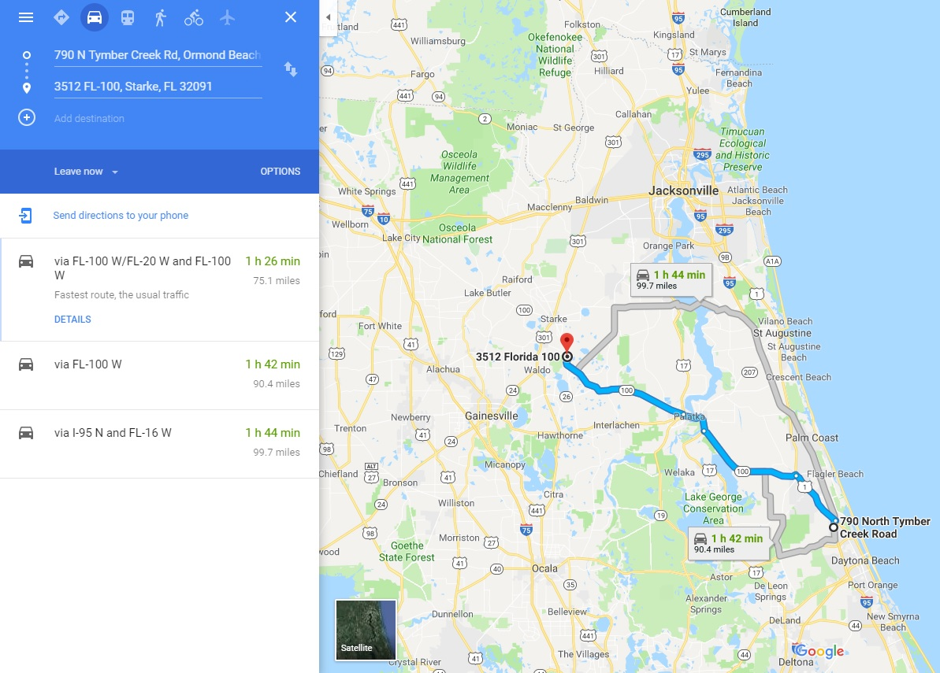
Figure 30 2577 (I-95 South) – 2568 (SR 100 North) - Old model trips = 1562 vs. new estimates = 84

Conclusion
In QA/QC section, we compared the new estimated X-X trip table with the previous estimated X-X trip table. We have concluded the new estimated X-X trip table is more reliable than the previous estimated X-X trip table due to:
- The old X-X trip table is estimated based on the origin and destination’s AADTs. Other factors impacting the likelihood of X-X trips (e.g. distance) were not considered. The new X-X trip tables are estimated based on the Bluetooth matches combined with AADT information (such as growth rate).
- The old X-X trip estimation function (based on AADTs) is unable to provide a reliable estimate for O-D pairs with low AADT values. The updated X-X trip tables for lower volume external stations are estimated based on actual data and are not dependent on AADT.
- The old X-X trip table estimated unreasonably large number of X-X trips compared to total origin/destination AADT.
The new estimated X-X trip table isn’t 100% accurate, even though it is more reliable than old estimates. There are several ways to increase the accuracy of X-X trip table estimates in future:
- Conduct a thorough data cleaning process on the raw Bluetooth data, as follows:
  - Screen-out trips with same vehicle ID, origin, destination, and date that occur at almost same time of day
  - Screen-out trips where starting time is earlier than ending time of vehicles last trip
  - Screen-out trips with unreasonably high or low travel time
- Calculate expansion factor based on all the detected Bluetooth devices at each external station instead of detected Bluetooth devices that were also detected by other Bluetooth stations.
- Identify anomalies by checking data consistency at each station for different time-periods. For example, it is reasonable to assume that the penetration rate between 9-10 AM and 10-11 AM periods are similar for each external station.

Network Updates

Network Link Updates
The previous Existing + Committed (E+C) network, known as 2040A in the 2010 model setup, was used as the starting point for the 2015 network. Table 28 lists the previous E+C network links that were modified to be consistent with 2015 base year conditions. Modifications included revisions to the number of lanes, facility type, and turn restrictions.
UPDATE (01/30/2020): BUSTFAC_45C was set to 0 in the 2045 network fields. This was causing problems with transit assignment resulting in very low transit ridership. RSG set this to 1 for all links since BUSTFAC_15A has it set to 1 for all links. This resolved the low transit ridership issue in the scenario year 2045.
Before setting up a model run, please make sure that in the transit route input file (or any subsequent transit route input files), the skyway modes are coded as MODE=24 instead of 23 and commuter rail “CR_SE-Rail” is coded as MODE=25 instead of 27 to be consistent with the new in-vehicle time skims.
Table 28 E+C Network (2040A) Links to change for 2015 Network
County | Route | From | To
Nassau | Chester Rd. | SR A1A | Green Pine Rd.
Duval | First Coast Expwy. (SR 23) | Clay CL | Argyle Forest Blvd.
Duval | First Coast Expwy. (SR 23) | Argyle Forest Blvd | I-10
Clay | First Coast Expwy. (SR 23) | Blanding Blvd (SR 21) | Duval CL
Duval | I-10 @ I-95 | Roosevelt Ave. (US 17) | San Marco Ave.
Duval | I-295 | SR 9B | J.T. Butler Blvd. (SR 202)
Duval | I-295 | I-10 | Commonwealth Ave.
Duval | I-295 | Buckman Bridge | I-95
Duval | I-295 | I-95 (South) | SR 9B
Duval | Martin Luther King Jr. Pkwy | at 21st St./Talleyrand Ave.
Duval | SR 9B | Philips Hwy. (US1) | I-295
Duval | SR 9B | I-95 | Philips Hwy. (US1)
Duval | US 301 (SR 200) | South of Baldwin | North of Baldwin
Duval | Blanding Blvd/SR 21 | South of Old Jennings | North of CR 218
Duval | I-10 @ Beaver Street | Remove access to Beaver Street
Nassau | US 301 (SR 200) | Duval CL | Callahan

Transit Network Updates
<JTA>

Volume Count Updates
The North Florida TPO provided AADT counts from 2015 FDOT portable traffic monitoring sites at point locations throughout the network. Each count was for total vehicles and did not include directionality or time of day factors. It was assumed that counts on bidirectional roads were equally split between both directions.
These points were spatially joined to the network links and then spot checked to ensure the join was accurate. Particular attention was paid to on and off ramps as they tended to have the least accuracy.
The NERPM-AB has four time periods: AM, midday (MD), PM, and night (NT). The 2010 network contains count data for each of these periods on some links. To create time of day count data for the 2015 counts, the 2015 count was distributed between the four time periods using the same ratio as the 2010 counts. Links with a 2015 count but no 2010 time of day counts used nearby 2010 time of day counts. If no 2010 count was nearby, that 2015 count was not used.

Cube Model update
Several updates were made to the NERPM-AB Cube model during this project. The previous version of the model had model steps and scripting logic that was left over from the previous four-step model. Therefore, enhancements were made wherever necessary to make sure that the model system and results appear reasonable.

External-Internal Trips Calibration
While looking at auxiliary model demand it was found that IE trips are very long – average VMT per trip is approximately 32 miles, compared to 8 miles for internal trips. The VMT needed to be reduced by factoring either or both total IE or truck trips, or by factoring the length of IE trips for which the gravity model used to distribute them needed adjustment. To help inform this decision, the relationship between the observed counts and the estimated link volumes at external stations was investigated. It was found that both ends of I-95 and on I-10 were low, IE trips needed to be increased. It was also possible that the IE trips were traveling too far, which could be adjusted by making the friction factor curve used in trip distribution for IE trips steeper.
The first step taken to resolve this issue is the modification/balancing of External-External (EE) trips using Iterative Proportional Fitting (IPF). There were certain significant imbalances for certain stations, that is, significantly more origins than destinations, or vice-versa. The EE trip table (EETRIPS.DBF) is an input to the trip ‘GENERATION’ step in the NERPM-AB model. Table 29 below summarizes the EETRIPS for the current 2015 input to the North Florida TPO model by external stations for the major facilities I – 95 and I – 10.
Table 29 Summary of EE trips for Major facilities (original input)
TAZ | Description | Trips as Origin | Trips as Destination | Absolute Difference
2550 | I – 95 North | 14,553 | 12,536 | 2,017
2559 | I – 10 West | 6,416 | 13,943 | 7,527
2577 | I – 95 South | 12,153 | 670 | 11,483
It can be noted that there are some significant imbalances for these stations, that is, more origins than destinations, or vice-versa. To minimize these inconsistencies, the EE trips are balanced using IPF method. The goal of the IPF method is that the estimated totals must equal the observed totals. In this case, from the EE trip matrix, the observed total is calculated by averaging row totals and column totals. Next, the EE trip matrix is balanced using the balancing factors over a series of iterations until the maximum difference is reduced. In the first iteration, the balancing factor is calculated by dividing the row observed totals with the row estimated totals. Then the matrix is multiplied with the balancing factors and a new estimated total is calculated. In the next iteration, the balancing factor is calculated using column totals and similarly the matrix is multiplied with the balancing factors to calculate a new estimated total. A total of 13 iterations is completed until the maximum difference calculated was less than 1. Table 30 summarize the EETRIPS for the modified 2015 input to the North Florida TPO model and it can be observed that the balance of trips between external origins and destinations is maintained.
Table 30 Summary of EE trips for Major facilities (modified input)
TAZ | Description | Trips as Origin | Trips as Destination | Absolute Difference
2550 | I – 95 North | 13,544 | 13,545 | 1
2559 | I – 10 | 10,180 | 10,180 | 0
2577 | I – 95 S | 12,020 | 12,020 | 0
The next step is to adjust the trips attractions in the trip generation step of the model. The distribution of the trip attractions was adjusted using one percentage that considers both total productions and attractions instead of just total attractions. Once the adjustments were made, the output was checked to make sure the total EI trips is unchanged (see Table 31).
Table 31 EI Trip Comparison
EI Trip type | Previous Trips | Updated Trips
SOV | 62,268 | 62,268
HOV | 39,669 | 39,669
Light Truck | 2,997 | 2,997
Heavy Truck | 10,992 | 10,992
Total | 115,925 | 115,925
In the next step, the distribution model was run to see what effect it has on trip length. It was found that the average trip length of IE trips has slightly reduced. Therefore, in the next step, the IE trip friction factor curves were replaced with steeper curves and the IE trips were broken out into a separate trip distribution step and run using only 1 iteration in the model run. This reduced the average trip lengths of IE trips significantly as can be seen on Table 32.
Table 32 Comparison of Average Trip Length
Purpose | Average Trip Length in minutes (all counties)
Purpose | Previous | Updated | Difference
HBW | 24.67 | 24.67 | 0
HBSH | 22.25 | 22.24 | -0.01
HBSR | 25.33 | 25.32 | -0.01
HBO | 24.36 | 24.34 | -0.02
NHB | 17.99 | 17.99 | 0
Light Truck | 16.29 | 16.29 | 0
Medium Truck | 16.38 | 16.37 | -0.01
Heavy Truck | 16.44 | 16.44 | 0
IE_SOV | 50.63 | 36.87 | -13.76
IE_HOV | 47.42 | 35.76 | -11.66
IE_LT | 50.46 | 35.74 | -14.72
IE_HT | 43.18 | 36.57 | -6.61
Before running the updated distribution step, the EI input trip vector was adjusted to better match the counts at the external stations by scaling the percent difference at each external station. These enhancements to the model significantly increased the VMT as can be observed in Table 33.
Table 33 Comparison of VMT
Model |  | DAYSIM | IE | EE | TRUCK | Total
Previous | TRIPS | 3,311,459 | 185,820 | 50,293 | 865,163 | 4,412,735
Previous | VMT | 28,268,172 | 6,024,135 | 3,714,863 | 5,969,775 | 43,976,945
Previous | AVG. VMT | 8.54 | 32.42 | 73.86 | 6.90
Updated | TRIPS | 3,214,837 | 185,831 | 50,339 | 415,067 | 3,866,073
Updated | VMT | 27,558,206 | 6,399,105 | 3,715,758 | 9,524,112 | 47,197,181
Updated | AVG. VMT | 8.57 | 34.44 | 73.81 | 22.95

transit skimming Updates
From the initial transit assignment results, it was found that the skyway/monorail boardings were significantly lower than observed boardings. Therefore, the next model enhancement made was to add alternative-specific constants (ASC) to DaySim for transit modes based on an in-vehicle time skim. For the transit alternatives that need to be modeled in the scenarios, the in-vehicle time (IVT) needs to be skimmed in a separate skim matrix, and any tour or trip that has the transit mode in the OD Pair should get the constant. The following table shows the ASC and IVT changes for various transit modes to be used in the model.

Table 34 IVT Modifier and ASC by Transit Mode
Mode | IVT modifier | ASC
- Local and express Bus | 1.0 | 0 min
- Premium Bus | 1.0 | 0 min
- Circulator bus | 1.0 | 0 min
- Light, Heavy rail | 0.9 | -15 min
- Commuter rail | 0.7 | -30 min
- Other mode | 1.0 | 0 min

To incorporate these constants in the model, the following changes were made
- Transit network preparation Cube script was changed to introduce the mode-specific weighing factor (RUNFACTOR) for rail mode
- Connectors Cube script was changed to develop all peak and off-peak connectors to include the rail mode
- Transit Skimming Cube script was changed to create separate skims for rail mode
- DaySim roster file was changed to include all transit sub-modes
- DaySim configuration file was changed to include the additive weights and path constants
- Replaced the old DaySim files with updated DaySim files to include the Jacksonville DLL files which includes the intra-county and river crossing effects.

highway skimming for tolls
In the E+C 2045 networks, express lanes or managed lanes were introduced in the highway network. Initially the toll variable, CARTOLL, was set at zero for all links. This was changed to 20 cents per mile (0.20). This value (CARTOLL) was then multiplied with the link length throughout the model setup to calculate the cost. Moreover, the occupancy for HOV2 and HOV3+ were also changed to 1.3 and 1.5, respectively.

daysim model calibration & Validation
A calibration process adjusts the model to ensure that the model generates demand that reasonably follows the behavior depicted in observed data. The demand is defined as frequency of trips by origin and destination (OD) pair. The frequency of trips by OD pair can have different segmentation for ex. trip mode, time of day etc. The demand is then loaded on to network (assignment) to determine frequency of trips using each link in the network. For highway, this provides vehicle flows on every link (road) in the highway network and for transit, generates number of people (boardings) using each transit service.
After a model is calibrated to produce demand that reasonably predicts observed travel behavior in the region, the model is validated to ensure network-level usage of the demand. The model validation includes, on the highway side, comparing estimated traffic volume from the model with observed traffic counts, and on the transit side, comparing estimated transit boardings from the model with observed transit ridership.
The rest of this chapter presents model calibration and validation in separate sections. For each, first, the observed data are discussed followed by summaries from a final calibration and validated model run. In the end, a summary of the chapter presents key takeaways from the discussions.
In model calibration, alternative-specific constants (ASCs) and other model parameters are iteratively adjusted until the model generates demand that reasonably matches travel patterns in observed data. Typically, models are calibrated according to the following procedure: first, create comparisons between observed data and estimated model results. Next, calculate ASC adjustments by calculating natural log of the ratio between the observed value and the estimated value for each alternative. Then, add the adjustments to the ASCs from the previous iteration. Next, run the model with the updated constants. Table 35 presents a list of datasets utilized to calibrate the NERPM-AB.
Table 35 model calibration datasets
Dataset | Year | Source | Purpose
North Florida Household Travel Survey | 2017 |  | Jacksonville Tour Destination and other sub-models
Transit On-Board Survey | 2016 | Transit On-Board Survey Program | Transit Tours/Trips
CTPP | 2010 | Census | Worker Flow
The present effort used multiple datasets to calibrate the NERPM-AB. The 2017 North Florida Travel Survey was the primary dataset used during the calibration. Whenever available, additional datasets were utilized to inform more accurate information for particular types of travel. For example, transit on-board survey provided information about transit travel, informing transit travel targets (tours and trips) in mode choice calibration. Also, the 2010 CTPP ACS Journey to Work data provided flow of workers and used to validate estimated work location choice of North Florida residents.

North Florida Household Travel Survey
In spring 2017 the North Florida Transportation Planning Organization (North Florida TPO) commenced the 2017 North Florida Travel Survey (2017 HTS). The North Florida TPO was the lead agency for this study. Additional sponsors include the Florida Department of Transportation (FDOT). The North Florida TPO has a Board and Technical Coordinating Committee (TCC) and a Citizens’ Advisory Committee (CAC), all of which were informed about the survey throughout its lifecycle. The survey consultants, RSG and the Hester Group, conducted the survey.
The North Florida survey region included Baker, Clay, Duval, Nassau, Putnam, and St. Johns counties. The primary purpose of the 2017 HTS was to collect current information about household and individual travel patterns for residents throughout the six-county North Florida region to support regional travel models. The 2017 HTS provides planners with comprehensive travel behavior datasets to help regional stakeholders and other local agencies understand current travel behaviors of people and households, which allow them to make informed planning and policy decisions.
The model calibration further processed the 2017 HTS data to prepare targets for model calibration. First, the data were filtered to keep only weekday travel by removing weekend and holiday travel. Then the travel weights were scaled appropriately to match total travel in the original survey data.
During preparing calibration targets, household and person level summaries used respective weights. The 2017 HTS data were geocoded for origin (home, tour, and trip) and destination locations (work, school, tour, and trip) to assign corresponding MAZ and TAZ in the North Florida TPO model region.

Transit On-Board Survey
A transit on-board survey was conducted in 2016 across the JTA service area, collecting data from approximately 31k transit trips. RSG expanded the data to represent total boardings at a route level based on observed ridership data and calculated total linked transit trips by adding the linked weight for each transit trip. Figure 31 shows the percent of transit trips from on-board survey by tour purposes.

Figure 31 transit trips by tour purposes

Worker Flows
Commute travel is a very important and significant component of any regional travel. Therefore, in addition to verifying number of workers by work location, it is essential to validate workers by their origin (home) and destination (work) locations. This project obtained 2010 CTPP ACS worker dataset and validated workers flow between home and work districts. The flows are compared at an aggregate level (6 Counties) since observed data are likely to show more variance/error at a more detailed geography. The dataset is obtained from the respective website.

Calibration Summaries
An R-utility summarizes DaySim outputs into statistics that are meaningful and easy to understand. The summaries are prepared by key model components and include work and school location, auto ownership, day pattern, tour/trip destination choice, mode choice, and time of day. These summaries from the final calibrated model are presented below.

Synthetic Population
Table 36 and

Table 37 compare synthetic population in DaySim with observed data (HTS for the North Florida TPO region). Note that compared to the HTS data, the synthetic population includes slightly more part-time workers. The total workers (full-time and part-time) in the synthetic population (663,578) were greater than the HTS data (599,749).
Table 36 population by person type
Person type | SURVEY | POPSIM
Full Time Worker | 540,570 | 566,852
Part Time Worker | 96,726 | 59,179
Retired | 172,447 | 142,992
Non-Worker | 203,794 | 208,490
University Student | 43,943 | 55,998
Student Age 16+ | 37,901 | 48,543
Student Age 5-15 | 185,288 | 197,734
Kid under 5 | 83,362 | 102,243
Total | 1,326,484 | 1,419,578

Table 37 population by person type (%)
Person type | SURVEY | POPSIM
Full Time Worker | 41% | 40%
Part Time Worker | 4% | 7%
Retired | 13% | 10%
Person type | SURVEY | POPSIM
Non-Worker | 15% | 15%
University Student | 3% | 4%
Student Age 16+ | 3% | 3%
Student Age 5-15 | 14% | 14%
Kid under 5 | 6% | 7%
Total | 100% | 100%

Home to Work Distance
As presented in Table 38, the survey data indicate an average home to work distance of 13.2 miles regionwide. The ABM is calibrated to a distance (12.4 miles) close to the observed value. The distance by worker type are also reasonably calibrated between the two observed datasets.
Table 38 average home to work distance
Worker Type | survey | daysim
Full Time | 13.7 | 13.3
Part Time | 9.1 | 6.8
Other | 9.9 | 14.5
Total | 13.2 | 12.4

Figure 32 shows a distribution of home to work distances of individuals. The X-axis is distance in miles and the Y-axis is share (%) of the total number of persons. Due to relatively lower samples, the observed dataset shows lumpy distributions. The ABM distribution is smoother and generally follows the observed distribution from the survey.

Figure 32 distribution of home to work distances
As shown in Table 39, estimated workers working at a location were compared at an aggregate geography (6 counties). The comparison is extended to compare estimated workers with observed workers from multiple data sources: CTPP and HTS. Note that the HTS data is scaled to match estimated workers by County. Generally, the observed data source shows some significant differences, however, the ABM compared reasonably well with the datasets.

Table 39 workers by county
COUNTY | CTPP | HTS | daysim
1 | 7,283 | 5,383 | 9,681
2 | 59,391 | 80,418 | 84,565
3 | 286,647 | 400,012 | 420,057
4 | 18,556 | 17,424 | 32,801
5 | 13,779 | 10,901 | 20,362
6 | 64,325 | 79,338 | 97,402
TOTAL | 449,980 | 593,476 | 664,868

Home to School Distance
As per HTS, in Table 40, the average distance travelled by students to go from home to school is 6.48 miles. The ABM is adjusted to a value (7.46 mile) close to the HTS, though slightly higher.
Table 40 average home to school distance
Worker Type | survey | daysim
Kids 5 to 15 | 5.40 | 5.69
Student 16+ | 7.06 | 6.95
University Student | 14.09 | 13.99
Total | 6.48 | 7.46
Figure 33 presents a comparison of observed and estimated frequency distribution of trip lengths between home and school. As DaySim is calibrated to follow the HTS profile, the DaySim trip length frequency distribution (TLFD) follows the HTS TLFD closely.

Figure 33 distribution of home to school distance

Auto Ownership
The auto ownership model predicts number of vehicles owned by a household. The auto ownership model is structured as a multinomial logit (MNL) with five available alternatives: 0, 1, 2, 3, and 4+. Key variables are the numbers of working adults, non-working adults, students of driving age, children below driving age and income. Table 41 and Table 42 present share of households by number of vehicles and drivers in the household from the HTS and the ABM respectively. Difference of household shares between the two datasets are presented in Table 43. The ABM is calibrated to reasonably match the HTS shares.

Table 41 share of vehicles by households and drivers (HTS)
No. of Drivers | Number of Vehicles
No. of Drivers | 0 | 1 | 2 | 3 | 4+ | Total
1 | 5.4% | 26.7% | 3.6% | 0.2% | 0.1% | 35.9%
2 | 1.5% | 9.1% | 29.2% | 5.3% | 1.1% | 46.1%
3 | 0.5% | 2.0% | 3.6% | 4.5% | 0.8% | 11.4%
4+ | 0.0% | 0.4% | 1.7% | 1.4% | 3.2% | 6.6%
Total | 7.3% | 38.1% | 38.1% | 11.4% | 5.2% | 100.0%

Table 42 SHARE OF VEHICLES BY HOUSEHOLDS AND DRIVERS (daysim)
No. of Drivers | Number of Vehicles
No. of Drivers | 0 | 1 | 2 | 3 | 4+ | Total
1 | 4.8% | 25.9% | 4.2% | 0.9% | 0.1% | 35.9%
2 | 1.8% | 10.1% | 28.6% | 4.7% | 0.8% | 46.1%
3 | 0.5% | 1.4% | 4.3% | 4.0% | 1.1% | 11.4%
4+ | 0.1% | 1.1% | 1.7% | 1.3% | 2.5% | 6.6%
Total | 7.2% | 38.5% | 38.8% | 11.0% | 4.5% | 100.0%

Table 43 difference in VEHICLES shares BY HOUSEHOLDS AND DRIVERs
No. of Drivers | Number of Vehicles
No. of Drivers | 0 | 1 | 2 | 3 | 4+ | Total
1 | -0.5% | -0.8% | 0.6% | 0.7% | 0.0% | 0.0%
2 | 0.3% | 1.0% | -0.6% | -0.5% | -0.2% | 0.0%
3 | 0.0% | -0.6% | 0.7% | -0.5% | 0.3% | 0.0%
4+ | 0.1% | 0.7% | 0.0% | -0.1% | -0.7% | 0.0%
Total | -0.1% | 0.4% | 0.8% | -0.4% | -0.7% | 0.0%

Day Pattern
Day pattern summaries compare observed and estimated resident travel (tours and trips) by purpose and person type. Table 44 compares tours by tour purpose. As per the HTS data, the majority are mandatory purposes (work-29% and school-16%) related. About 10% are shopping and 12% are social and recreational. The share of tours in the ABM are calibrated to match closely with the HTS data.
Table 44 tours by purpose
Tour PuRpose | HTS | ABM | DIFF (ABM-HTS)
Work | 32% | 29% | -3.0%
School | 14% | 16% | 2.0%
Escort | 14% | 14% | 0.0%
Personal Business | 11% | 12% | 1.0%
Shop | 10% | 10% | 0.0%
Meal | 4% | 4% | 0.0%
Social/Recreation | 12% | 12% | 0.0%
Work-based | 3% | 3% | 0.0%
Total | 100.0% | 100.0% | 0.0%
A tour rate is calculated as the number of tours divided by the number of persons. Table 45 compares tour rates by tour purpose. The HTS indicates on average 1.18 tours per person in the NFTPO region. The calibrated ABM produces a similar but slightly higher tour rate (1.26) for the region. The ABM tour rates by purpose match closely with tour rates in the HTS data.
Table 45 tour rate by purpose
Tour PuRpose | HTS | ABM | DIFF (ABM-HTS)
Work | 0.38 | 0.37 | -0.01
School | 0.17 | 0.20 | 0.03
Escort | 0.17 | 0.18 | 0.01
Personal Business | 0.13 | 0.15 | 0.02
Shop | 0.11 | 0.13 | 0.02
Meal | 0.05 | 0.05 | 0.01
Social/Recreation | 0.14 | 0.15 | 0.02
Work-based | 0.03 | 0.03 | 0.00
Total | 1.18 | 1.26 | 0.09

Table 46 compares observed and estimated tours by person type. Generally, the tours in the ABM match with the HTS distribution by person type. The differences in tours for some person type are due to differences in population in the two datasets. As seen in Table 37, compared to the HTS distribution for the NFTPO region, the ABM is low on number of retirees and high on university students and kids under 5 years of age. This difference in population distribution is reflected in total tours for these person types.
Table 46 tours by person type
Person type | HTS | ABM | DIFF (ABM-HTS)
Full-Time Worker | 46% | 45% | -1.0%
Part-Time Worker | 5% | 6% | 1.0%
Retired | 12% | 10% | -2.0%
Non-Worker | 13% | 12% | -1.0%
Person type | HTS | ABM | DIFF (ABM-HTS)
University Student | 3% | 4% | 1.0%
Student 16+ | 3% | 3% | 0.0%
Student 5-15 | 13% | 13% | 0.0%
Kid Under 5 | 5% | 7% | 2.0%
Total | 100% | 100% | 0%
As presented in Table 47, comparison of tour rate by person type also exhibit some differences. These differences are small, and are, in part, due to the differences in the population counts by person type.
Table 47 tour rate by person type
Person type | HTS | ABM | DIFF (ABM-HTS)
Full-Time Worker | 1.33 | 1.42 | 0.08
Part-Time Worker | 1.19 | 1.20 | 0.01
Retired | 1.11 | 1.22 | 0.10
Non-Worker | 1.00 | 1.07 | 0.08
University Student | 1.07 | 1.23 | 0.16
Student 16+ | 1.13 | 1.20 | 0.07
Student 5-15 | 1.10 | 1.18 | 0.08
Kid Under 5 | 0.99 | 1.15 | 0.15
Total | 1.18 | 1.26 | 0.09

The distribution of ABM trips by destination purpose matches well with the HTS data of the NFTPO region. The trip shares in the ABM are generally within 1-3% of the HTS shares.

Table 48 trips by purpose
Destination PuRpose | HTS | ABM | DIFF (ABM-HTS)
Work | 15% | 13% | -1.9%
School | 6% | 6% | -0.1%
Escort | 10% | 10% | -0.8%
Personal Business | 10% | 13% | 3.0%
Shop | 11% | 11% | 0.0%
Meal | 5% | 5% | 0.0%
Social/Recreation | 7% | 8% | 1.0%
Home | 36% | 35% | -1.0%
Total | 100% | 100% | 0.0%
As shown in Table 49, according to the HTS data, a resident of the NFTPO region makes 3.20 trips in a day on average. The ABM produces a slightly higher estimate of the trip rate with 3.55 trips per person. The estimated trip rates by destination purpose match well with the HTS trip rates, with slightly higher trip rate for return home purpose.
Table 49 trip rate by purpose
Destination PuRpose | HTS | ABM | DIFF (ABM-HTS)
Work | 0.46 | 0.45 | -0.02
School | 0.19 | 0.21 | 0.02
Escort | 0.34 | 0.34 | 0.01
Personal Business | 0.31 | 0.47 | 0.15
Shop | 0.35 | 0.38 | 0.03
Meal | 0.17 | 0.18 | 0.01
Social/Recreation | 0.24 | 0.30 | 0.06
Home | 1.14 | 1.23 | 0.09
Total | 3.20 | 3.55 | 0.35
As indicated in Table 50, The HTS data suggests, on average, residents of the NFTPO region make 2.72 trips on a tour. The ABM produces a similar estimate of 2.81 trips per tour for the residents. The estimated trips per tour by destination purpose show slight differences but are generally like the HTS data.
Table 50 trips per tour by purpose
Destination PuRpose | HTS | ABM | DIFF (ABM-HTS)
Work | 2.69 | 2.92 | 0.23
School | 2.82 | 2.74 | -0.08
Escort | 2.93 | 2.94 | 0.02
Personal Business | 2.86 | 2.84 | -0.02
Shop | 2.63 | 2.30 | -0.33
Meal | 2.39 | 2.21 | -0.18
Social/Recreation | 2.54 | 2.51 | -0.03
Total | 2.72 | 2.81 | 0.09

The distribution of model trips by person type categories is similar to the HTS data for the NFTPO region as shown in Table 51. As described in comparison of tours by person type, the differences for some person categories (part-time workers, retired, non-worker, student 16+ and kids under 5 year) are due to differences in population of those persons in the two datasets.
Table 51 trips by person type
Person type | HTS | ABM | DIFF (ABM-HTS)
Full-Time Worker | 46% | 46% | 0.9%
Part-Time Worker | 5% | 6% | 1.6%
Retired | 13% | 10% | -3.1%
Non-Worker | 14% | 13% | -1.1%
Person type | HTS | ABM | DIFF (ABM-HTS)
University Student | 3% | 3% | 0.2%
Student 16+ | 2% | 3% | 0.1%
Student 5-15 | 12% | 12% | -0.5%
Kid Under 5 | 5% | 7% | 1.8%
Total | 100% | 100% | 0.0%
As presented in Table 52, similar to the tour rate by person type (see Table 47), the regional trip rate in the ABM is slightly higher (3.55 trips/person) than the HTS trip rate (3.20 trips/person) for the NFTPO region. Comparison by person type categories also show higher trip rates in the ABM.

Table 52 trip rate by person type
Person type | CHTS (SJV) | ABM | DIFF (ABM-CHTS)
Full-Time Worker | 3.58 | 4.13 | 0.55
Part-Time Worker | 3.36 | 3.29 | -0.07
Retired | 3.26 | 3.58 | 0.32
Non-Worker | 2.85 | 3.05 | 0.20
University Student | 2.82 | 2.82 | 0.00
Student 16+ | 2.69 | 2.65 | -0.04
Student 5-15 | 2.80 | 2.98 | 0.18
Kid Under 5 | 2.65 | 3.47 | 0.81
Total | 3.20 | 3.55 | 0.35

Other Tour Destination
A comparison of average tour lengths by purpose between the observed (HTS) and the model data is presented in Table 53. A tour length is calculated as distance between tour origin and primary destination. The comparison includes only non-mandatory tour purposes - mandatory tour purposes (work and school) have been discussed before (see Table 38 and Table 40). Due to insufficient sample size for each purpose category, shopping and personal business purposes are aggregated into the maintenance category, and shopping, meal and social/recreational purposes are aggregated into the discretionary category.
For each purpose, the average model tour length is calibrated within a range of the HTS values. Due to smaller sample size in the observed dataset, the tour length frequency distributions of the escort tours are very lumpy, Figure 36. This makes it difficult to know the real travel behavior for the escort tours. As shown in Figure 34, Figure 35 and Figure 37, the observed distributions for other tour purposes are relatively smoother due to more samples for these purposes. The ABM distributions are generally smooth and follow distributions from the observed dataset.

Table 53 average tour lengths for other tour purpose
Tour Purpose | HTS | ABM
Maintenance | 6.96 | 6.93
Discretionary | 6.80 | 6.71
Escort | 5.97 | 6.33
Work-based | 3.53 | 3.49

Figure 34 tour length distribution for discretionary travel

Figure 35 tour length distribution for maintenance level

Figure 36 TOUR LENGTH DISTRIBUTION FOR escort LEVEL

Figure 37 TOUR LENGTH DISTRIBUTION FOR work-based LEVEL

Tour Mode Choice
Tour mode is an abstract concept, defined as the main mode of travel used to get from the origin to the primary destination and back. The following 8 tour modes are available in the ABM: drive alone, shared-ride 2, shared-ride 3+, bike, walk, drive-transit, walk-transit, and school bus. The tour mode is coded in the survey based on a set of rules that are dependent on the combination of trip modes used on the tour. The rules can be summarized as follows:
- Any tour with a transit trip is defined as a transit tour
- Any transit tour with a PNR trip is defined as a PNR-transit tour
- Any transit tour with neither a PNR trip nor a KNR trip is defined as a walk-transit tour
- Any tour with a bicycle trip is defined as a bicycle tour
- Any tour with an auto trip is defined as an auto tour
- The highest occupancy mode of all auto trips on the tour is used to set the occupancy of the tour
- Remaining tours are walk tours
A similar set of rules is used in tour mode choice to constrain the availability of trip modes based on tour mode. These rules also influence the accessibilities used to choose the locations of intermediate stops on tours; for example, transit and walk accessibilities are used to choose stop locations on transit tours, rather than auto accessibility.
After scaling the original HTS targets to accommodate transit targets from the transit on-board survey, the HTS targets are scaled one more time for tour mode calibration. Generally, a tour mode choice calibration aims to adjust the mode choice model so that the distribution of tours by mode is similar to observed share. Therefore, tour mode choice adjustments are made to alternative-specific constants to match observed mode shares. As transit tour targets are calculated directly from a transit on-board survey, the model needs to be calibrated to the same numbers. However, when calibrated using mode shares, the number of transit tours based on the share of transit mode in the HTS will result in a different number due to a different value of total tours in the ABM. For example, if a survey says that there are 100 transit tours among 10,000 total tours, then the transit share would be 1%. However, if the model is generating 12,000 total tours then calibrating the model to the survey transit share of 1% will result in 120 transit tours. Since we want to calibrate the model to match the absolute number of transit tours inferred from the on-board survey, we adjust observed tours by mode, keeping the transit tours constant but scaling other modes to match total tours in the model by purpose and auto sufficiency.
Overall, the tour mode shares in the ABM match the HTS shares reasonably well (Figure 38). The comparison within the tour purpose categories is also similar as shown in Table 54, Table 55 and Table 56. The HTS observe an overall tour mode share of 40.8% by drive-alone (SOV) and 24.6% and 19.4% by shared-ride 2 and shared-ride 3 respectively. Only 1.0% of the tours use some form of transit mode with most (0.9%) using walk to transit. The non-motorized tour modes (walk and bike) comprise 7.8% of the regional tours.

Figure 38 tour mode shares (total)

Table 54 tour mode shares (HTS)
Mode | Work | School | Escort | Other | Work-Based | Total
Drive Alone | 75% | 11% | 2% | 39% | 30% | 40.8%
SR2 | 14% | 24% | 42% | 29% | 9% | 24.6%
SR3+ | 8% | 30% | 52% | 15% | 5% | 19.4%
Drive Transit | 0% | 0% | 0% | 0% | 0% | 0.1%
Walk Transit | 1% | 1% | 0% | 1% | 0% | 0.9%
Bike | 0.6% | 1.8% | 0% | 2.2% | 1% | 1.3%
Walk | 1% | 4% | 3% | 14% | 5% | 6.5%
School Bus | 0% | 28% | 0% | 0% | 50% | 6.5%
Total | 100% | 100% | 100% | 100% | 100% | 100%

Table 55 tour mode shares (ABM)
Mode | Work | School | Escort | Other | Work-Based | Total
Drive Alone | 76% | 13% | 2% | 38% | 32% | 39.5%
SR2 | 14% | 24% | 40% | 31% | 7% | 25.1%
SR3+ | 8% | 31% | 55% | 16% | 5% | 20.4%
Drive Transit | 0% | 0% | 0% | 0% | 0% | 0.1%
Walk Transit | 1% | 1% | 0% | 1% | 0% | 0.8%
Bike | 0.4% | 1.2% | 0% | 2.1% | 1% | 1.2%
Walk | 0% | 3% | 3% | 13% | 5% | 6.2%
School Bus | 0% | 27% | 0% | 0% | 50% | 6.7%
Total | 100% | 100% | 100% | 100% | 100% | 100%

Table 56 tour mode shares (HTS-ABM)
Mode | Work | School | Escort | Other | Work-Based | Total
Drive Alone | 1.1% | 1.2% | -0.3% | -1.1% | 1.9% | -1.3%
SR2 | -0.1% | 0.1% | -1.2% | 1.1% | -1.2% | 0.5%
SR3+ | 0.0% | 0.1% | 2.0% | 1.1% | -0.4% | 1.0%
Drive Transit | 0.0% | 0.0% | 0.0% | 0.0% | 0.0% | 0.0%
Walk Transit | 0.0% | 0.0% | -0.1% | -0.2% | 0.0% | -0.1%
Bike | -0.2% | -0.6% | 0.0% | 0.0% | 0.0% | -0.1%
Walk | -0.7% | -0.4% | -0.4% | -0.8% | -0.2% | -0.3%
School Bus | 0.0% | -0.5% | 0.0% | -0.1% | 0.0% | 0.3%
Total | 0.0% | 0.0% | 0.0% | 0.0% | 0.0% | 0.0%

Trip Destination

Table 57As presented in Table 57, the HTS data suggest an average trip length of 7.77 miles region wide. For the same, the calibrated ABM produces only a slightly lower trip length value (7.68 miles). The trip lengths by trip destination purpose also match reasonably well.

Table 57 trip lengths (miles) by destination purpose
Trip Destination Purpose | HTS | ABM
Home | 7.84 | 8.38
Work | 11.59 | 10.97
School | 6.91 | 7.85
Escort | 6.70 | 6.20
Personal Business | 7.23 | 6.56
Shop | 5.71 | 5.77
Trip Destination Purpose | HTS | ABM
Meal | 6.05 | 5.79
Social/Recreational | 7.19 | 6.72
Total | 7.77 | 7.68

Tour Time of Day
Plots of tour arrival and departure times at primary destination are presented in Figure 39 through Figure 46. The ABM distribution generally match well with the HTS distribution by purpose. The work-based arrival times are more peaked in the survey than in the model, which is common since the model tends to predict smooth distributions.

Figure 39 time of day distribution of work arrival times

Figure 40 TIME OF DAY DISTRIBUTION OF WORK DEPARTURE TIMES

Figure 41 TIME OF DAY DISTRIBUTION OF SCHOOL ARRIVAL TIMES

Figure 42 TIME OF DAY DISTRIBUTION OF SCHOOL DEPARTURE TIMES

Figure 43 TIME OF DAY DISTRIBUTION OF OTHER PURPOSE ARRIVAL TIMES

Figure 44 TIME OF DAY DISTRIBUTION OF OTHER PURPOSE DEPARTURE TIMES

Figure 45 TIME OF DAY DISTRIBUTION OF WORK-BASED ARRIVAL TIMES

Figure 46 TIME OF DAY DISTRIBUTION OF WORK-BASED DEPARTURE TIMES

Trip Mode Choice
Trip mode targets are prepared from the HTS data for the NFTPO region and updated with transit trip targets from the transit on-board survey. Other mode targets are appropriately scaled to keep the total trips by purpose the same, similar to the process described above for creation of tour mode choice targets. This ensures that the absolute number of expanded transit trips from the transit onboard survey is matched in calibration.
The calibration process involves adjustment of alternative-specific constants to match observed trips by trip mode and tour mode within each tour purpose. The trip mode choice model can be thought of as a ‘mode switching’ model, in which the tour mode constrains which modes are available for trips on tours.
Overall, the ABM generates a trip mode distribution very similar to the observed distribution (Figure 47, Table 58, Table 59 and Table 60). The HTS data indicate that on an average weekday, 47.8% trips in the NFTPO region are drive alone and 41.8% are shared-ride (SR2 and SR3), approximately 0.6% resident trips are made by transit, and 7.2% are made by a non-motorized mode (walk or bike).

Figure 47 trip mode shares (total)

Table 58 trip mode shares (HTS)
Mode | Work | School | Escort | Other | Work-Based | Total
Drive Alone | 79% | 13% | 25% | 42% | 63% | 48.7%
SR2 | 12% | 31% | 36% | 29% | 16% | 24.3%
SR3+ | 5% | 30% | 36% | 13% | 10% | 16.1%
Transit | 1% | 1% | 0% | 1% | 0% | 0.8%
Bike | 1% | 2% | 0% | 2% | 1% | 1.2%
Walk | 2% | 5% | 3% | 13% | 10% | 6.6%
School Bus | 0% | 19% | 0% | 0% | 0% | 2.4%
Total | 100% | 100% | 100% | 100% | 100% | 100%

Table 59 trip mode shares (ABM)
Mode | Work | School | Escort | Other | Work-Based | Total
Drive Alone | 81% | 14% | 25% | 39% | 66% | 47.8%
SR2 | 11% | 32% | 37% | 33% | 15% | 25.8%
SR3+ | 6% | 29% | 34% | 13% | 8% | 16.0%
Transit | 1% | 1% | 0% | 1% | 0% | 0.6%
Bike | 0% | 1% | 1% | 2% | 1% | 1.2%
Walk | 1% | 5% | 3% | 12% | 10% | 6.0%
School Bus | 0% | 18% | 0% | 0% | 0% | 2.5%
Total | 100% | 100% | 100% | 100% | 100% | 100%

Table 60 trip mode shares (ABM-HTS)
Mode | Work | School | Escort | Other | Work-Based | Total
Drive Alone | 1.8% | 1.1% | -0.1% | -2.4% | 3.0% | -0.8%
SR2 | -1.2% | 1.2% | 1.0% | 3.8% | -1.1% | 1.5%
SR3+ | 1.0% | -0.9% | -1.5% | -0.4% | -1.8% | 0.0%
Transit | -0.1% | 0.1% | -0.1% | -0.2% | 0.0% | -0.1%
Bike | -0.1% | -0.1% | 0.7% | -0.1% | 0.0% | 0.0%
Walk | -1.4% | -0.7% | 0.0% | -0.5% | -0.1% | -0.6%
School Bus | 0.0% | -0.7% | 0.0% | -0.1% | 0.0% | 0.1%
Total | 0.0% | 0.0% | 0.0% | 0.0% | 0.0% | 0.0%

model summaries
There were additional summaries for which Cube and R scripts were created and integrated with the North Florida TPO model setup. These summaries are explained below:

VMT by VC Ratio
Table 61 shows the vehicle miles travelled (VMT) by volume to capacity (VC) ratio for the 2015 scenario run. Links with VC ratio less than 0.9 shows close to 70% of VMT.
Table 61 VMT by VC Ratio (2045)
Group | VC Range | Total VMT | Percent Total
1 | LT 0.9 | 32,420,897 | 69%
2 | 0.9 - 1.1 | 8,315,188 | 18%
3 | 1.1 - 1.3 | 4,184,136 | 9%
4 | GT 1.3 | 1,942,692 | 4%
Total |  | 46,862,913 | 100%

Trips by Mode and Income
Table 62 to Table 66 show the number of trips cross-tabulated by mode and income across all tour purpose categories as well as the totals for the 2015 scenario.
Table 62 Trips by Mode and Income (work)
Mode | Income Category (Tour purpose=Work) |  |  |  | Total
Mode | 0 - $30,000 | $30,001 - $60,000 | $60,001 - $100,000 | Greater than $100k | Total
SOV | 118,337 | 301,000 | 396,592 | 456,938 | 1,272,867
HOV2 | 14,623 | 34,896 | 50,957 | 56,161 | 156,637
HOV3 | 7,895 | 18,630 | 30,103 | 33,369 | 89,997
Walk | 2,386 | 3,681 | 3,693 | 4,213 | 13,973
Bike | 1,448 | 1,887 | 1,626 | 1,546 | 6,507
Transit | 3,460 | 5,657 | 4,608 | 4,345 | 18,070
School Bus | - | - | - | - | -
Total | 148,149 | 365,751 | 487,579 | 556,572 | 1,558,051
Table 63 TRIPS BY MODE AND INCOME (School)
Mode | Income CATEGORY (TOUR PURPOSE=School) |  |  |  | Total
Mode | 0 - $30,000 | $30,001 - $60,000 | $60,001 - $100,000 | Greater than $100k | Total
SOV | 12,713 | 18,366 | 18,817 | 24,328 | 74,224
HOV2 | 40,626 | 49,641 | 52,709 | 54,866 | 197,842
HOV3 | 38,947 | 46,829 | 51,748 | 53,862 | 191,386
Walk | 10,962 | 9,304 | 7,468 | 7,367 | 35,101
Bike | 3,035 | 2,332 | 1,852 | 1,886 | 9,105
Transit | 1,773 | 1,837 | 1,160 | 829 | 5,599
School Bus | 37,742 | 29,624 | 24,293 | 24,854 | 116,513
Total | 145,798 | 157,933 | 158,047 | 167,992 | 629,770
Table 64 TRIPS BY MODE AND INCOME (Shop)
Mode | Income Category (Tour purpose=Shop) |  |  |  | Total
Mode | 0 - $30,000 | $30,001 - $60,000 | $60,001 - $100,000 | Greater than $100k | Total
SOV | 146,131 | 155,666 | 125,883 | 128,435 | 556,115
HOV2 | 86,406 | 105,298 | 85,034 | 78,173 | 354,911
HOV3 | 30,553 | 39,126 | 36,784 | 34,606 | 141,069
Walk | 26,782 | 16,724 | 10,750 | 9,724 | 63,980
Bike | 14,671 | 6,975 | 4,686 | 4,104 | 30,436
Transit | 6,646 | 1,305 | 454 | 271 | 8,676
School Bus | - | - | - | - | -
Total | 311,189 | 325,094 | 263,591 | 255,313 | 1,155,187
Table 65 TRIPS BY MODE AND INCOME (Other)
Mode | Income CATEGORY (TOUR PURPOSE=Other) |  |  |  | Total
Mode | 0 - $30,000 | $30,001 - $60,000 | $60,001 - $100,000 | Greater than $100k | Total
SOV | 98,988 | 124,240 | 127,474 | 126,842 | 477,544
HOV2 | 113,215 | 137,754 | 136,434 | 128,404 | 515,807
HOV3 | 81,278 | 99,275 | 107,504 | 92,658 | 380,715
Walk | 64,719 | 56,122 | 49,103 | 46,862 | 216,806
Bike | 6,612 | 3,728 | 3,216 | 2,848 | 16,404
Transit | 1,892 | 391 | 167 | 132 | 2,582
School Bus | - | - | - | - | -
Total | 366,704 | 421,510 | 423,898 | 397,746 | 1,609,858
Table 66 TRIPS BY MODE AND INCOME (Total)
Mode | Income CATEGORY (TOUR PURPOSE=Total) |  |  |  | Total
Mode | 0 - $30,000 | $30,001 - $60,000 | $60,001 - $100,000 | Greater than $100k | Total
SOV | 376,169 | 599,272 | 668,766 | 736,543 | 2,380,750
HOV2 | 254,870 | 327,589 | 325,134 | 317,604 | 1,225,197
HOV3 | 158,673 | 203,860 | 226,139 | 214,495 | 803,167
Walk | 104,849 | 85,831 | 71,014 | 68,166 | 329,860
Bike | 25,766 | 14,922 | 11,380 | 10,384 | 62,452
Transit | 13,771 | 9,190 | 6,389 | 5,577 | 34,927
School Bus | 37,742 | 29,624 | 24,293 | 24,854 | 116,513
Total | 971,840 | 1,270,288 | 1,333,115 | 1,377,623 | 4,952,866

County-County Flows
Table 67 to Table 71 illustrates the county to county trip flows across all tour purpose categories as well as the total for the 2015 scenario.
Table 67 County to COunty Flows (Work)
County | Baker | Clay | Duval | Nassau | Putnam | StJohns | Total
Baker | 9,970 | 609 | 4,341 | 218 | 6 | 97 | 15,241
Clay | 583 | 96,482 | 57,232 | 595 | 2,246 | 5,793 | 162,931
Duval | 4,368 | 57,362 | 971,410 | 16,058 | 1,071 | 46,739 | 1,097,008
Nassau | 213 | 614 | 16,052 | 39,238 | 9 | 277 | 56,403
Putnam | 8 | 2,242 | 1,080 | 9 | 30,976 | 3,057 | 37,372
StJohns | 99 | 5,622 | 46,893 | 285 | 3,064 | 133,133 | 189,096
Total | 15,241 | 162,931 | 1,097,008 | 56,403 | 37,372 | 189,096 | 1,558,051
Table 68 COUNTY TO COUNTY FLOWS (School)
County | Baker | Clay | Duval | Nassau | Putnam | StJohns | Total
Baker | 9,653 | 126 | 589 | 61 | 1 | 5 | 10,435
Clay | 119 | 70,829 | 15,596 | 71 | 710 | 1,595 | 88,920
Duval | 593 | 15,595 | 368,716 | 3,455 | 40 | 14,024 | 402,423
Nassau | 65 | 68 | 3,453 | 21,999 | - | 19 | 25,604
Putnam | - | 711 | 43 | - | 25,118 | 320 | 26,192
StJohns | 5 | 1,591 | 14,026 | 18 | 323 | 60,233 | 76,196
Total | 10,435 | 88,920 | 402,423 | 25,604 | 26,192 | 76,196 | 629,770
Table 69 COUNTY TO COUNTY FLOWS (Shop)
County | Baker | Clay | Duval | Nassau | Putnam | StJohns | Total
Baker | 16,171 | 231 | 1,266 | 100 | 1 | 8 | 17,777
Clay | 226 | 130,419 | 19,427 | 251 | 1,677 | 1,172 | 153,172
Duval | 1,279 | 19,449 | 662,513 | 6,246 | 200 | 18,006 | 707,693
Nassau | 94 | 259 | 6,238 | 56,250 | 3 | 38 | 62,882
Putnam | 1 | 1,686 | 194 | 3 | 65,419 | 554 | 67,857
StJohns | 6 | 1,128 | 18,055 | 32 | 557 | 126,028 | 145,806
Total | 17,777 | 153,172 | 707,693 | 62,882 | 67,857 | 145,806 | 1,155,187
Table 70 COUNTY TO COUNTY FLOWS (Other)
County | Baker | Clay | Duval | Nassau | Putnam | StJohns | Total
Baker | 20,591 | 306 | 1,698 | 140 | 6 | 38 | 22,779
Clay | 293 | 183,525 | 29,550 | 372 | 2,053 | 1,846 | 217,639
Duval | 1,696 | 29,505 | 963,673 | 7,571 | 493 | 24,924 | 1,027,862
Nassau | 154 | 383 | 7,535 | 64,728 | 5 | 96 | 72,901
Putnam | 5 | 2,045 | 511 | 3 | 77,653 | 804 | 81,021
StJohns | 40 | 1,875 | 24,895 | 87 | 811 | 159,948 | 187,656
Total | 22,779 | 217,639 | 1,027,862 | 72,901 | 81,021 | 187,656 | 1,609,858
Table 71 COUNTY TO COUNTY FLOWS (Total)
County | Baker | Clay | Duval | Nassau | Putnam | StJohns | Total
Baker | 56,385 | 1,272 | 7,894 | 519 | 14 | 148 | 66,232
Clay | 1,221 | 481,255 | 121,805 | 1,289 | 6,686 | 10,406 | 622,662
Duval | 7,936 | 121,911 | 2,966,312 | 33,330 | 1,804 | 103,693 | 3,234,986
Nassau | 526 | 1,324 | 33,278 | 182,215 | 17 | 430 | 217,790
Putnam | 14 | 6,684 | 1,828 | 15 | 199,166 | 4,735 | 212,442
StJohns | 150 | 10,216 | 103,869 | 422 | 4,755 | 479,342 | 598,754
Total | 66,232 | 622,662 | 3,234,986 | 217,790 | 212,442 | 598,754 | 4,952,866

Model Validation
A model validation tests the model’s predictive capabilities before it is used to produce forecasts. There are two types of model validation; static validation, which compares model outputs against independent data that was not used to build the travel model, and dynamic validation, in which model inputs are systematically varied to assess the reasonableness of model responses. The static validation process compares outputs from model assignment with observed data. Model parameters are adjusted until the model outputs fall within an acceptable range of error.
In the assignment step, model demand (e.g. trips by time period, mode, and vehicle class\value-of-time) are loaded on to network. The output from this step includes vehicle flows on every link (road) in the highway network and for transit assignment, the output includes the number of boardings on each route. These are compared to observed traffic counts and observed transit ridership respectively. The two observed datasets (traffic counts and transit boardings) used in the present model validation are described in the next section, followed by highway and transit validation summaries.

Validation Data
Table 72 presents a list of datasets utilized in the validation of the NERPM-AB.
Table 72 Model Validation Datasets
Dataset | Year | Source | Purpose
Traffic Counts | 2015 | North Florida TPO | Highway Validation
Transit On-Board Survey | 2016 | Transit On-Board Survey | Transit Validation

Highway Traffic Counts
Observed traffic counts are used to validate link-level estimated daily traffic flow generated by a model. The observed traffic counts are assembled from North Florida TPO. The data provides traffic counts on highways (interstates and state routes) in the State of Florida.

Transit Boardings
The transit boardings are assembled from transit 2016 on-board survey. This data provides daily ridership in year 2016 for their transit routes.

Highway Validation
The estimated traffic flows from the model and the observed traffic counts are compared in various dimensions, including:
- Region
- Facility Type
- Volume Group

Region
As described before, the observed traffic count database used in this model validation effort encompass 2,568 links on the highway network. The total traffic across these links sum up to 24.96 million vehicles. On the same links, the ABM produce a comparable estimate of traffic volume (25.01 million vehicles) and is only 0.2% higher than the total observed vehicle count.

Figure 48 Daily Traffic Counts Vs Model Flows
Regionally, the estimated traffic flows are compared with the observed traffic counts by creating a scatter plot, Figure 48. Points in the scatter plot are links where traffic counts are available. A point represents observed traffic count on the X-axis and the corresponding estimated flow on the Y-axis. The scatter plot includes several measures/guidelines assessing accuracy of the model flows with respect to the observed traffic counts. The plot includes a 45-degree line representing a virtual scenario of perfect match between traffic counts and estimated flows. The 45-degree line is useful in quickly identifying overestimation (flow>count) or underestimation (flow<count) of a flow. A highway validation aims to make most points as close to this line as possible. An ideal validation would have all count locations on the 45-degree line. However, perfect match for all count locations is almost impossible to achieve for various reasons such as error in traffic counts, simulation errors in the model etc. A linear regressed line of all points is also added to the plot. Slope of the regressed line measures regional match between the estimated flows and the traffic counts - a slope of less than 1 means underestimation region wide and more than 1 indicates overestimation. The plot also displays a R-squared value representing goodness of fit of all data points. As displayed in the scatter plot, the linear regressed line has a slope of 1.001 and R-squared value of 0.94. The slope indicates a that estimated flows are slightly overestimated compared to the traffic counts. The r-squared value close to 1.0 indicates that the fitted regression line represents the data well

Volume Group
The estimated and observed volumes are compared to the level of volume on the links. Table 73 and Table 74, compares the estimated traffic flows and the traffic counts in six volume groups that are formed based on the range of the observed traffic counts. Overall, links with lower volumes show larger differences and RMSE values. This is not surprising given that these links are more likely to be collectors or arterials and as we discussed previously, respective traffic counts are less reliable. Links with traffic volume higher than 25,000 outperform other volume groups. The lower volume (<25,000) links are underperforming.
Table 73 Comparison by VoLume Group
Volume Group |  | Count | Model | DIFF | DIFF (%)
>=0 | <1000 | 97,775 | 142,889 | 45,114 | 46%
>=1000 | <2500 | 660,534 | 593,591 | (59,293) | -9%
>=2500 | <5000 | 2,018,218 | 1,979,073 | (29,745) | -1%
>=5000 | <10000 | 4,435,844 | 3,749,570 | (712,024) | -16%
>=10000 | <25000 | 8,466,368 | 8,101,857 | (338,461) | -4%
>=25000 |  | 9,278,218 | 10,793,318 | 1,287,600 | 14%
ALL |  | 24,956,957 | 25,360,298 | 193,191 | 1%

Table 74 Root Mean Square Error (RMSE) by Volume Group
Volume Group |  | sum of error^2 | # counts | sum of counts | RMSE
>=0 | <1000 | 247,560,090 | 172 | 97,775 | 212%
>=1000 | <2500 | 986,810,062 | 371 | 652,884 | 93%
>=2500 | <5000 | 2,639,799,010 | 557 | 2,008,818 | 60%
>=5000 | <10000 | 4,759,487,819 | 629 | 4,461,594 | 39%
>=10000 | <25000 | 10,051,296,278 | 547 | 8,440,318 | 28%
>=25000 |  | 7,007,328,319 | 232 | 9,505,718 | 13%
ALL |  | 25,692,281,578 | 2,508 | 25,167,107 | 32%

Facility Type
Table 75 presents a summary of links by facility type. The facilities in the NFTPO region are grouped into five categories: freeway/highway, arterial, collector, one-way and ramps. The table also contains the FHWA’s guidelines of recommended threshold of difference for each facility type. Overall, the estimated traffic volume from the model matches closely (0%) with the total counts on the compared links. The comparison within the facility type is exhibit good match as well. The Collector and one-ways, show underestimation.
Table 75 Percent Difference by Facility Type
FACTYP | Description | Count | Model | DIFF | DIFF (%)
1 | Arterial | 11,237,166 | 10,912,344 | (324,822) | -3%
2 | Collector | 1,760,575 | 1,541,608 | (218,967) | -12%
3 | Freeway | 8,871,066 | 9,408,340 | 537,274 | 6%
4 | One-way | 339,150 | 320,774 | (18,376) | -5%
5 | Ramps | 2,959,150 | 3,177,233 | 218,083 | 7%
 | ALL | 25,167,107 | 25,360,298 | 193,191 | 1%

Transit Validation
Transit ridership produced by the model is compared to observed ridership. The ridership (boarding) is compared regionally as well by transit line.

Region
Regionally, Table 76, the ABM generates only 5% more transit boardings then the observed data and the corresponding transit trips in the ABM are also well matched with the observed transit trips (5%).The model indicates a boarding rate of 1.64 which is close to the value (1.60) calculated from the observed data.
Table 76 Total Boardings
Measure | Observed | ABM | DIFF | % DIFF
boardings | 42,058 | 45,655 | 3,597 | 9%
trips | 31,720 | 34,355 | 2,635 | 8%
boarding rate | 1.33 | 1.33 | 0 | 0%

Transit Line
A comparison of ridership by transit line examines the model’s ability of producing transit ridership by transit line. A scatter plot in Figure 49 shows the relationship between the transit boardings from the ABM and the observed boarding by transit line. The X-axis in the plot represent the observed boardings and the estimated boardings from the model are presented on the Y-axis.
The regression line fitting all data points shows a R-squared value of 0.72 indicating that it is a reasonable fit. This suggests that the model is predicting the transit behavior reasonably well.

Figure 49 Obersved and Estimated Transit Boardings

A comparison of number of boardings by individual transit lines is presented in Figure 50. The X-axis is transit line id and the Y-axis is number of boardings. The transit lines are sorted from high observed boarding to low observed boarding. In general, the plot shows a reasonable match across all transit lines.

Figure 50 Boardings by Transit Line

Synthetic Population
This appendix describes the setup and process to generate synthetic population for the NERPM-AB model. The synthetic population is generated using PopulationSim which is an open platform for population synthesis, and it is automated using several R scripts and Windows Command Prompt batch files.
Development of PopulationSim was funded by Oregon Department of Transportation. PopulationSim is used to generate population for the year of 2015 to represent the population in the NFTPO modeling region. The objective of this task is to create a PopulationSim setup to work for NERPM:AB. All the data processing scripts are written in R and automated using batch files including processes to build geographic crosswalks, download Census data across various geographies, build controls, process the Public Use Microdata Sample (PUMS), running the PopulationSim software and generate validation summaries and plots. The following sections of this memo describe instructions on setting up a PopulationSim run, details of R scripts, batch files and validation results.

Software Requirements
The instructions below are for a machine with Windows. To setup PopulationSim, the following software are included in the model setup and can be found in the following location w.r.t the project folder:
- Anaconda2 with Python 2.7 – “.\User.prg\Population_Synthesis\Anaconda2”
The subsequent sub-sections provide installation steps for the above software if needed.

Anaconda with python 2.7
Go to the following page to download latest Anaconda (Python 2.7 version): https://www.anaconda.com/distribution/
In this page, Click “Windows”:
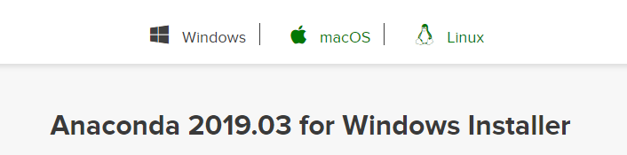
Download the Python 2.7 version 64-Bit windows executable (Anaconda2-2019.03-Windows-x86_64.exe) to a desired location on your machine. After the download is complete, go to the download folder and double click on the EXE file (Anaconda2-2018.12-Windows-x86_64).

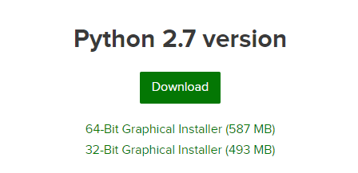
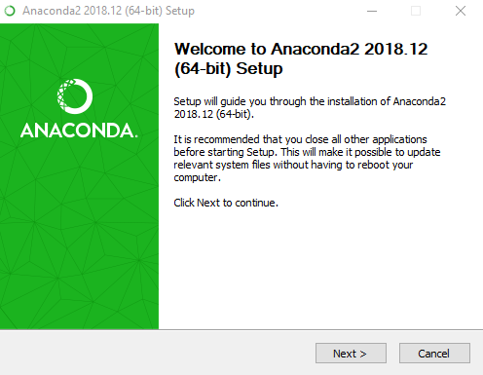
Click “Next”.
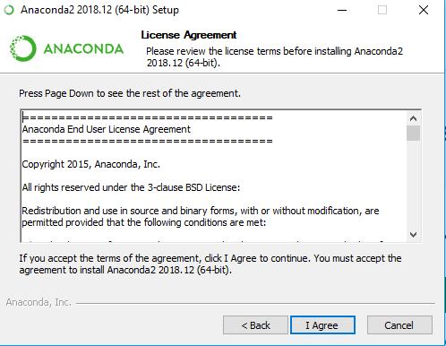
Click “I Agree”.
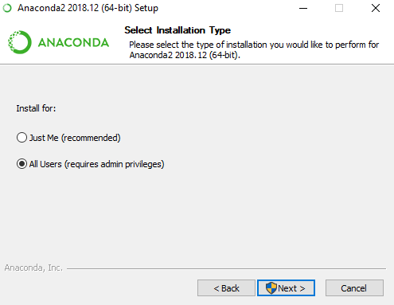
Make sure you have Admin privileges in the computer you are trying to setup the run. Then, Click “Next”.
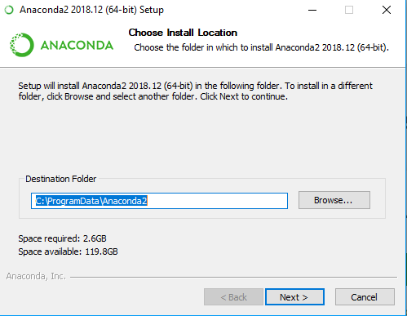
Choose a different folder if you want to install in a different location, otherwise keep the default and click “Next”.
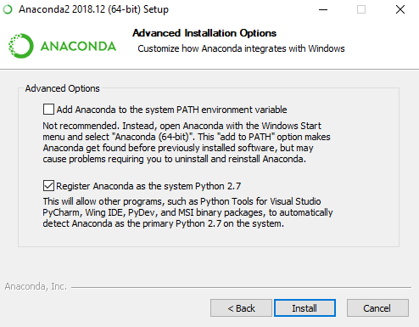
Keep the default options (as shown above) and click “Install”.
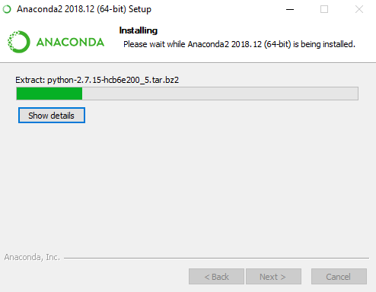
This will start the installation.
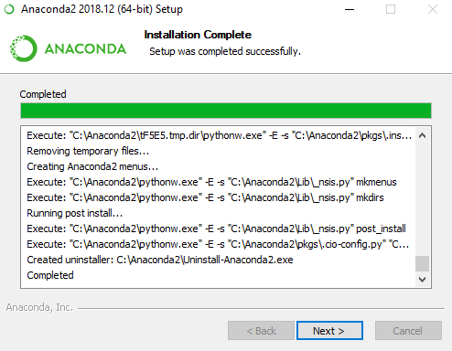
Once Installation is finished, click “Next”.
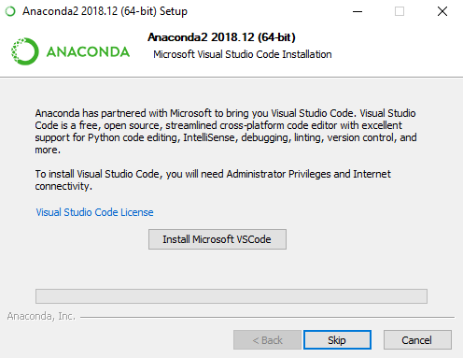
Click “Skip”.

Uncheck the two options above if you want to learn more or get started later. Click “Finish” to complete the installation.
In the next step, perform the following tasks:
- Create and activate an Anaconda environment (basically a Python install just for this project)
- Get and install other required libraries, which can be found online.
- Get and install the PopulationSim package on the activated conda Python environment
The details of these tasks can be found in the following PopulationSim github website:
https://activitysim.github.io/populationsim/getting_started.html

Setup & RUN Populationsim

Setup Directory
Figure 51 presents the directory structure for the PopulationSim setup. To set up a PopulationSim run, the user must create the directory structure as shown in below.
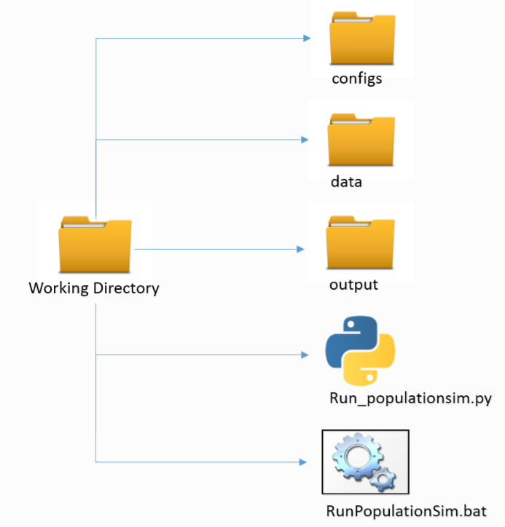
Figure 51 PopulationSim Directory Structure

The folders and files in the directory are explained as follows:
- The data directory holds all the input data like seeds data, control data and crosswalks.
  - SCOUNTY Control totals
  - TAZ Control totals
  - MAZ Control totals
  - Geographic Crosswalk
  - Household Seed table
  - Person Seed table
- The Anaconda2 directory houses the core PopulationSim software files and associated libraries and packages.
- The configs folder contains the settings.yaml file and controls.csv file
  - PopulationSim is configured using the settings.yaml file. For this project, it is configured to run in base mode which means it is run from beginning to end and produces a new synthetic population
  - controls.csv file specifies all the targets, geography, seed table, control field and their expression to the seed table required for the PopulationSim run.
- The output folder will have the final synthetic household and person file and summary attributes after a successful run.
- This batch file activates the PopulationSim environment and then calls the run_populationsim.py Python script to launch a PopulationSim run.
- PopulationSim is run using the RunPopulationSim.bat batch file in Command Prompt Window. Before starting the run, the path to the Anaconda install must be updated within this file.
The PopulationSim procedure is automated and once you have all the data in place, the user just needs to run the batch file from the command prompt window. To run the PopulationSim for 2030 or 2045 the user need to update the ‘data_dir’ field in the settings.yaml file. The ‘data_dir’ field for different scenario years are:
- 2015: The ‘data_dir’ in settings.yaml file should be set to ‘data’
- 2030: The ‘data_dir’ in settings.yaml file should be set to ‘data_2030’
- 2045: The ‘data_dir’ in settings.yaml file should be set to ‘data_2045’

Preparing Land-Use Data for 2045
The steps below created the land-use data for 2045:
- Create 2040 land-use data by first spatially joining the 2040 parcel centroids with 2015 MAZs containing MAZ attributes like MAZ, County, TAZ, etc. Aggregate the parcel data by MAZ. Assign zero values for household, enrollment, and employment variables to the MAZs with no parcel centroid.
- Create the 2010 land-use data by spatially joining the 2010 parcel centroids with 2015 MAZs. Aggregate the parcel data by MAZ. Assign zero values for household, enrollment, and employment variables to the MAZs with no parcel centroid data.
- Calculate the 5-year and 30-year growth rate by county from BEBR data by taking the ratio of 2040 and 2045 projections, and 2015 and 2045 projections respectively.
- Use the forecasting logic shown in Table 10 to prepare land-use data for 2045. Update the variable values in the MAZs where negative growth rate is observed from 2015 to 2045 with 2015 land-use values.
- Adjust the TAZ level 2015 PopulationSim household size controls to account for aging population as follows (discussed in Section 4.1) for each TAZ.
  - Calculate the sum of proportion of 3-person and 4+ person households.
  - If the proportion is less than 10% then no adjustment is made.
  - If the proportion is between 10% and 15% then the proportion of 1-person and 2-person households are increased by 5% and the proportion of 3-person and 4+ person households are decreased accordingly so that the total proportions add up to 100%.
  - If the proportion is between 15% and 20% then the proportion of 1-person and 2-person households are increased by 8% and the proportion of 3-person and 4+ person households are decreased accordingly so that the total proportions add up to 100%.
  - If the proportion is more than 20% then the proportion of 1-person and 2-person households are increased by 10% and the proportion of 3-person and 4+person households are decreased accordingly so that the total proportions add up to 100%.
- Calculate the implied population for 2045 by MAZ by using the adjusted household size distribution from 2015 PopulationSim controls and 2045 land-use data created in the earlier step.
- Calculate the adjustment rate for six counties so that the implied population for 2045 matches well with BEBR population in 2045. Apply these adjustment rates to the estimated household counts.
- Choose the maximum of 2015 or 2045 household count for each MAZ.
- Obtain the employment and enrollment variables similarly, but without adjusting the proportions in 2015 TAZ level PopulationSim controls for the respective variables.

Preparing Control Data for 2045
Control data was prepared according to the steps below:
- Create the COUNTY level controls (Table 12) from BEBR data (https://www.bebr.ufl.edu/sites/default/files/Research%20Reports/projections_2016_asrh.xlsx) for the projection year 2045. The counties are grouped into super counties to use Census 2000 and Census PUMS data, with their different geographies.
- Adjust the TAZ level 2015 PopulationSim household size controls to account for aging population as follows (discussed in Section 4.1) for each TAZ.
  - Calculate the sum of proportion of 3-person and 4+ person households.
  - If the proportion is less than 10% then no adjustment is made.
  - If the proportion is between 10% and 15% then the proportion of 1-person and 2-person households are increased by 5% and the proportion of 3-person and 4+ person households are decreased accordingly so that the total proportions add up to 100%.
  - If the proportion is between 15% and 20% then the proportion of 1-person and 2-person households are increased by 8% and the proportion of 3-person and 4+ person households are decreased accordingly so that the total proportions add up to 100%.
  - If the proportion is more than 20% then the proportion of 1-person and 2-person households are increased by 10% and the proportion of 3-person and 4+person households are decreased accordingly so that the total proportions add up to 100%.
- Create TAZ level 2045 PopulationSim household size control by distributing the total households counts from 2045 land-used data based on newly calculated household size distribution by TAZ.
- Create TAZ level 2045 PopulationSim controls like households by number of workers, householder age, and household income using the total household counts from 2045 land-use data and same distribution as 2015 PopulationSim controls for the respective variables.

Preparing Land-Use Data for 2030
The steps below created the land-use data for 2030:
- Create 2025 land-use data by first spatially joining the 2025 parcel centroids with 2015 MAZs containing MAZ attributes like MAZ, County, TAZ, etc. Aggregate the parcel data by MAZ. Assign zero values for household, enrollment, and employment variables to the MAZs with no parcel centroid.
- Create the 2010 land-use data by spatially joining the 2010 parcel centroids with 2015 MAZs. Aggregate the parcel data by MAZ. Assign zero values for household, enrollment, and employment variables to the MAZs with no parcel centroid data.
- Calculate the 5-year and 15-year growth rate by county from BEBR data by taking the ratio of 2025 and 2030 projections, and 2015 and 2030 projections respectively.
- Use the forecasting logic shown in Table 16 to prepare land-use data for 2030. Update the variable values in the MAZs where negative growth rate is observed from 2015 to 2030 with 2015 land-use values.
- Adjust the TAZ level 2015 PopulationSim household size controls to account for aging population as follows (discussed in Section 4.1) for each TAZ.
  - Calculate the sum of proportion of 3-person and 4+ person households.
  - If the proportion is less than 10% then no adjustment is made.
  - If the proportion is between 10% and 15% then the proportion of 1-person and 2-person households are increased by 5% and the proportion of 3-person and 4+ person households are decreased accordingly so that the total proportions add up to 100%.
  - If the proportion is between 15% and 20% then the proportion of 1-person and 2-person households are increased by 8% and the proportion of 3-person and 4+ person households are decreased accordingly so that the total proportions add up to 100%.
  - If the proportion is more than 20% then the proportion of 1-person and 2-person households are increased by 10% and the proportion of 3-person and 4+person households are decreased accordingly so that the total proportions add up to 100%.
- Calculate the implied population for 2030 by MAZ by using the adjusted household size distribution from 2015 PopulationSim controls and 2030 land-use data created in the earlier step.
- Calculate the adjustment rate for six counties so that the implied population for 2030 matches well with BEBR population in 2030. Apply these adjustment rates to the estimated household counts.
- Choose the maximum of 2015 or 2030 household count for each MAZ.
- Obtain the employment and enrollment variables similarly, but without adjusting the proportions in 2015 TAZ level PopulationSim controls for the respective variables.

Preparing Control Data for 2030
Control data was prepared according to the steps below:
- Create the COUNTY level controls (Table 12) from BEBR data (https://www.bebr.ufl.edu/sites/default/files/Research%20Reports/projections_2016_asrh.xlsx) for the projection year 2030. The counties are grouped into super counties to use Census 2000 and Census PUMS data, with their different geographies.
- Adjust the TAZ level 2015 PopulationSim household size controls to account for aging population as follows (discussed in Section 4.1) for each TAZ.
  - Calculate the sum of proportion of 3-person and 4+ person households.
  - If the proportion is less than 10% then no adjustment is made.
  - If the proportion is between 10% and 15% then the proportion of 1-person and 2-person households are increased by 5% and the proportion of 3-person and 4+ person households are decreased accordingly so that the total proportions add up to 100%.
  - If the proportion is between 15% and 20% then the proportion of 1-person and 2-person households are increased by 8% and the proportion of 3-person and 4+ person households are decreased accordingly so that the total proportions add up to 100%.
  - If the proportion is more than 20% then the proportion of 1-person and 2-person households are increased by 10% and the proportion of 3-person and 4+person households are decreased accordingly so that the total proportions add up to 100%.
- Create TAZ level 2030 PopulationSim household size control by distributing the total households counts from 2030 land-used data based on newly calculated household size distribution by TAZ.
- Create TAZ level 2030 PopulationSim controls like households by number of workers, householder age, and household income using the total household counts from 2030 land-use data and same distribution as 2015 PopulationSim controls for the respective variables.

Updating PopulationSim Controls
When updating land-use data it is necessary to update the PopulationSim controls. The following example shows how to update the controls when adding 100 households to MAZ 1439:
- Update the land-use “nftpo_microzones_{year}.csv” file by adding 100 households to MAZ 1439. Figure 52 shows the land-use file before the addition of 100 households and Figure 53 shows the land use file after the addition of 100 households.
Edit the variables listed in

- Table 77 within the CUBE script “update_controls.S” located in “./User.prg/Population_Synthesis/” folder. The script performs following actions:
  - Makes a copy of control files.
  - Updates MAZ level household controls by comparing existing control values with land-use values.
  - Updates TAZ level household controls by aggregating land-use values by TAZ. Redistributes the additional households by household size based on the distribution of households by household size as observed in control data. Similarly redistributes additional household based on distribution of households by householder age, number of household workers, and household income respectively as observed in the control data.
  - Updates County level population controls by adding additional person based on average household size calculated for each county from existing controls. The additional population is distributed across gender and age group based on distribution of population observed in controls for respective categories.
- Run “update_controls.bat” file, located in “./User.prg/Population_Synthesis/” folder, by double-clicking. This will call the Cube Voyager and run the “update_controls.S” script.
- The control files are now updated and are ready to be used by PopulationSim.
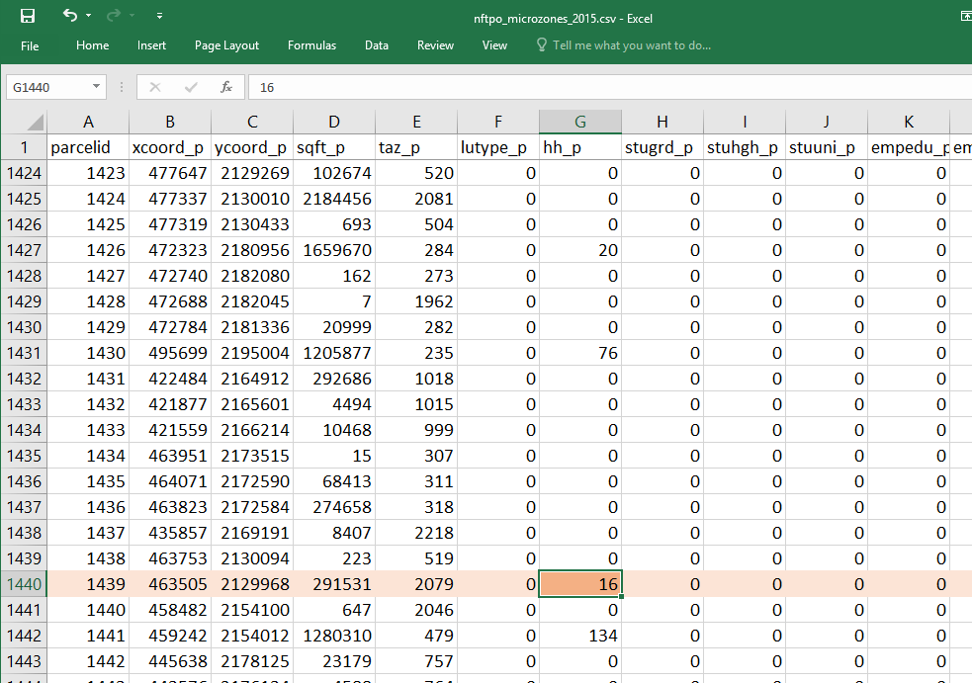
Figure 52 land-use file before adding 100 households
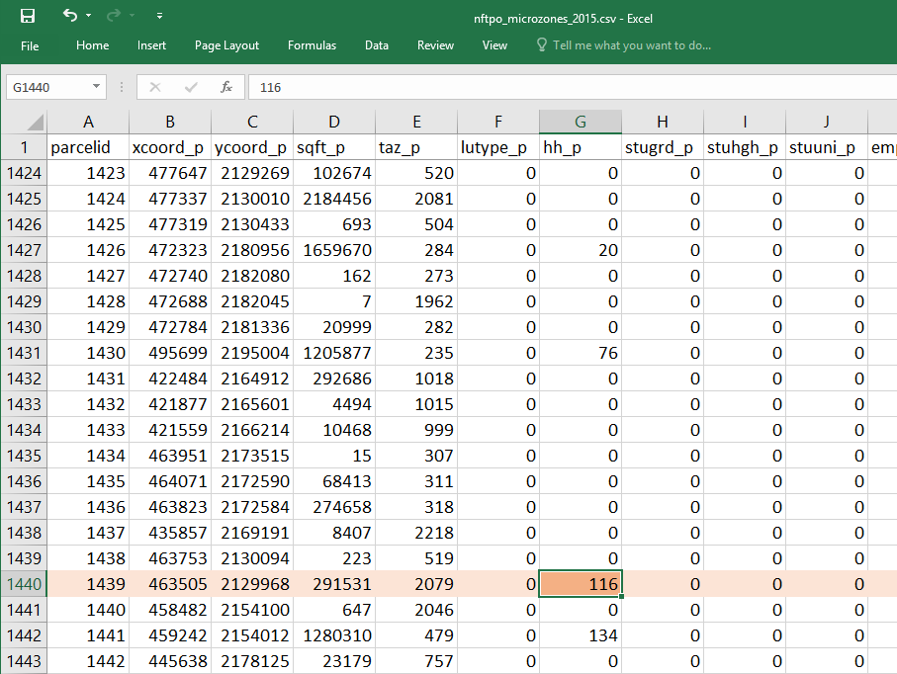
Figure 53 land-use file after adding 100 households

Table 77 Variables to update by user when updating popsim controls
VARIABLE NAME | DESCRIPTION | EXAMPLE
LANDUSE_PATH | Full path to the folder that contains the land-use file. | '.\NERPMABv2.1.1\User.prg\DaySim_Data_Tools'
LANDUSE_FILE | Name of the land-use file | 'nftpo_microzones_2015.csv' or 'nftpo_microzones_2030.csv' or 'nftpo_microzones_2045.csv'
POPSIM_PATH | Full path to the PopulationSim folder | '.\NERPMABv2.1.1\User.prg\Population_Synthesis'
CONTROL_FOLDER | Name of the folder containing the control data | 'data' or  'data_2030' or  'data_2045'
OVERWRITE_INITIAL | A value of 0 will not overwrite the initial files and a value of 1 will overwrite the initial files. | 0: Does not overwrite the control_totals_{zone}_initial.csv file  1: Overwrites the control_totals_{zone}_initial.csv file.

Prepare DaySim Inputs

Transit Stops File
The transit stops file is created using the input transit network from Jacksonville Transit Authority: TROUTE_{Year}{Alt}.LIN
Follow the sequential step below:
- Create a geodatabase (gdb) in Cube
- Import the input transit network file and the highway network file
- Export the nodes (PTNetwork_PTNode) to a shapefile
- Open the shapefile in ArcMap and select the nodes that have STOPNODE=1. These are the transit stops
- Export the selected nodes (stops) to a new stops shapefile. Also Export the transit line file to a shapefile.
- Open the attribute table of the new stops file and add four fields: xcoord_p (double), ycoord_p (double), mode (int) and id (long).
- Calculate xcoord_p and ycoord_p using calculate geometry for the two fields.
- Join transit line by object id and calculate a new field “mode” equal to the MODE field in the line file (1-localbus, 2-skyway). Jacksonville mode codes and daysim mode codes are different, convert these to daysim mode codes before running buffer tools.
2015 | 2030 | 2045 | DaySim
21 = LB | 21 = LB | 21 = LB | 1 = LB
24 = Skyway (coded as LB) | 23 = Skyway (coded as LB) | 23 = Skyway (coded as LB) | 2 = EB
 | 27 = CR | 27 = CR | 3 = CR
- Calculate stopid as “FID+1”.
- Keep only four fields in the attribute table: id, mode, x_coord, y_coord.
- Export all records in the attribute table to a csv file: Jacksonville_transitstops.csv
The stops file is in the following format:
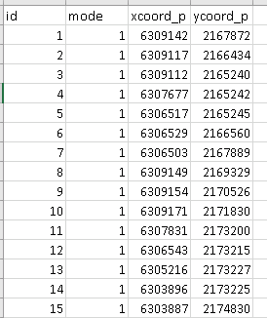

DaySim Data Editing
This section of the appendix contains various input data preparation and processing for DaySim updates. With the base year moving from 2010 to 2015, microzones replacing parcels and new population data, the inputs for DaySim needed to be updated. The following steps describe the DaySim input data preparation and update for the NERPM-AB model including the tool and input data used and output formed.

Network Data Preparation
This step calculates “nearby” node pairs of microzones for shortest distance path calculations to be used in DaySim.
Tool: Network_DataPrepv2.exe
Directory: \User.prg\DaySim_Data_Tools
Inputs:
- input_node.csv (Node x,ys from an all-streets network)
- jax_MAZs_2015.dat (The coordinates of the newly developed microzones)
- jax_netprep.ctl (Network prep control file)
Output:
- input_od_pairs.csv (for input to shortest path update tool)

Shortest Path Update
This process is required to generate more accurate short distances based on an all streets network. DTALite, a dynamic traffic assignment software, is used to generate node-to-node shortest path distances using the all streets network.
Tool: DTALite64.exe
Inputs:
Directory: \User.prg\DaySim_Data_Tools
- input_od_pairs.csv (from the Network Data Preparation tool)
- input_node.csv (from all-street network)
- input_link_type.csv (from all-street network)
- input_link.csv (from all-street network)
- DTASettings.ini (settings file)
Output:
- output_shortest_path.txt (for input to Buffering microzones)

Buffering micro-zones
The Daysim buffering tool is run to prepare MAZ input file for DaySim. This step calculates the new Microzone buffer measures to be used in DaySim.
Tool: DSBuffTool.exe
Directory: \User.prg\DaySim_Data_Tools
Inputs:
- Jax_microzones_2015.csv (Base Microzone file)
- Jacksonville_Intersections.csv (Street intersections file)
- Jacksonville_transitstops.csv (Transit stops file)
- Jacksonville_openspaces.csv (Open spaces/parks file)
- input_node.csv (All-street Network nodes file)
- output_shortest_path.txt (Node-to-node shortest path distance file)
Output:
- buffered_microzone_2015.dat (to be used in DaySim)
- microzonenode.dat (to be used in DaySim)
- output_shortest_path.txt.bin (Change extension using batch file)
- output_shortest_path.txt.index (Change extension using batch file)
The file extension of the last two outputs above need to be changed for reading into DaySim. The last three output files are used in DaySim to estimate short-distances for car, walk and bike trips.
All three DaySim Data tools can be run using RunAll.bat from the command prompt window.

Running DSBuffTool.exe
Double-clicking the executable will bring up a GUI as shown in the following figure. The use of this tool is straightforward. The user just needs to specify all the inputs and click on the “Run” button at the bottom of the GUI.
Figure 10-54 DaySim Buffering Tool Gui
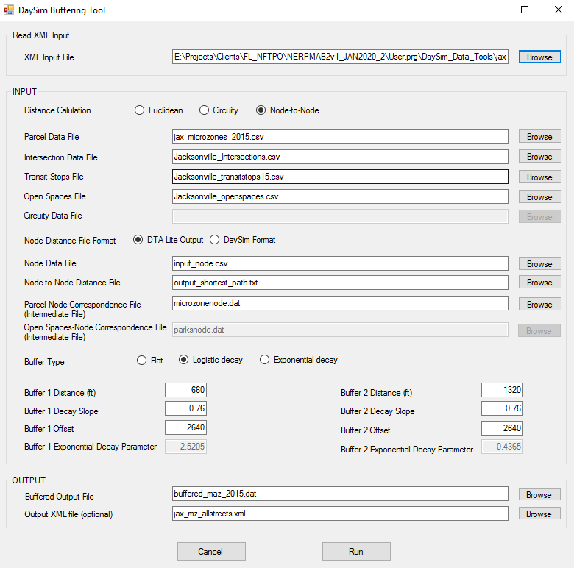
In the “INPUT” section of the GUI, distance calculation and buffer type are set to “Euclidean” and “Logistic decay” respectively. These are the recommended settings for running this tool. If node-to-node distances obtained from an all streets network are available, distance calculation may be set to “Node-to-Node”. The default recommended parameters for logistic decay weights (described in the model design chapter) such as buffer decay slope, offset etc., are also automatically populated in the appropriate fields in the GUI.
All other inputs are to specify file paths that can be done by clicking on the “Browse” button. This pops a file dialog as show in the figure below. The user may also enter full file paths manually using keyboard.
Figure 10-55 Buffer TooL File Selection Dialog
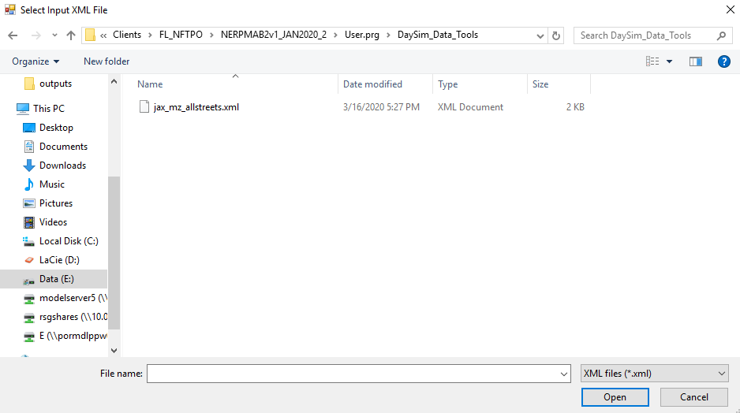

All file specification fields for the tool are described below. Details about formats for the input files can be found in the directory and data structures chapter.
- MAZ Data File: This is the base MAZ file. It is obtained by running the disaggregation tool.
- Intersection Data File: This file has the coordinates of intersections and the number of links intersecting at each one of them.
- Transit Stops File: This file has the transit stop location coordinates by transit sub-mode.
- Open Spaces File: This file has the locations and area of parks/open spaces in the model region.
- Circuity Data File: This is only required for “Circuity” distance calculation that is now an obsolete method.
When “Node-to-Node” distance calculation is selected, the user need to select a format of the input node-node distance file: output of DTALite or input file used in DaySim. The following files are only needed for “Node-to-Node” distance calculation method.
- Node Data File: This file contains the coordinates of node from an all streets network.
- Node to Node Distance File: This file contains the network shortest path distances between a list of node pairs that are within 3 miles of each other. It is either an output from DTALite or a distance file input to DaySim.
- MAZ-Node Correspondence File: This is an intermediate file created during the buffering process and contains the correspondence between MAZs and nodes.
- Open spaces-Node Correspondence File: This is an intermediate file created during the buffering process and contains the correspondence between open spaces and nodes.
Specification of the following XML files is optional. However, they store the input configuration of a buffering tool run and make it convenient to use the tool.
- Output XML File: If a file is specified in this field, an XML file containing all the input information specified by the user is stored upon clicking on “Run” button that initiated the buffer process.
- XML Input File: Once an XML file has been stored as described above, it can be selected to automatically populate all the input fields required for a buffer run. This can be used to re-run a buffer process with the same inputs or modify a few inputs to generate a different buffered MAZ file.
Finally, Buffered Output File field is used to specify the location and name of the buffered microzone output file that needs to go into DaySim inputs folder.

DaySim Files Update
The following files were updated in the latest 2015 DaySim run:
- New Microzone file containing aggregated household and employment inputs and buffered measures instead of parcels
- Household file containing all household information with respect to the microzones
- DaySim Configuration file containing the DaySim execution settings
- A set of updated DaySim input files
- A set of new Data files for short distance calculation
To accurately calculate short car, walk and bike trips, short distance node-to-node measure is introduced in DaySim. This includes the following changes:
- Change in DaySim Configuration file
- Utilization of three additional files in DaySim:
  - Microzone node file (microzonenode.dat)
  - Node Index file (output_shortest_path_txt_index.dat)
  - Node distance file (output_shortest_path_txt_bin.dat)

Activating TAZ
The model contains a list of TAZs that are dummy TAZs that act as a placeholder to be later used when building new TAZs. The steps to utilize or activate these dummy zones is as follow:
- Identify the dummy TAZ that needs to be activated.
- Update the input network MicroCodedHnet42.net within Cube.
  - Relocate the dummy TAZ to the centroid of new TAZ.
  - Update the attributes of the dummy TAZ.
  - Build network links that would connect the dummy TAZ to appropriate nodes on the network.
  - Update the attributes of these network links.
- Identify the overlap/association between existing MAZs and the new TAZ.
- Update the land-use file nftpo_microzones_year.csv.
  - Update the “taz_p” field for MAZs that are now identified as associated with new TAZ for all scenario years.
- Update the PopulationSim Inputs.
  - Update the fields associated with MAZs identified in the earlier step with updated TAZ in geo_cross_walk.csv.
  - Update the TAZ field for identified MAZs in control_totals_maz.csv file.
  - Update the control_totals_taz.csv file by adding a row for dummy TAZ and recording appropriate values in rest of the fields. It should be ensured that the values entered are reasonable for e.g. household size values should not all be 0 and should match up to total households.
  - Go through the steps described in Updating Land-use Manually later in this document.
- Update scenario input files in “scenario/Input/” folder.
  - Add/Update the “Zone_id” and “Zone_ordinal” field in the _jax_taz_indexes.dat file located in “scenario/Input/DaySimInput/01_TAZ_Index/” folder to the dummy TAZ. Set the “Dest_eligible” field for this TAZ to a value of 1.
  - Add/Update the TAZ field in the emp_year.dbf file located in “scenario/Input/DaySimInput/02_Parcel/” folder.
  - Add/Update the TAZ field in the _jax_worker_ixxifractions.dat file located in “scenario/Input/DaySimInput/05_ixxi/” folder.
  - Add/Update the TAZ field in the county_districts.csv file located in the “scenario/Input/DaySimInput/08_Summaries/” folder.
  - Add/Update the TAZ field in the RIVERCROSS.csv file located in the “scenario/Input/” folder.
This concludes the steps needed to activate a dummy TAZ, and the use can now run the regular model.

Updating Land-use Manually
When updating land-use data, like household or population attributes, for the base or future year, the steps below should be followed to ensure proper propagation of changes throughout the model:
- The starting point for such changes is the buffering micro-zones step. One of the inputs to the buffering tool is the MAZ file, for example, nftpo_microzones_2015.csv for the 2015 scenario. The user should manually update the land-use file for changes required in specific zones because of new development, changed land-use, etc. The user should then run the buffer tool and copy the output file (buffered_maz_2015.dat) to the scenario input directory.
- The next step is to update the PopulationSim controls by following the guidelines in Section 3.1 for the base year or in Appendix A (Updating Control Data). The user should then run PopulationSim.
- The user should then run the “popsim_to_daysim.bat” file by double clicking it in Windows or running it from a DOS command promt. The batch file runs the “convert.py” script that converts PopulationSim output to DaySim inputs. The DaySim inputs are output in the “./User.prg/PopulationSim/popsim_to_daysim/output/” folder. The output should be renamed as shown in Table 78. These outputs should be copied to the model scenario input directory.
Table 78 Rename popsim_to_daysim.bat output
Output File | Rename File
Output File | Base2015 | INT2030 | CF2045
household_2015.dat | household_2015.dat | household_2030.dat | household_2045.dat
person_2015.dat | person_2015.dat | person_2030.dat | person_2045.dat

This concludes the land-use updates step, and the user can now run the regular model.
1515 SW 5th Ave Suite 1030
Portland, OR 97005
503.360.5798
www.rsginc.com
 |  |  |  |  |  |  | 
 | White River Junction & Burlington, VT | Arlington, VA | Chicago, IL | Evansville, IN | Portland, OR | Salt Lake City, UT | San Diego, CA
RSG promotes sustainable business practices that minimize negative impacts on the environment. We print all proposals and reports on recycled paper that utilizes a minimum of 30% post-consumer waste. RSG also encourages recycling of printed materials (including this document) whenever practicable.
For more information on RSG’s sustainability practices, please visit www.rsginc.com.

Data is based on Internet sources, as shown in the Lodging/SpecGen memo (file:///E:\Projects\Clients\jax\Data-Development\NorthFloridaTPO_DATA\Task_5_Lodging_SpecGen\memo_lodging_specGen.docx)

